*A project report on*

# HEART DISEASE PREDICTION USING MACHINE LEARNING TECHNIQUES

*Submitted in partial fulfillment for the award of the degree of*

## Bachelor of Technology

*By*

**AASHISH BANSAL (19BIT0346)**



**School of Information Technology and Engineering**

May, 2023

**DECLARATION**

I here by declare that the thesis entitled “HEART DISEASE PREDICTION USING MACHINE LEARNING TECHNIQUES” submitted by me, for the award of the degree of Specify the name of the degree VIT is a record of bonafide work carried out by me under the supervision of Placement Authority.

I further declare that the work reported in this thesis has not been submitted and will not be submitted, either in part or in full, for the award of any other degree or diploma in this institute or any other institute or university.

Place: Vellore



Date: May 13, 2023 Signature of the Candidate

Internship completion certificate

**ABSTRACT**

I propose to develop an application which would be able to predict whether someone would be suffering from a coronary heart disease in the coming years. I propose to develop a simple user interface through which the user would just need to answer certain questions which would be provided to the Machine Learning Model as an input and the prediction would be provided to the user on the interface itself. Since this interface is a ready-to-use interface, there is no need for the user to create an account or sign-up. The questions being asked relate to the information obtained from the tests which the user might have undergone or the user might simply be aware of the information about himself in general. The Machine Learning model is created from the algorithms which are highly effective and could be used to deploy in the real-world scenario. While executing the program, the interface program predicts through the machine learning model which has been trained on similar kind of data. However, at this stage, this project is meant for educational purpose only with a real aim of being deployed into the real-world.

*i*

**ACKNOWLEDGEMENT**

It is my pleasure to express with deep sense of gratitude to <Guide name>,

<Designation>, School of Information Technology and Engineering, Vellore Institute of Technology, for his/her constant guidance, continual encouragement, understanding; more than all, he taught me patience in my endeavor. My association with him / her is not confined to academics only, but it is a great opportunity on my part of work with an intellectual and expert in the field of <area>.

I would like to express my gratitude to Dr. G. Viswanathan, Dr. Rambabu Kodali, Mr. Sankar Viswanathan, Dr. Sekar Viswanathan, Mr. G. V. Selvam, Dr. Partha Sharathi Mallick, Dr. V. S. Kanchana Bhaaskaran, and Dr. S. Sumathy, School of Information Technology and Engineering, for providing with an environment to work in and for his inspiration during the tenure of the course.

In jubilant mood I express ingeniously my whole-hearted thanks to School of Information Technology and Engineering. Dr. S. Sumathy (Dean), all teaching staff and members working as limbs of our university for their not-self-centered enthusiasm coupled with timely encouragements showered on me with zeal, which prompted the acquirement of the requisite knowledge to finalize my course study successfully. I would like to thank my parents for their support.

It is indeed a pleasure to thank my friends who persuaded and encouraged me to take up and complete this task. At last but not least, I express my gratitude and appreciation to all those who have helped me directly or indirectly toward the successful completion of this project.

Place: Vellore **Aashish Bansal**

Date: May 13, 2023 Name of the student

## CONTENTS

INTRODUCTION

* 1. Introduction
  2. Problem Statement

LITERATURE SURVEY

2.1 Summary of the Existing Works

2.2 Challenges Present in the Existing System

REQUIREMENTS

3.1 Hardware Requirements

3.2 Software Requirements

OBJECTIVE AND SCOPE OF THE PROJECT

4.1 Objective

4.2 Scope of the Project

ANALYSIS AND DESIGN

5.1 Proposed Architecture

5.2 Data Flow Diagram

5.3 Module Descriptions

IMPLEMENTATION AND TESTING

6.1 Base Paper

6.2 Dataset

6.3 Language Platform

6.4 Source Code

6.5 Outputs

RESULTS

7.1 Results and Outcomes

7.2 Result Analysis

CONCLUSIONS

FUTURE WORKS

REFERENCES

### LIST OF FIGURES

LIST OF TABLES

LIST OF ACRONYMS

**Chapter 1**

**Introduction**

* 1. INTRODUCTION

I propose to develop Heart Disease Predictor which can help us in predicting whether a person would suffer from a heart disease or not in the coming years. The user would provide input through an interface by answering certain questions. The questions have been designed the same way the data was collected for the study. Based on the answers to the questions, the Machine Learning Model would predict whether the user would suffer from a heart disease or not in the coming future. The user interface is meant to be a ready-to-use interface where the user could directly provide input and obtain the prediction as there is no need for creating any account or any sign-up.

* 1. PROBLEM STATEMENT

Nowadays, a lot of individuals are found with some type of pain in their chest or some sort of unknown disease around the thoracic region of the body. There are multiple reasons to this kind of pain and disease, from which, the major reason is the modern lifestyle and the eating habits of the individuals. The individuals do not consider having a balanced lifestyle or work-life balance which tends to have an adverse effect on their body.

**Chapter 2**

**Literature Survey**

2.1 SUMMARY OF THE EXISTING WORKS

|  |  |  |  |  |  |  |  |
| --- | --- | --- | --- | --- | --- | --- | --- |
| S. No. | Title of the Paper | Year | Dataset Name | Algorithms | Methods | Parameters | Metrics (Accuracy) |
| 1 | Heart Disease Prediction using Hybrid ML Algorithms | 2023 | Framingham Heart Study (FHS) dataset |  | Particle Swarm Optimization |  | NB: 87.6%,  Hybrid Algorithms: 97.43% |
| 2 | Improving Accuracy of Heart Disease Prediction through Machine Learning Algorithms | 2023 | UCI Heart Disease dataset; Framingham Heart Study Dataset; Heart Disease Cleveland Uci Dataset; Cardiovascular Disease Dataset | Logistic Regression, Random Forest, Decision Tree, k-Nearest neighbour | Attribute selection is performed through decision tree learning approach and random forest learning approach. |  | LR: 89.59%,  KNN: 80.97%, RF: 83%,  DT: 82.63% |
| 3 | Coronary Heart Disease Prediction and Classification using Hybrid Machine Learning Algorithms | 2023 | Framingham Heart Laboratory | Decision Tree and Ada Boosting |  |  | Naïve Bayes: 87.6%;  Hybrid Algorithms: 97.43% |
| 4 | Machine Learning based Mobile App for Heart Disease Prediction | 2023 | Not mentioned | Random Forest, Logistic Regression, and ANN Multilayer Perceptron | method bagging |  | Not provided |
| 5 | Heart Disease Prediction using Ensemble ML | 2023 | UCI Heart Disease dataset | SVM Classifier, KNN, Decision Tree, AdaBoost Classifier, Gaussian NB, Gradient Boosting Algorithm, MLP Classifier, Random Forest Classifier | Normal ML Model |  | KNN: 91.76%,  DT: 95.13%,  SVC: 95.88, RF: 95.50%,  AdaBoost: 94.38%,  MLP: 95.88%,  Gaussian NB: 94.38%,  DVC: 98.12%,  Gaussian Naïve Bias: 95.88% |
| 6 | An Effective Heart Disease Prediction Method using Extreme Gradient Boosting Algorithm Compared with Convolutional Neural Networks | 2023 |  | KNN, Naive Bayes, SVM, Simple Logistic Regression and ANN | CAD procedures | XGBoost | ANN: ~85%,  CNN: ~95%,  KNN: ~55%,  NB: ~75%,  SVM: ~80%,  XGBoost: ~90% |
| 7 | A Review: Heart Disease Prediction in Machine Learning & Deep Learning | 2023 |  |  |  |  |  |
| 8 | Machine Learning based Cardiac Disease Prediction- A Comparative Analysis | 2023 | UCI | Naïve Bayes, Logistic Regression, Random Forest | ETL, Data Enrichment |  | NB: 84.12%,  RF: 87%,  LR: 80% |
| 9 | Heart Disease Prediction: Optimization of Machine Learning Algorithms | 2023 |  | KNN, DT, RF, LR, SVM | Smoothing, normalization, and grouping |  | LR: 87.01%,  SVM: 86.04%,  KNN: 74.68%,  DT: 96.97%,  RF: 96.75% |
| 10 | A Comparison of Supervised Learning Algorithms to Prediction Heart Disease | 2023 | UCI | KNN, SVC, MLP |  |  | KNN: 91.8%,  SVC: 90.16%,  MLP: 88.52% |
| 11 | A Methodology For Early Prediction and Classification of Heart Diseases in Diabetic Patients With Machine Learning Techniques | 2022 | UCI | RF Classifier, LR Classifier, SVM |  |  | Avg Accuracy: 93.26% |
| 12 | Machine Learning Based Classification Algorithms Performance Analysis for Heart Disease Prediction | 2022 | UCI Cleveland heart disease dataset | LR, NB, KNN, DT, Ensemble Learning, RF, Gradient Boosting, XGBoost | ROC, AUC |  | LR: 82%,  NB: 75%,  KNN: 88%,  DT: 75%,  RF: 82%,  AdaBoost: 84%,  Gradient Boosting: 81%,  XGBoost: 79% |
| 13 | Heart Disease Prediction using Clustered Genetic Optimization Algorithm | 2023 | UCI | K-Means | Clustered Genetic Algorithm, Segmentation Process, Optimization Process |  | Accuracy: 94.56% |
| 14 | Software Development Framework for Cardiac Disease Prediction Using Machine Learning Applications | 2022 | UCI Cleveland | RF, Ensemble Learning with RF and Bagging | Bootstrap methods |  | KNN: 90.25%,  DT: 79.21%,  LR: 85.25%,  SVM: 81.97%,  RF: 91.1% |
| 15 | Machine Learning and Deep Neural Network Techniques for Heart Disease Prediction | 2022 | UCI repository | KNN, NB, SVM, AdaBoost, RF, DT, LR, XGBoost, LGBM, GB, CatBoost |  |  | XGB: 81.1%,  Deep Neural Network: 85.9% |
| 16 | A Review of Commonly used Machine Learning Classifiers in Heart Disease Prediction | 2022 | UCI Cleveland, Hungary, Switzerland, and Long Beach V databases | Naïve Bias, KNN (K-Nearest Neighbors), Random Forest, Decision Tree, SVM (Support Vector Machine), LR (Logistic regression) |  |  | SVM: 68.83%,  DT: 98.05%,  KNN: 87.01%,  LR: 75.97%,  NB: 75%,  RF: 95.13% |
| 17 | An intelligent framework for heart disease prediction deep learning-based ensemble Method | 2023 | UCI repository | AdaBoost, SVC, RF, MLP, GB, DT, GNB, KNN | Medical Body Area Network, Particle Swarm Optimization, K-Bins Discretization Technique, Elliptic Envelope, Isolation Forest, Tuned Model Randomized Search CV, Reduced Model PCA, Ensemble Module |  | AdaBoost: 49.9%,  SVC: 24.72%,  RF: 9.24%,  MLP: 32.68%,  Gradient Boosting: 0.18%,  KNN: 9.8%,  DT: 11.84%,  GNB: 0.22% |
| 18 | Heart Disease Prediction and Classification using Machine Learning and Transfer Learning Model | 2023 | UCI repository | Multilayer perception neural network (MLPNN), RF, SVM, HDPM | Conjugant feature scale factor (CFSF), Disease prone impact rate (DPIR), Relative feature margin selection (RFMS) |  | RF: 75%,  SVM: 81%,  HDPM: 84%,  RFMS-MLPNN: 87% |
| 19 | Heart Disease Prediction Model using Machine Learning | 2022 | UCI repository | SVM, DT, KNN, NB, LR, NN, RF |  |  | LR: 78.30%, 80.07%,  SVM: 74.66%,  KNN: 58.96%, 85.15%,  RF: 98.03%,  XGBoost: 79.23% |
| 20 | Machine Learning Heart Disease Prediction Using KNN and RTC Algorithm | 2022 | NLM database | DT, KNN |  |  | KNN: 85.71%,  DT: 98.05% |

2.2 CHALLENGES PRESENT IN EXISTING SYSTEM

**Chapter 3**

**Requirements**

3.1 HARDWARE REQUIREMENTS

Local Machine:

Processor: Intel i7 10th Generation

RAM: 32GB

GPU: NIVIDIA GeForce GTX 1650Ti (4 GB)

GPU Type: Dedicated

Google Collaboratory:

Processor:

RAM:

GPU:

GPU Type:

3.2 SOFTWARE REQUIREMENTS

Some of the software used while implementing the Application are:

* Anaconda Studio
  + Jupyter Notebook
  + Spyder
* Visual Studio Code
* Python
* Google Drive

**Chapter 4**

**Objective and Scope of the Project**

4.1 OBJECTIVE

4.2 SCOPE OF THE PROJECT

**Chapter 5**

**Analysis & Design**

5.1 PROPSED ARCHITECTURE

5.2 DATA FLOW DIAGRAM

5.3 MODULE DESCRIPTION

**Chapter 6**

**Implementation & Testing**

6.1 BASE PAPER

6.2 DATASET

6.3 LANGUAGE PLATFORM

6.4 SOURCE CODE

The Google Drive Link for the Project is:

Overall Drive Link:

Machine Learning Model:

User Interface:

Dataset:

The source code for the Machine Learning Model is:

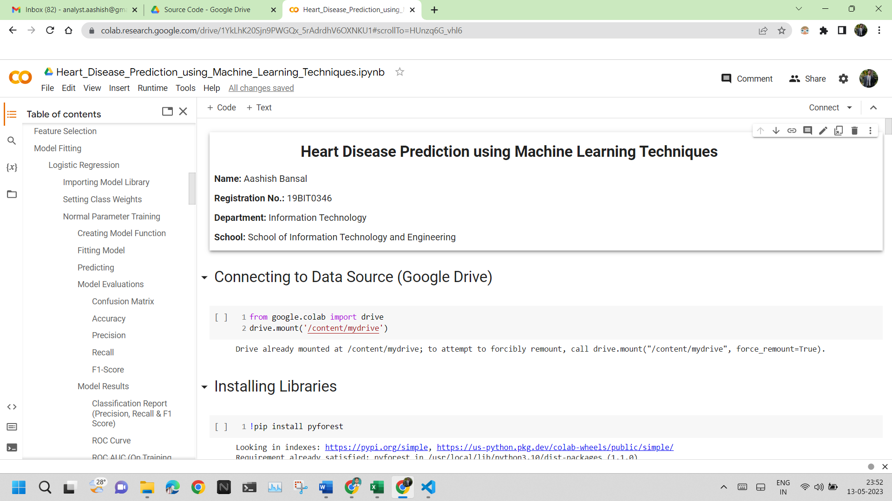

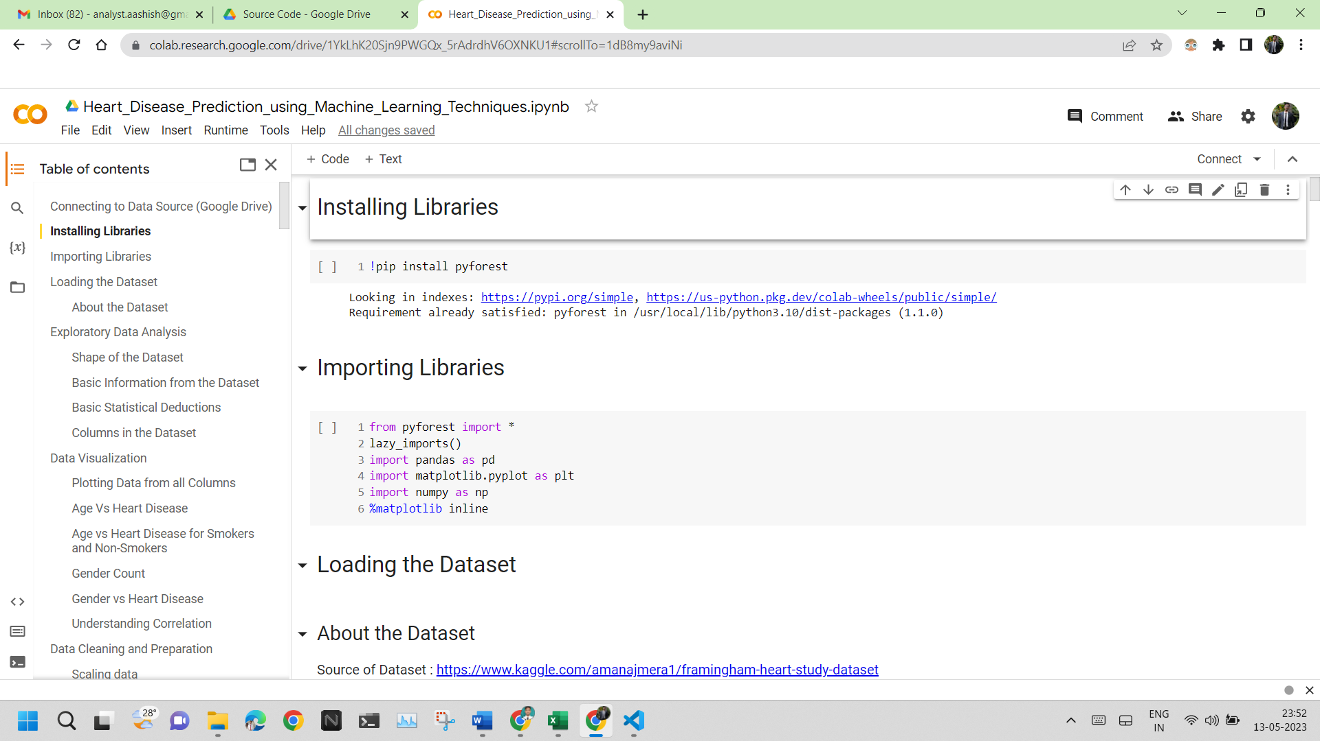

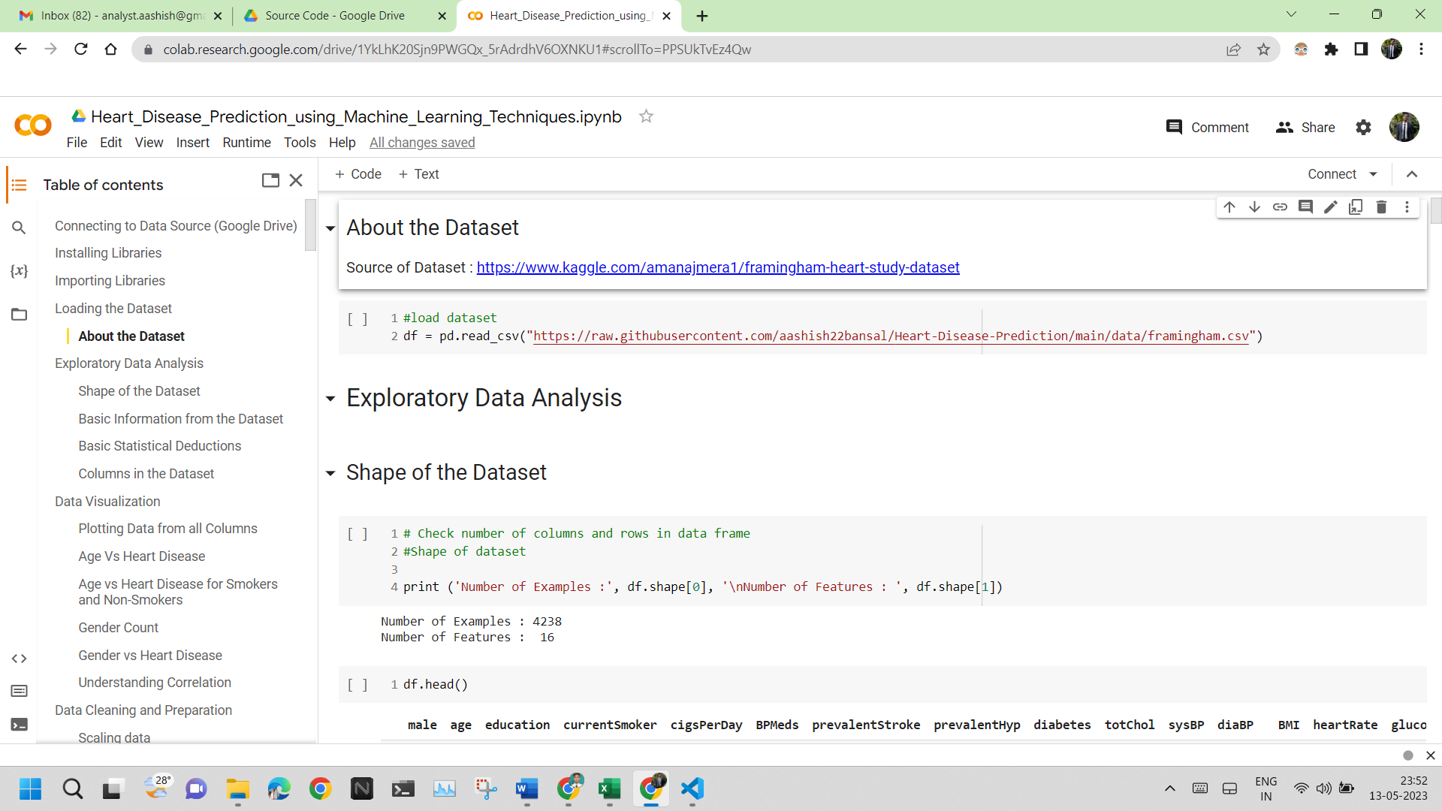

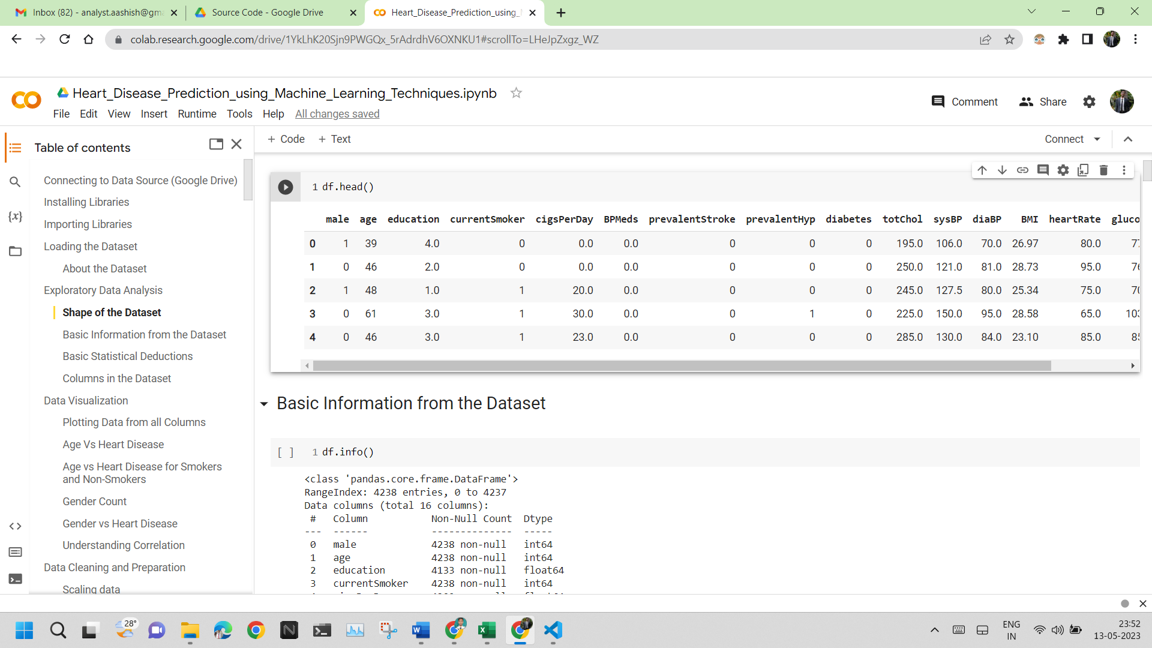

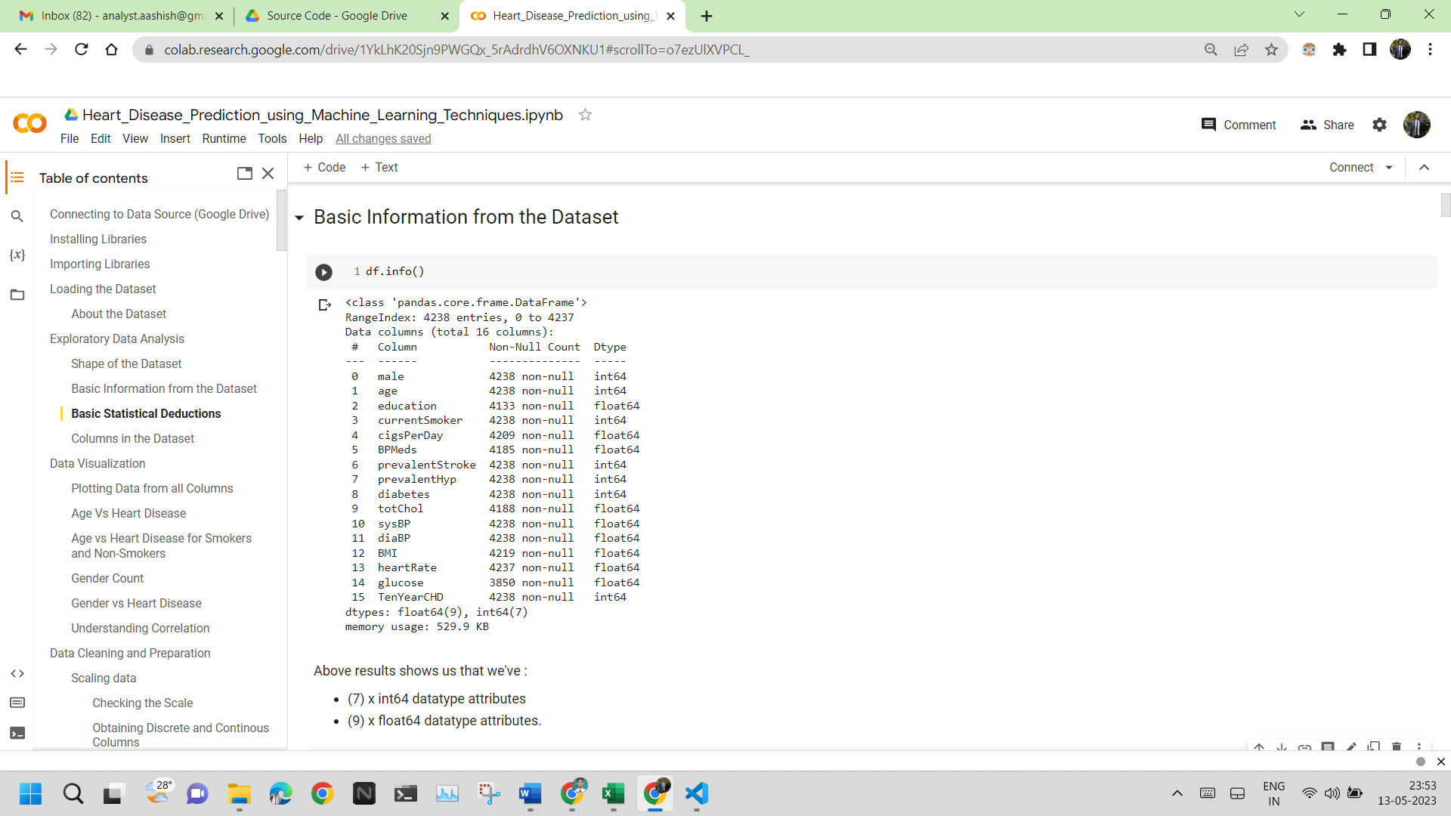

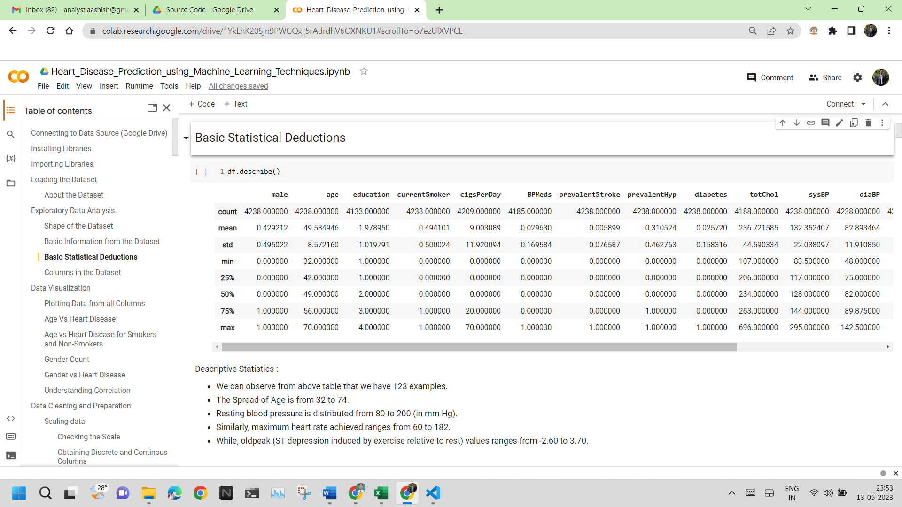

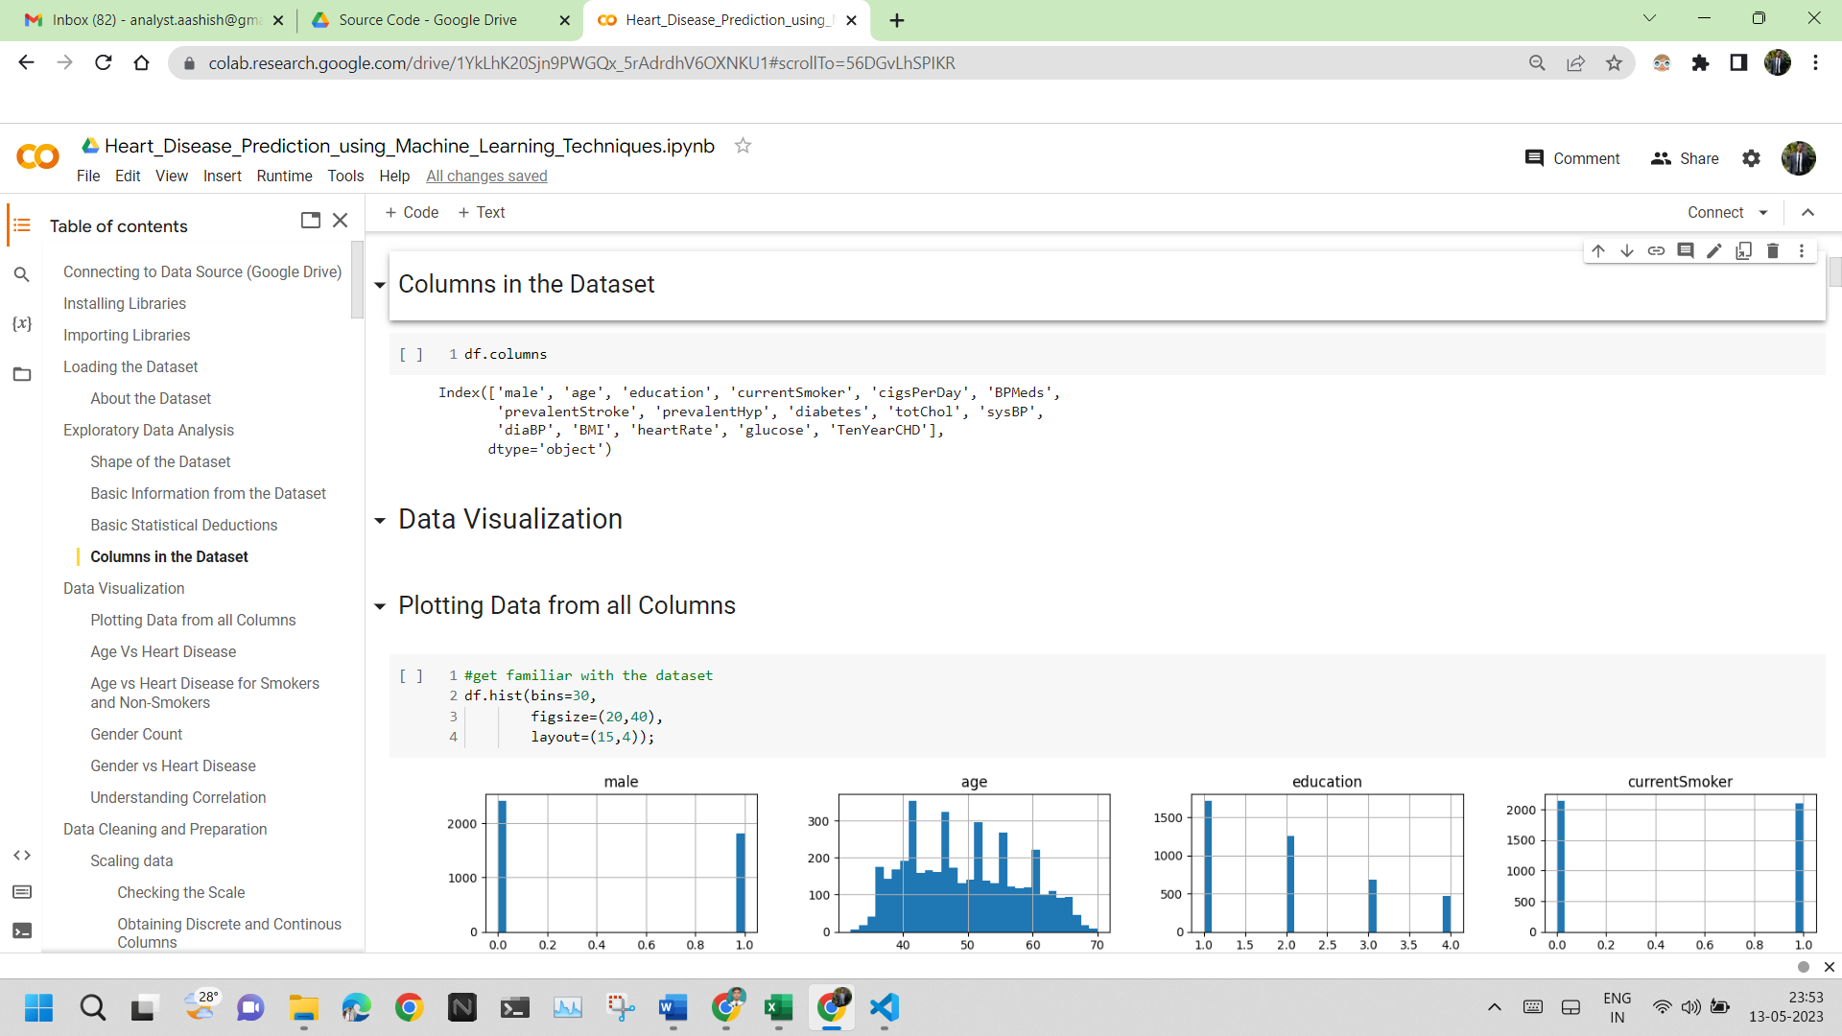

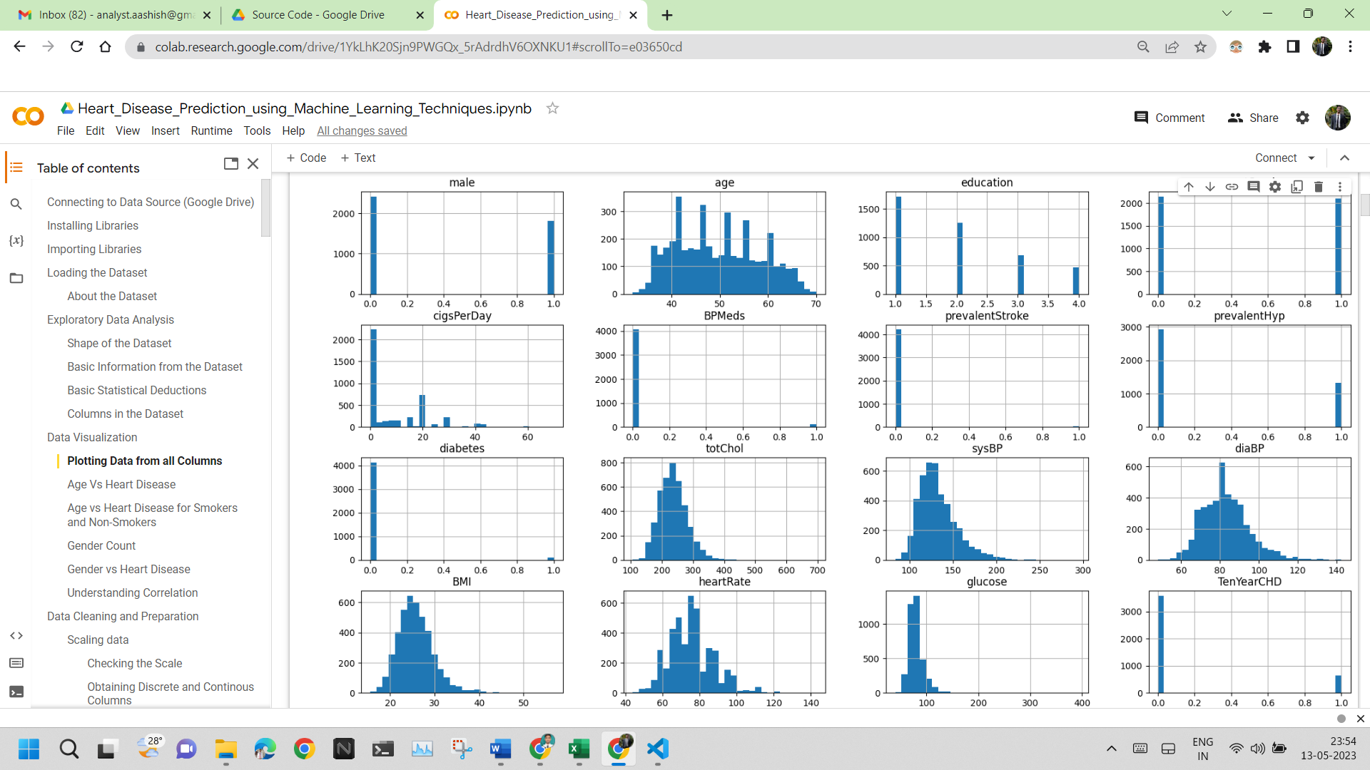

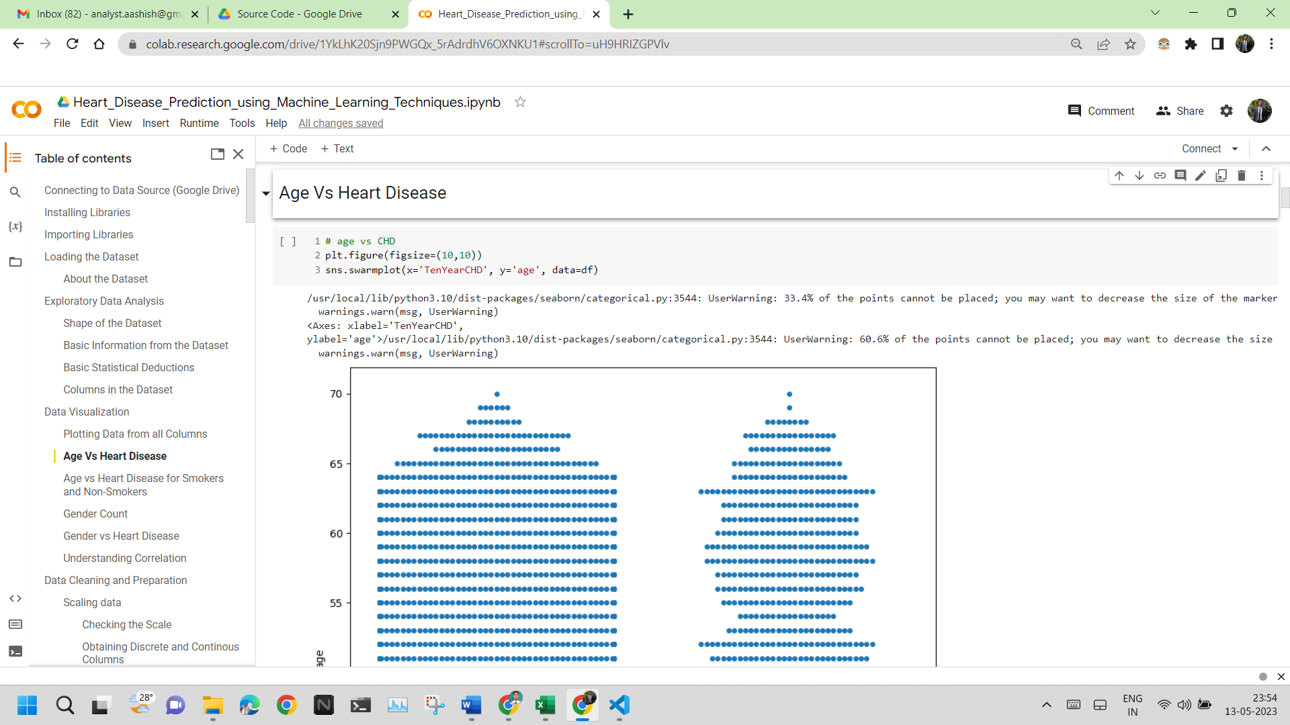

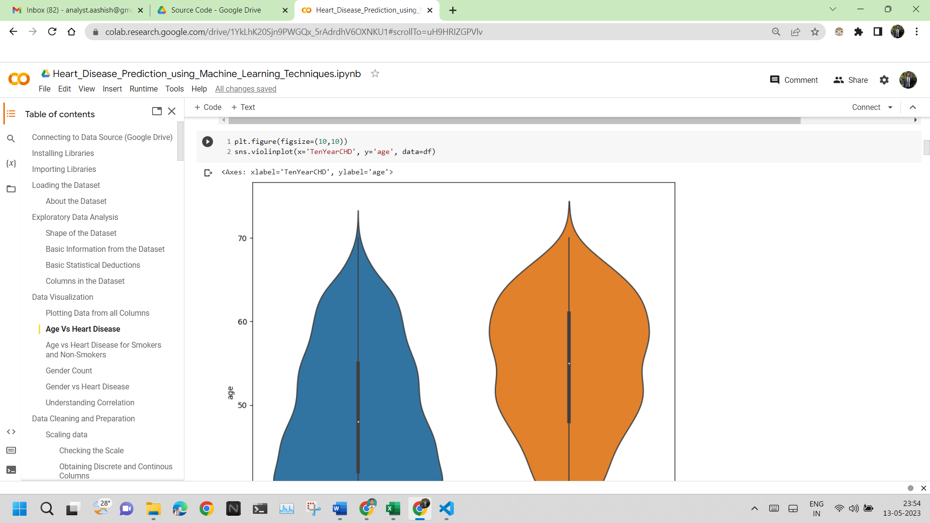

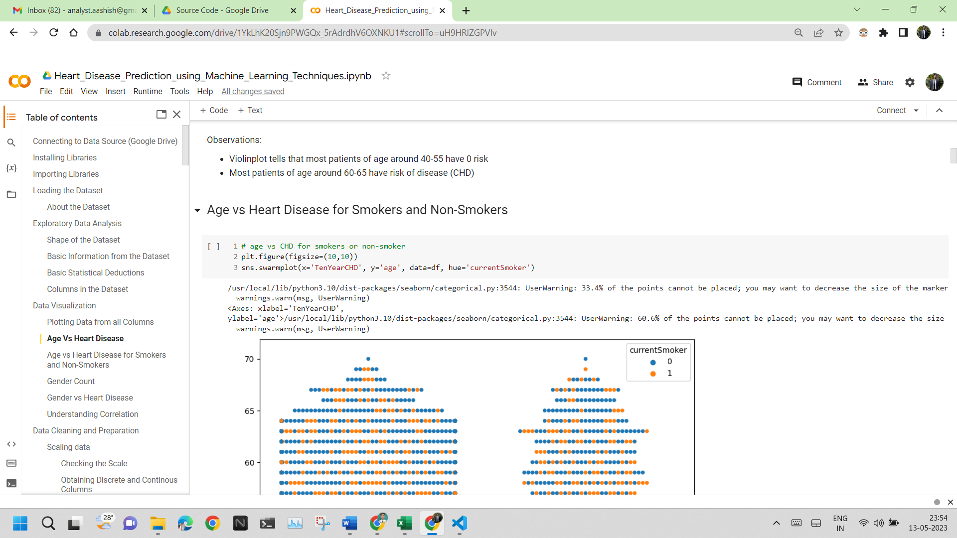

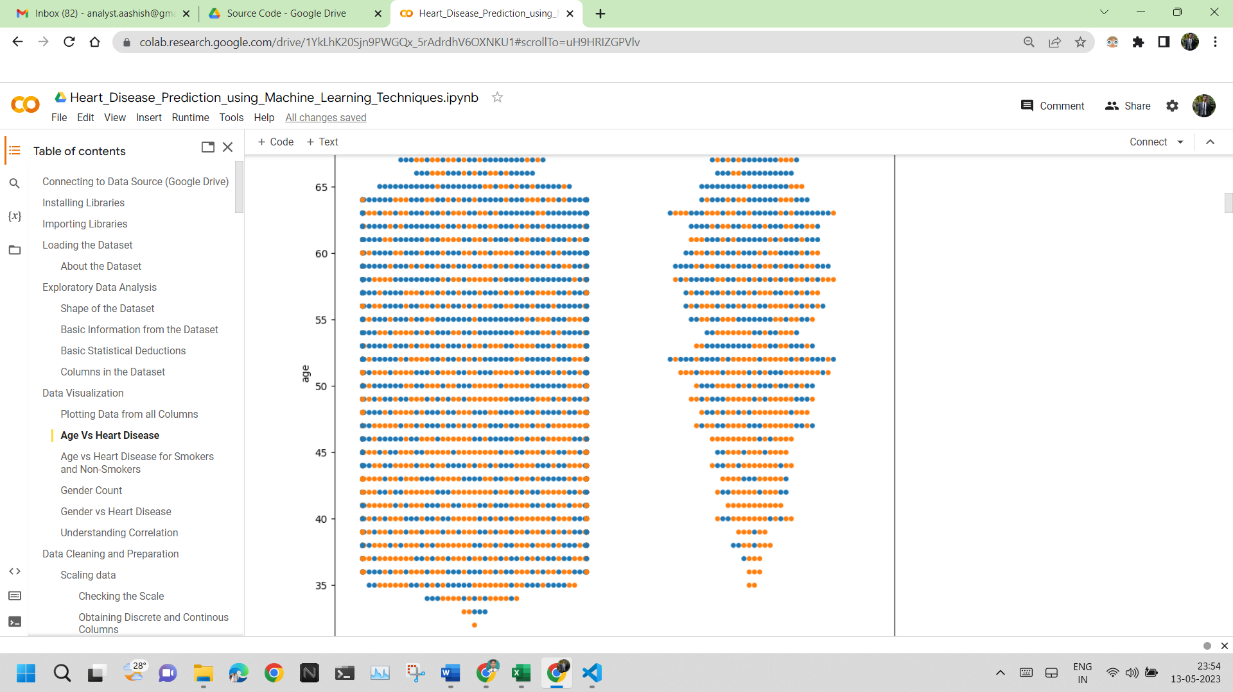

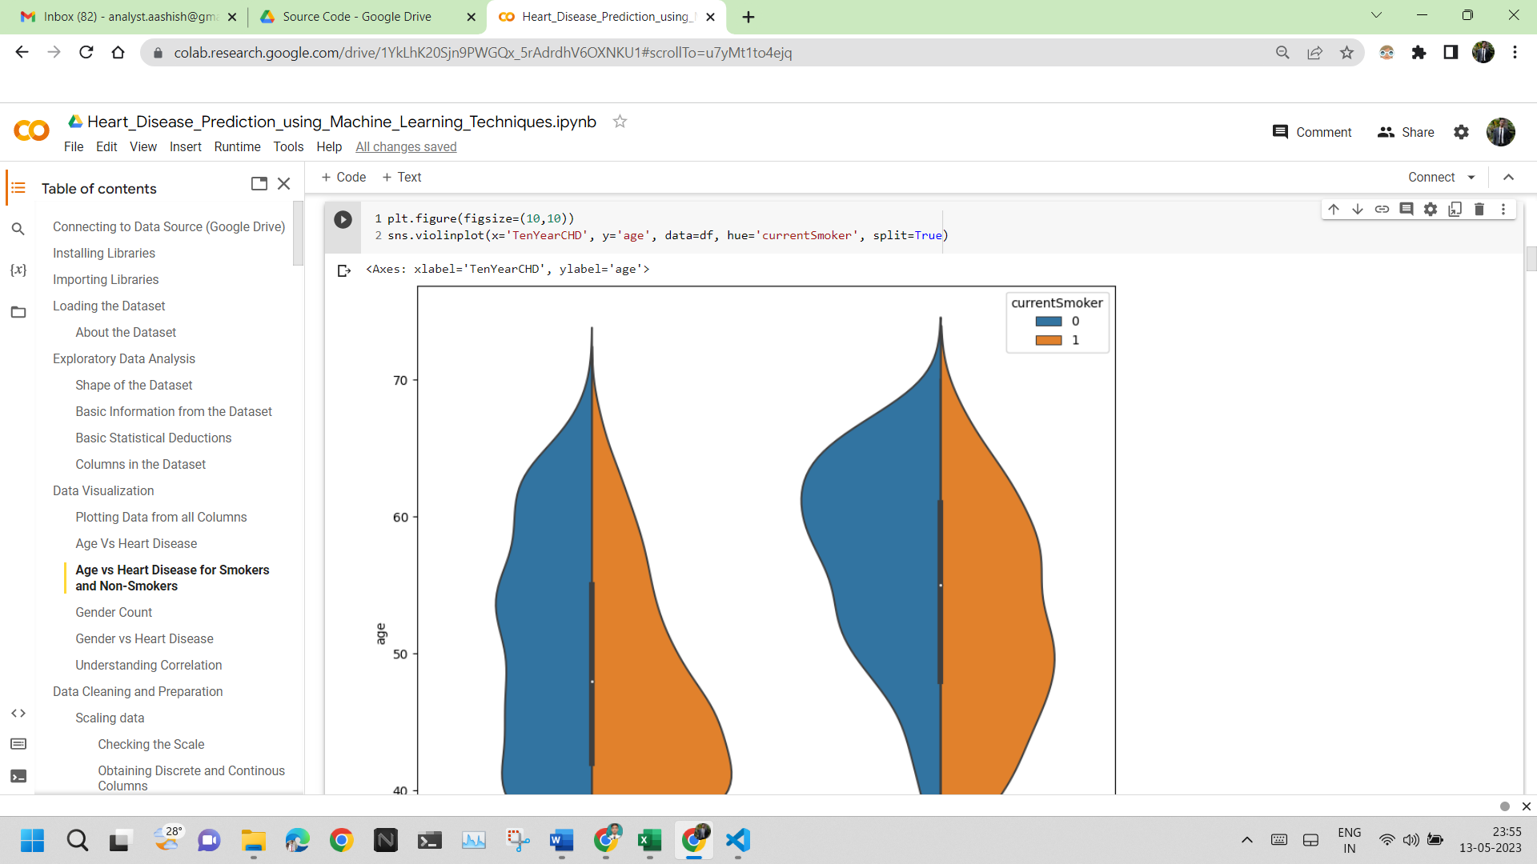

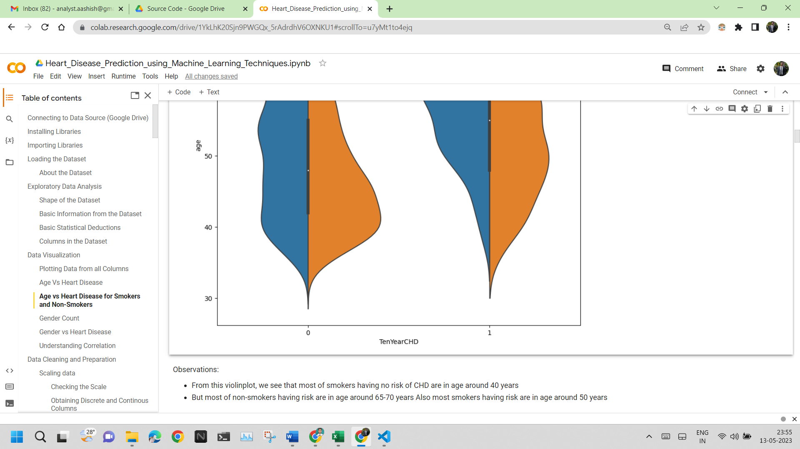

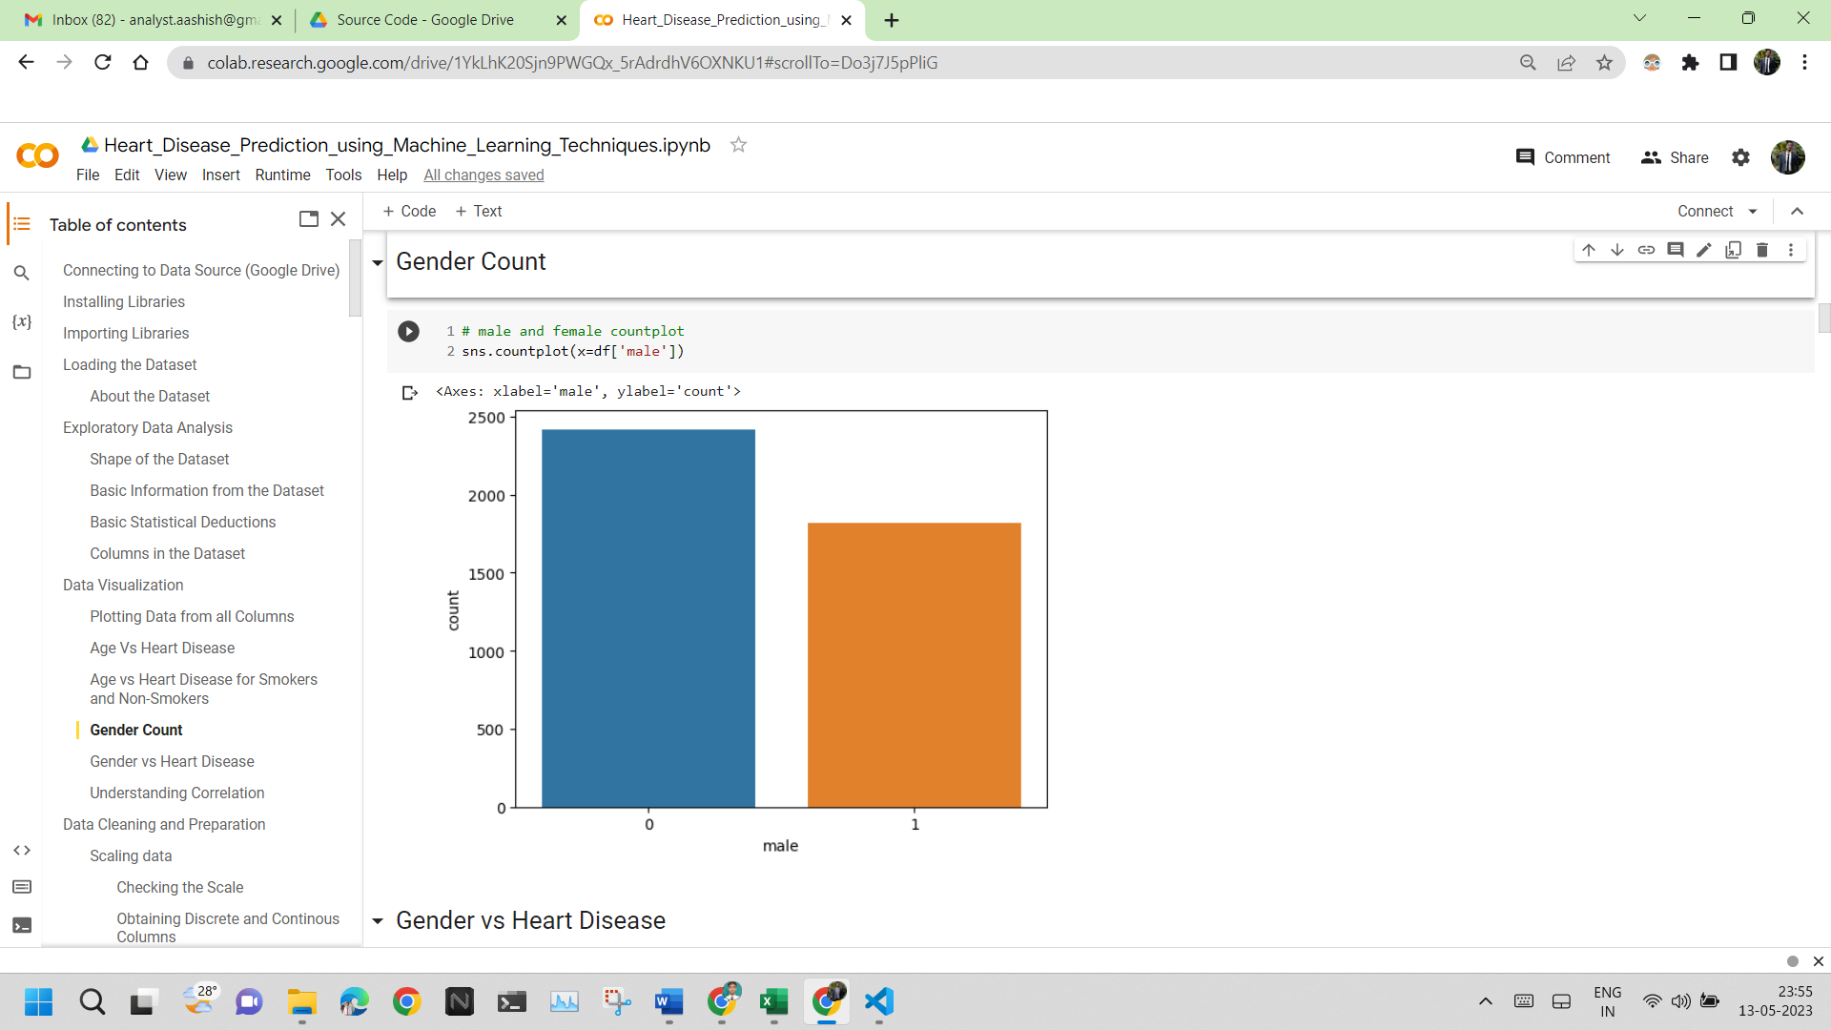

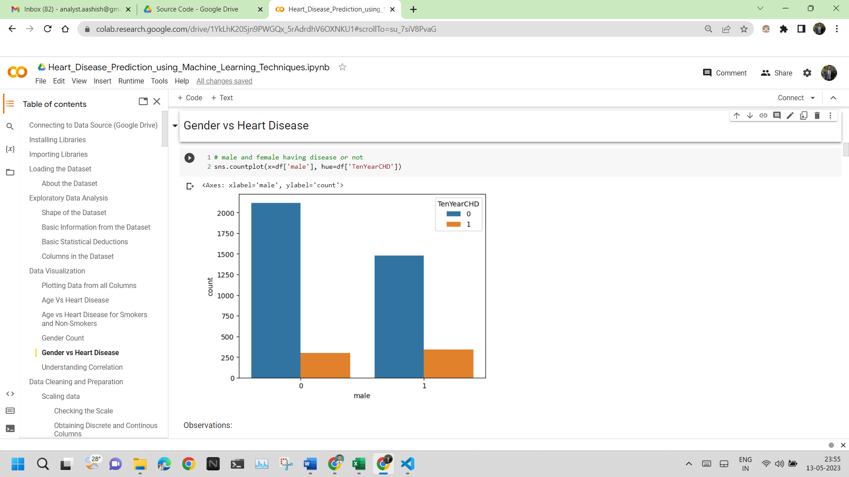

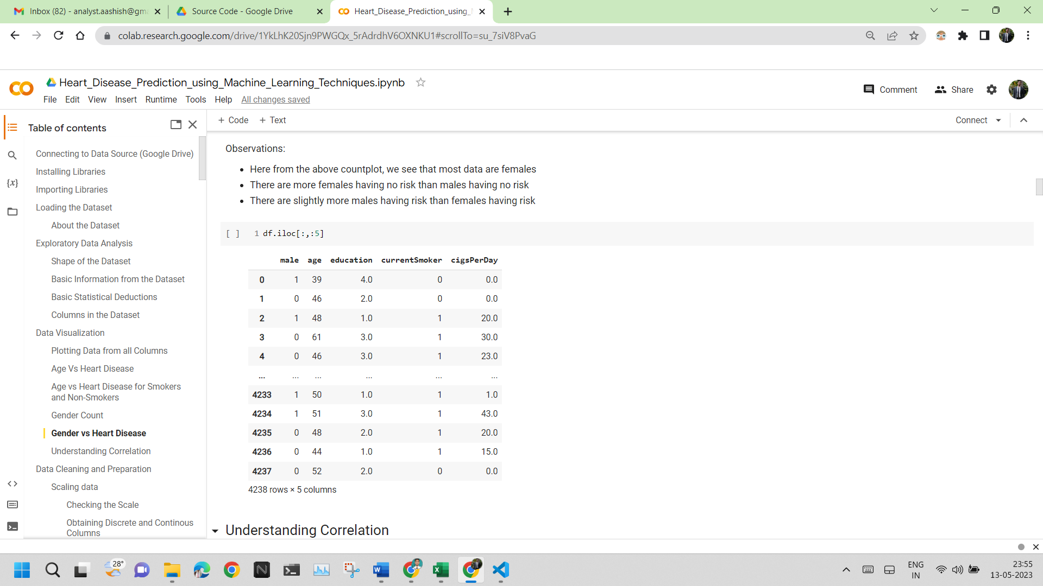

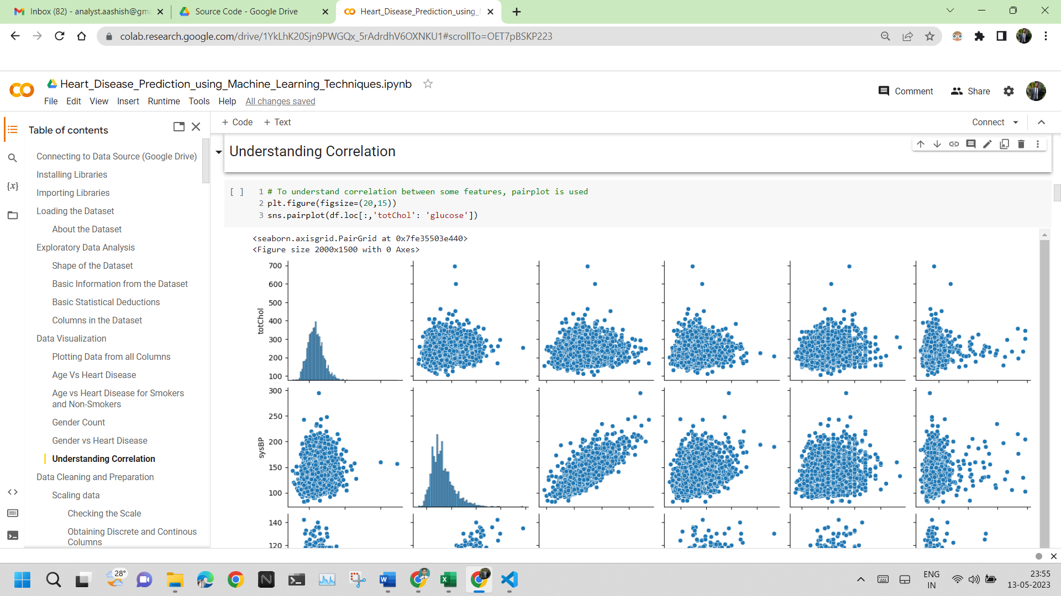

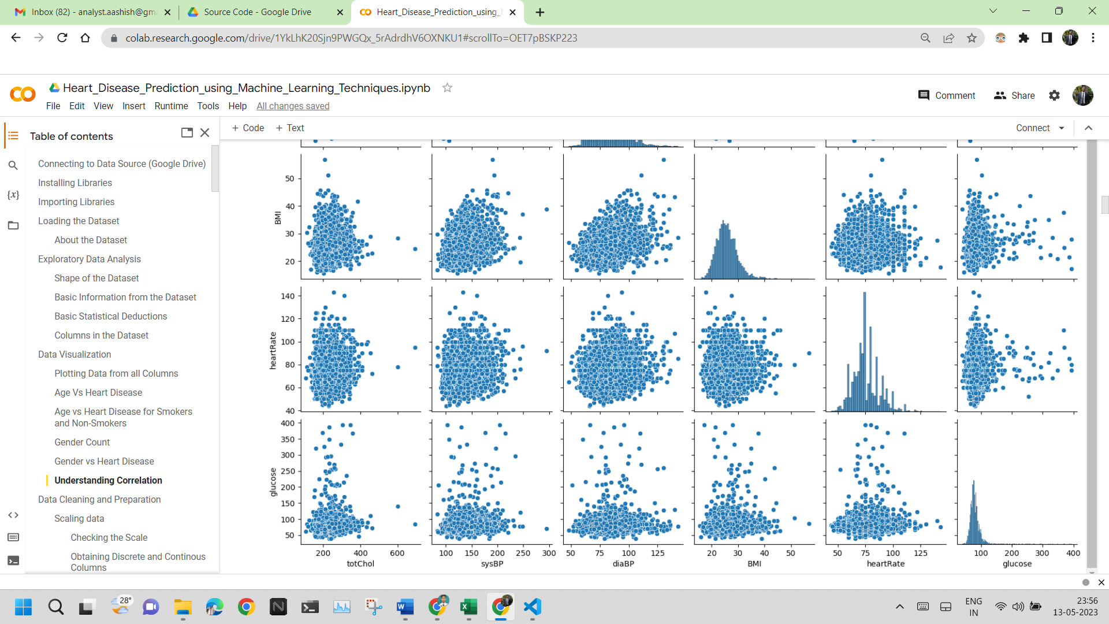

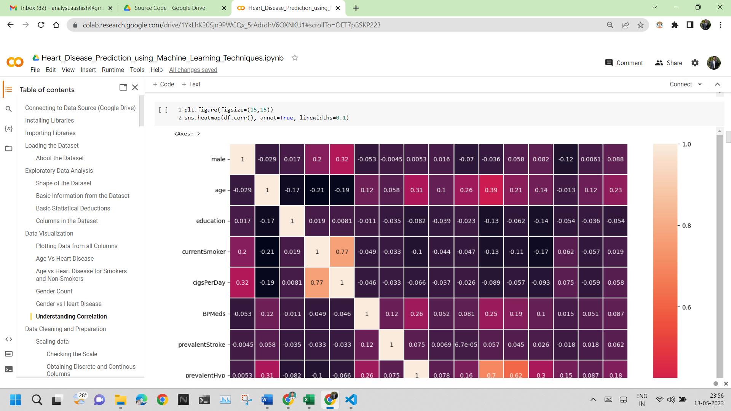

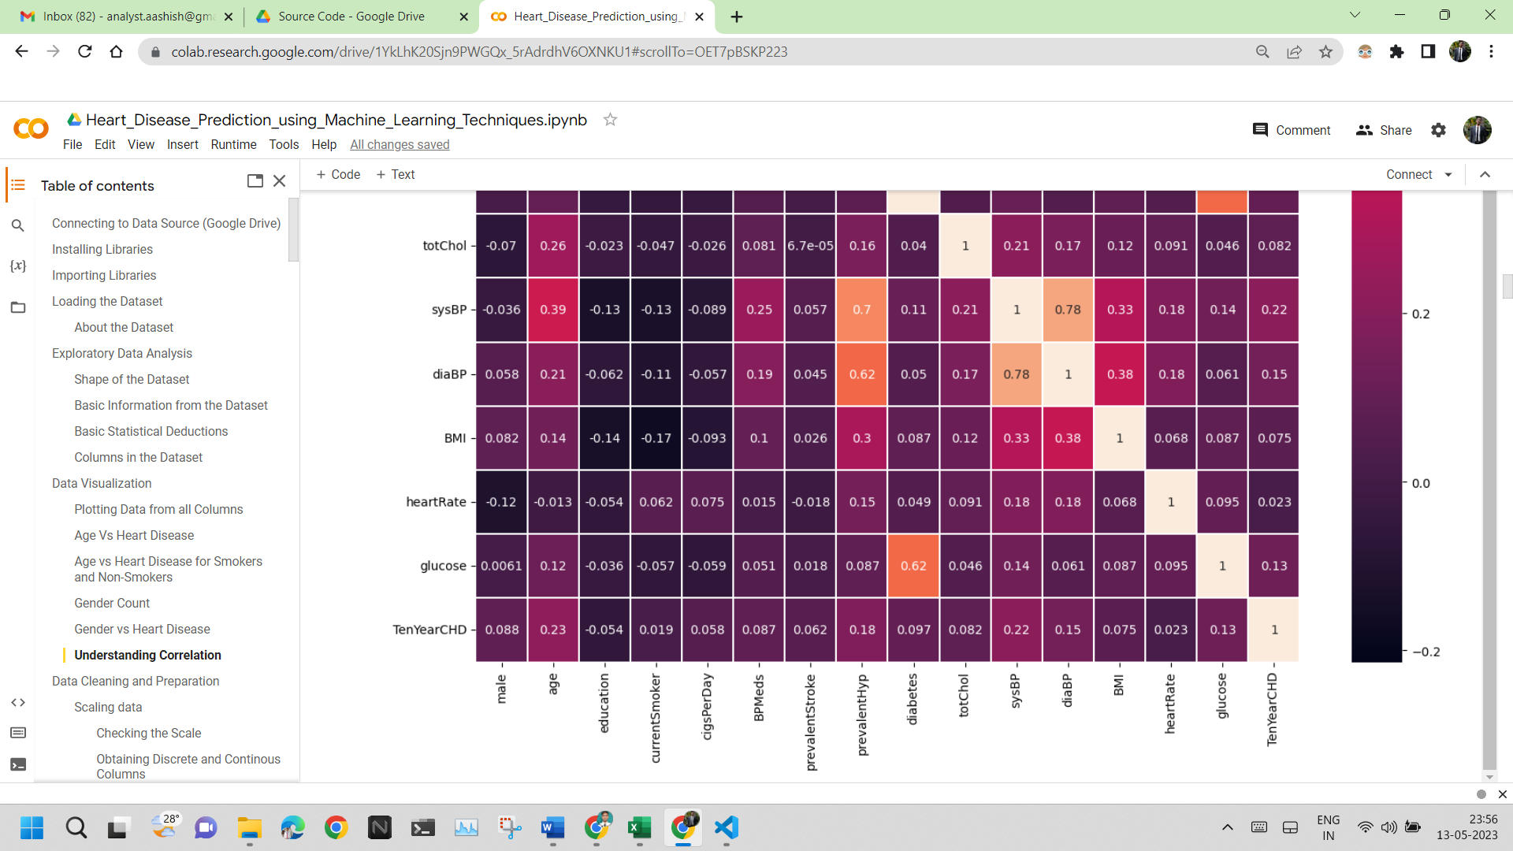

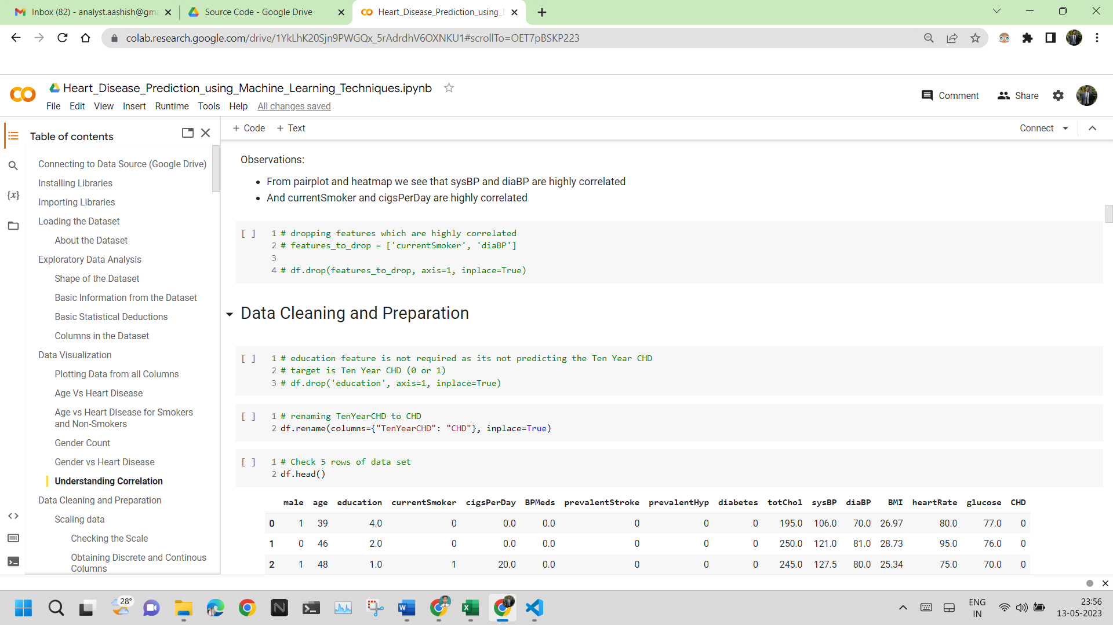

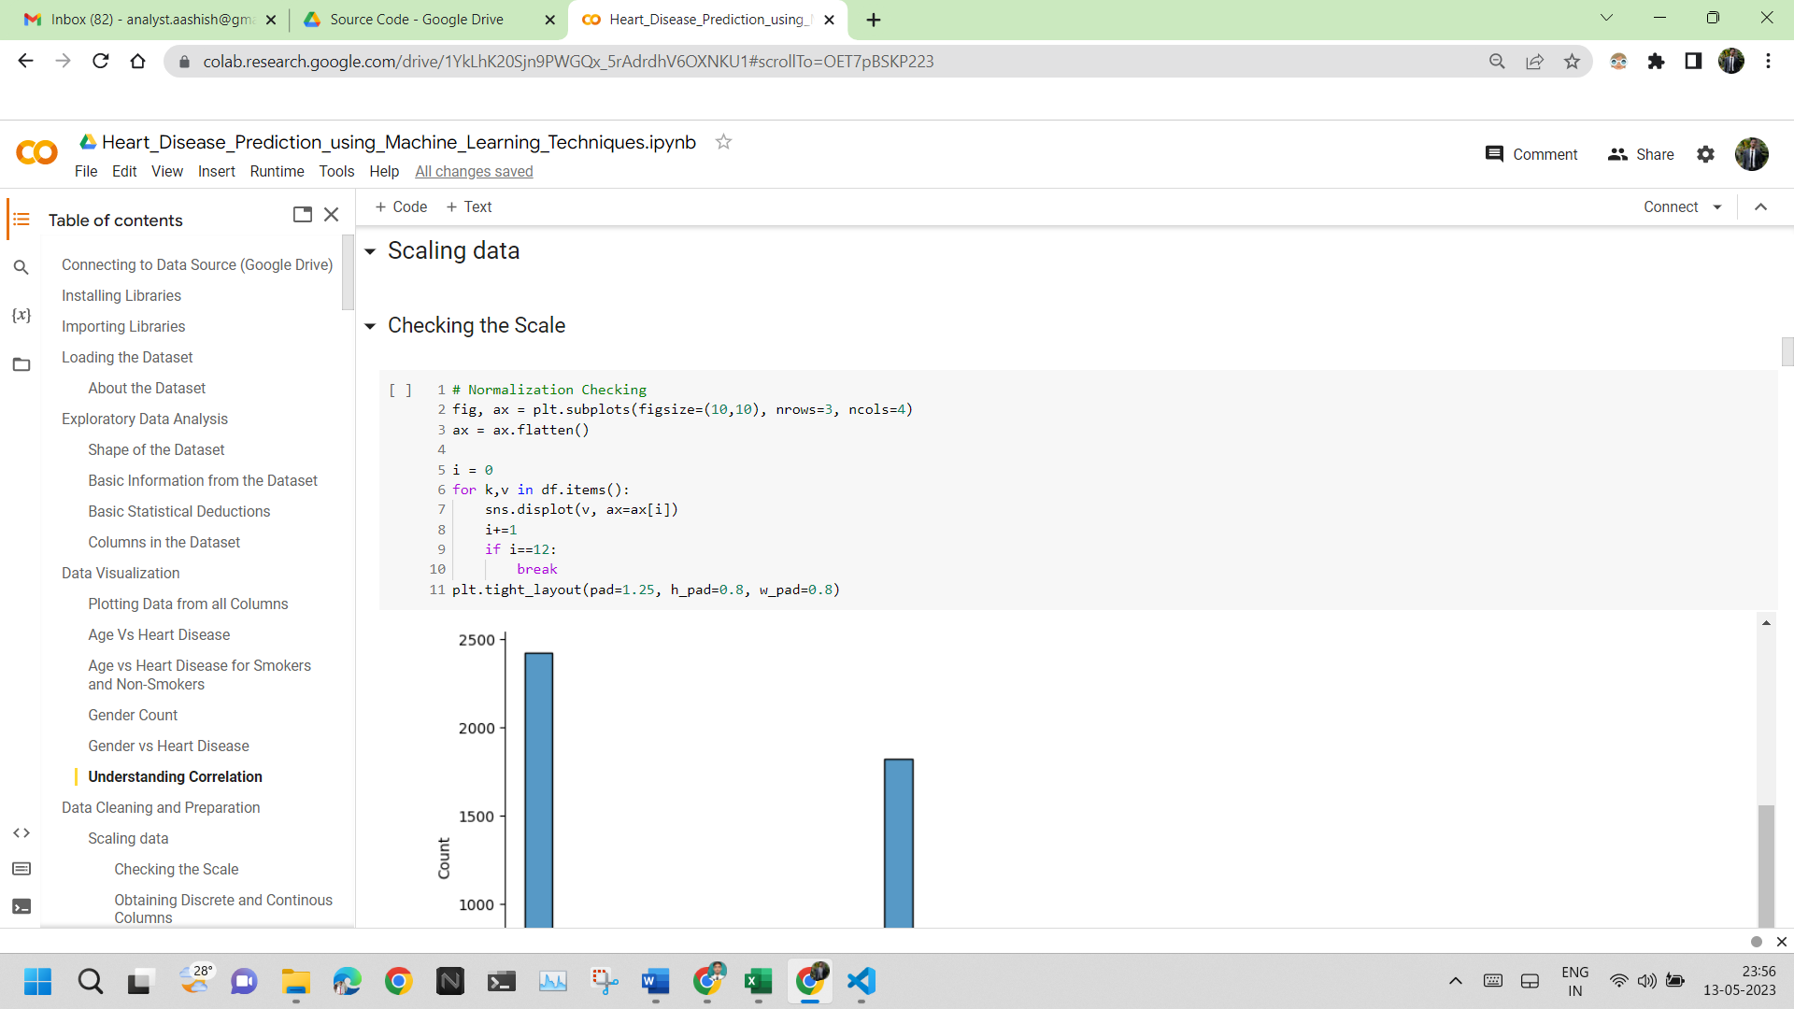

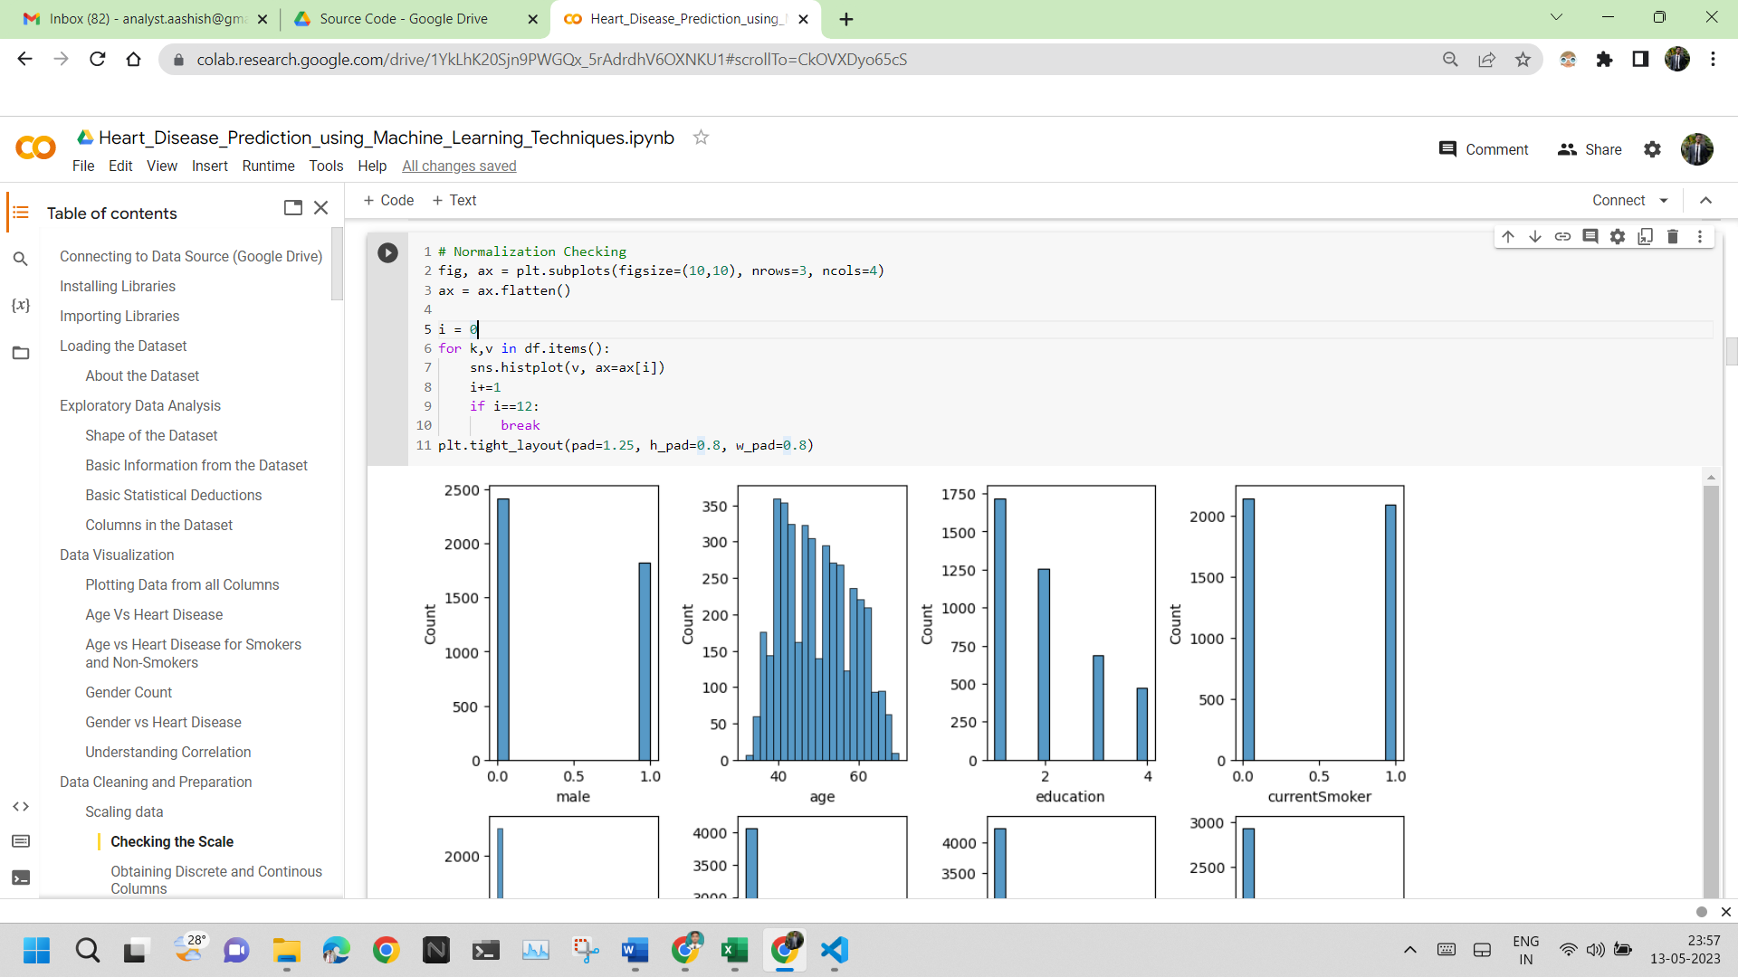

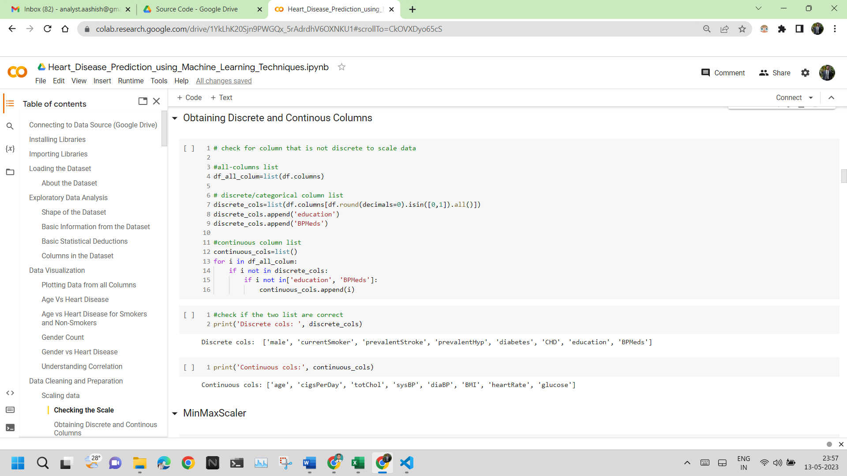

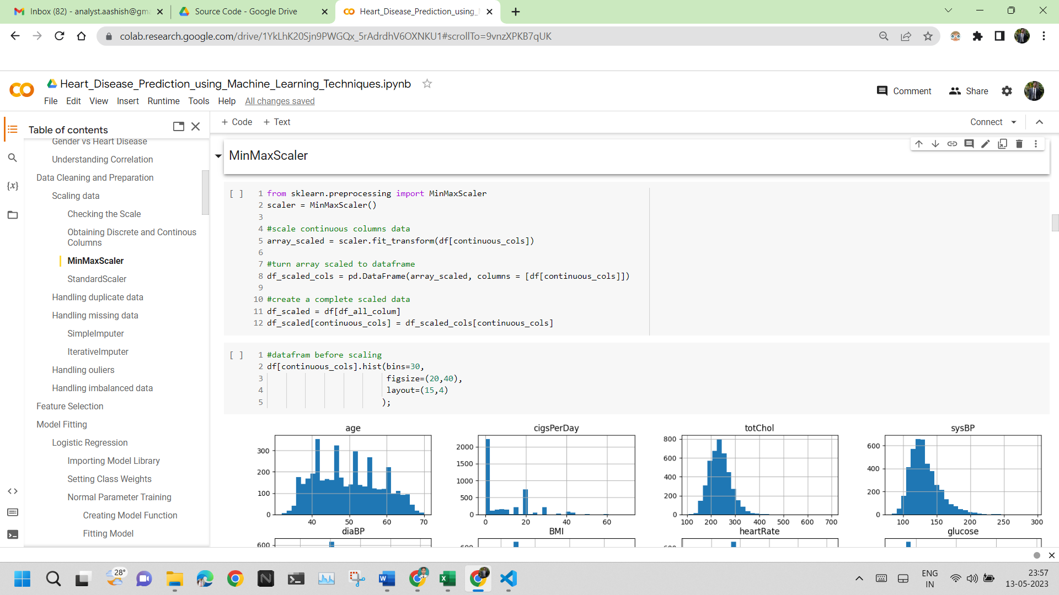

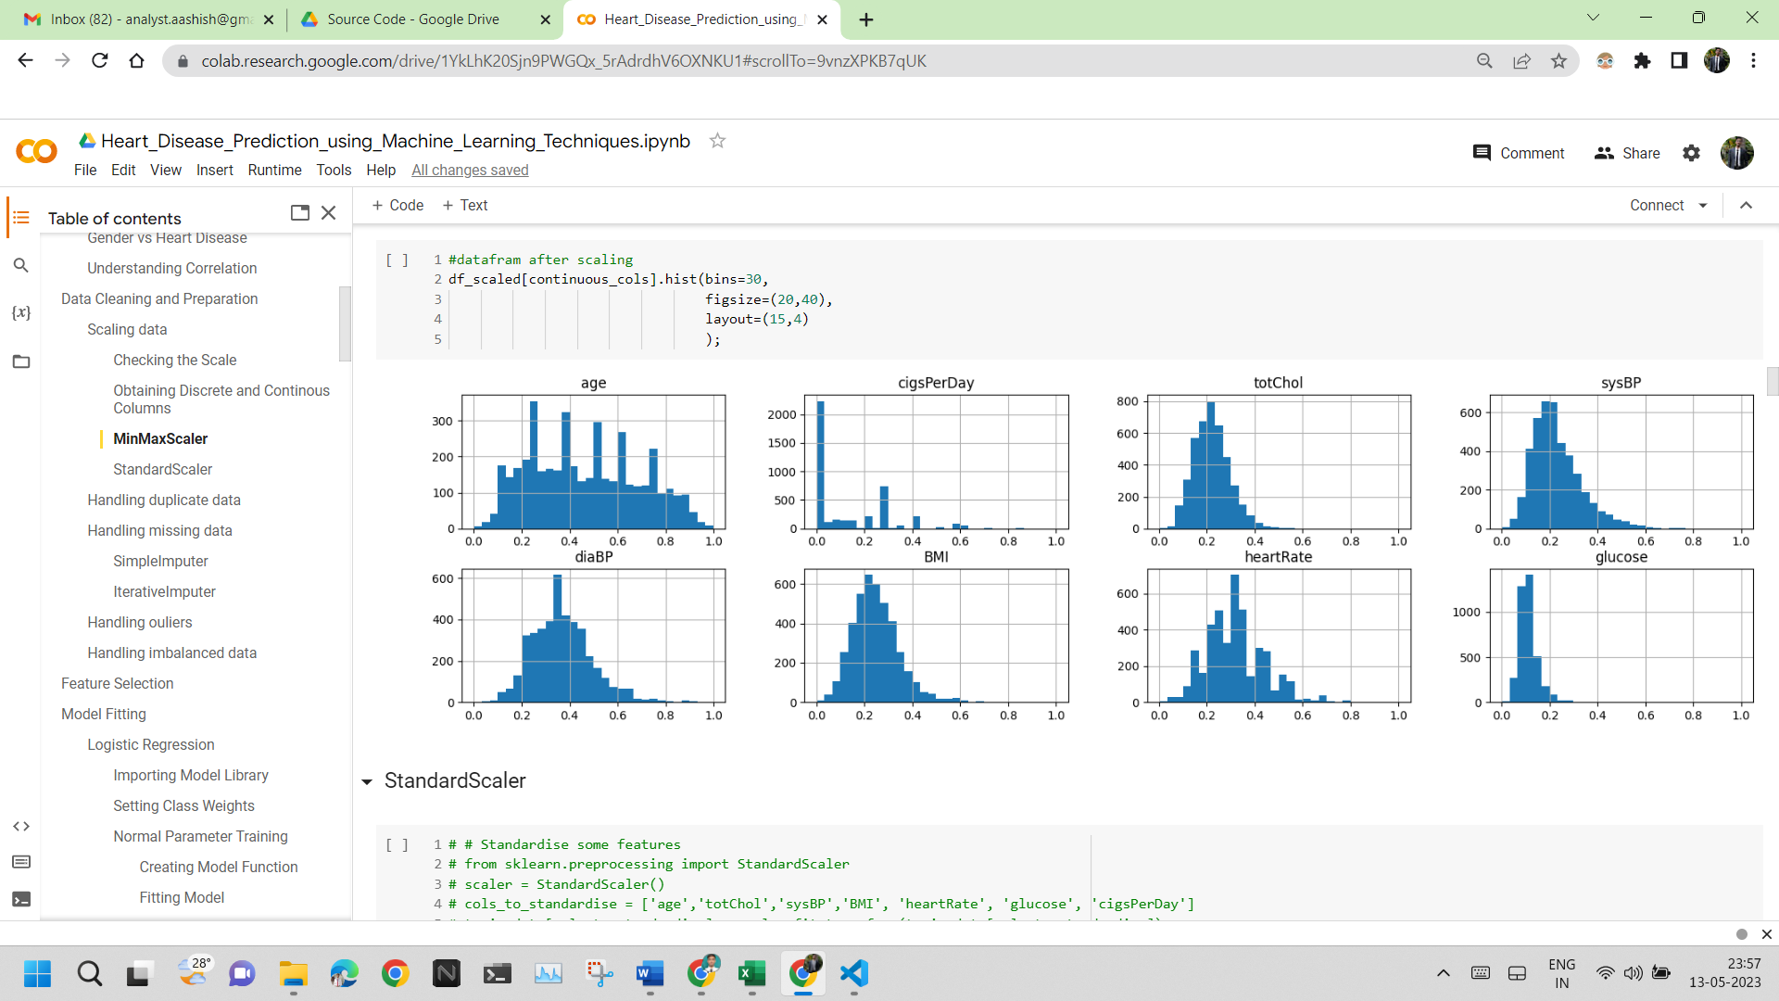

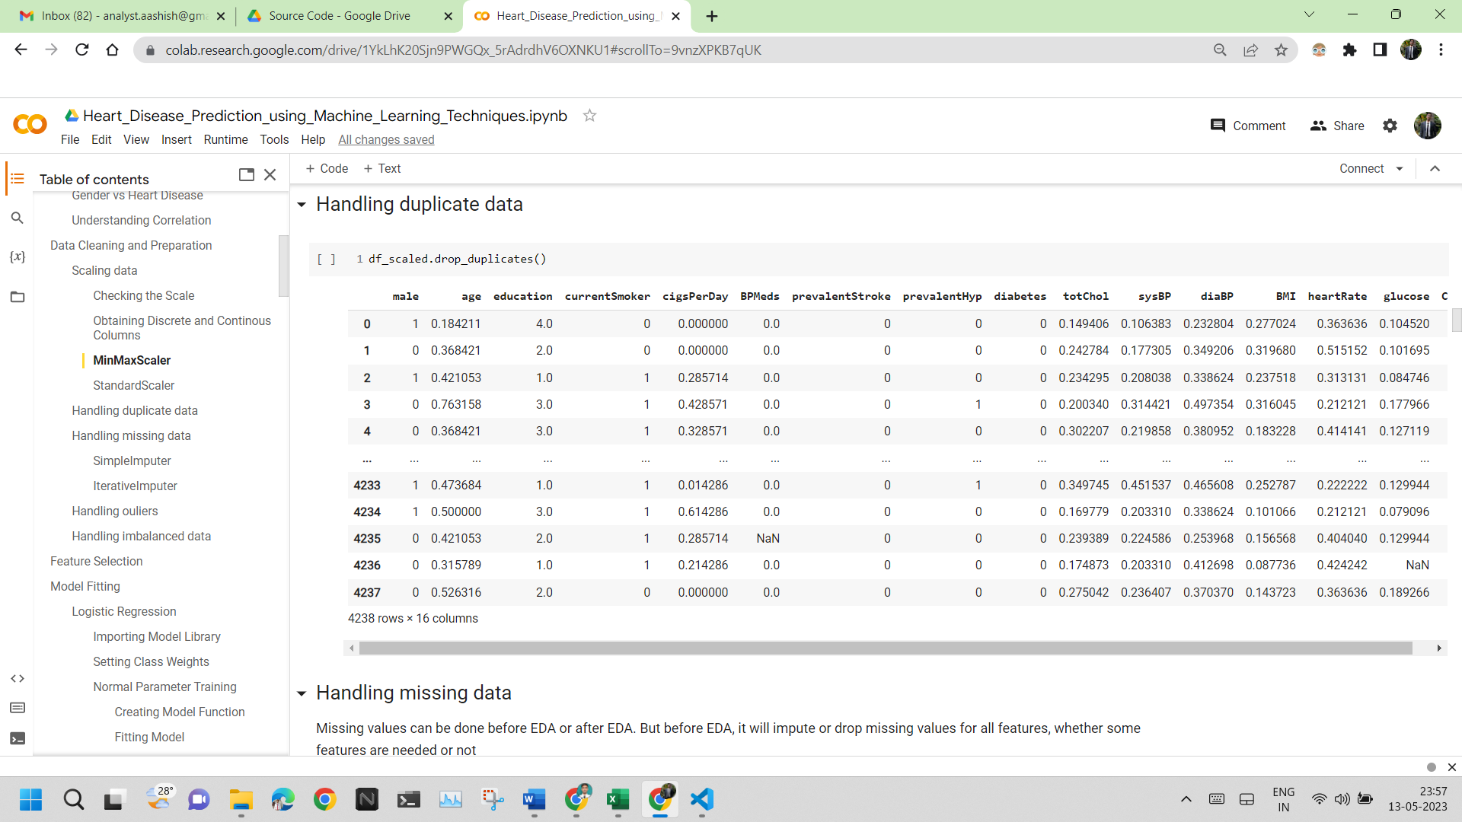

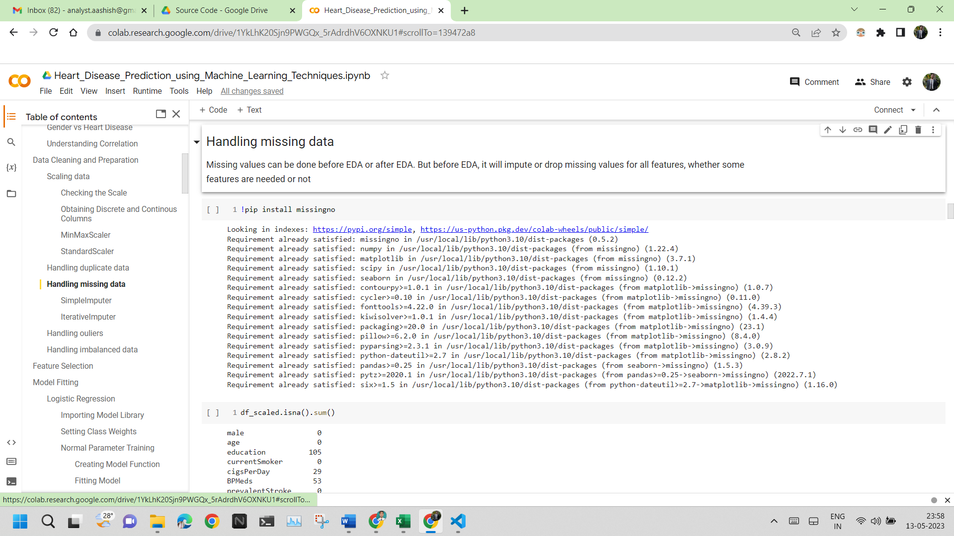

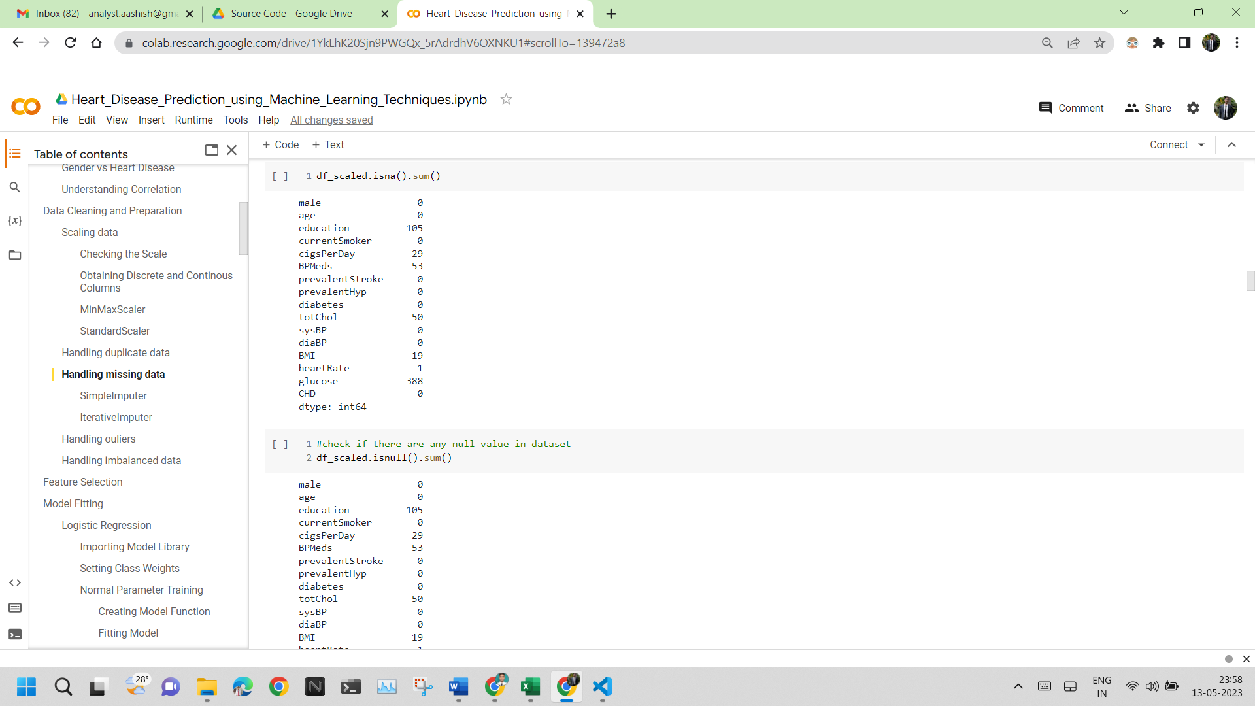

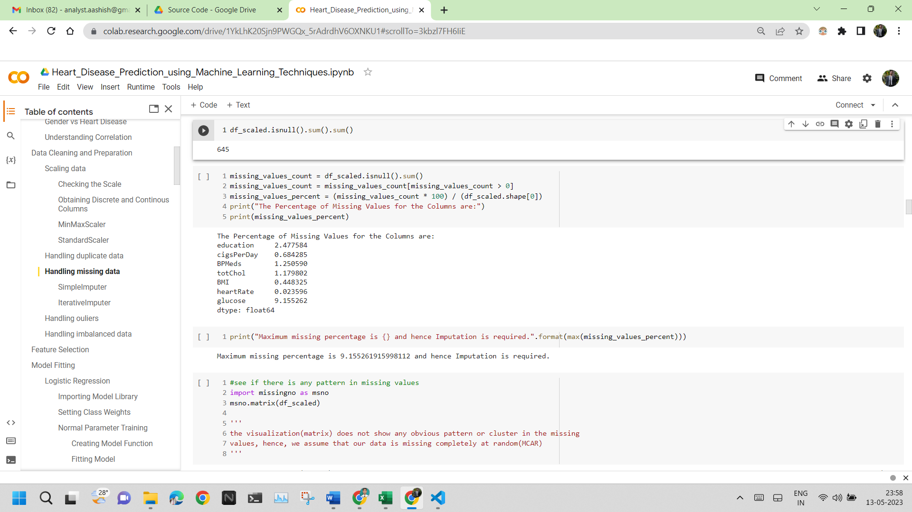

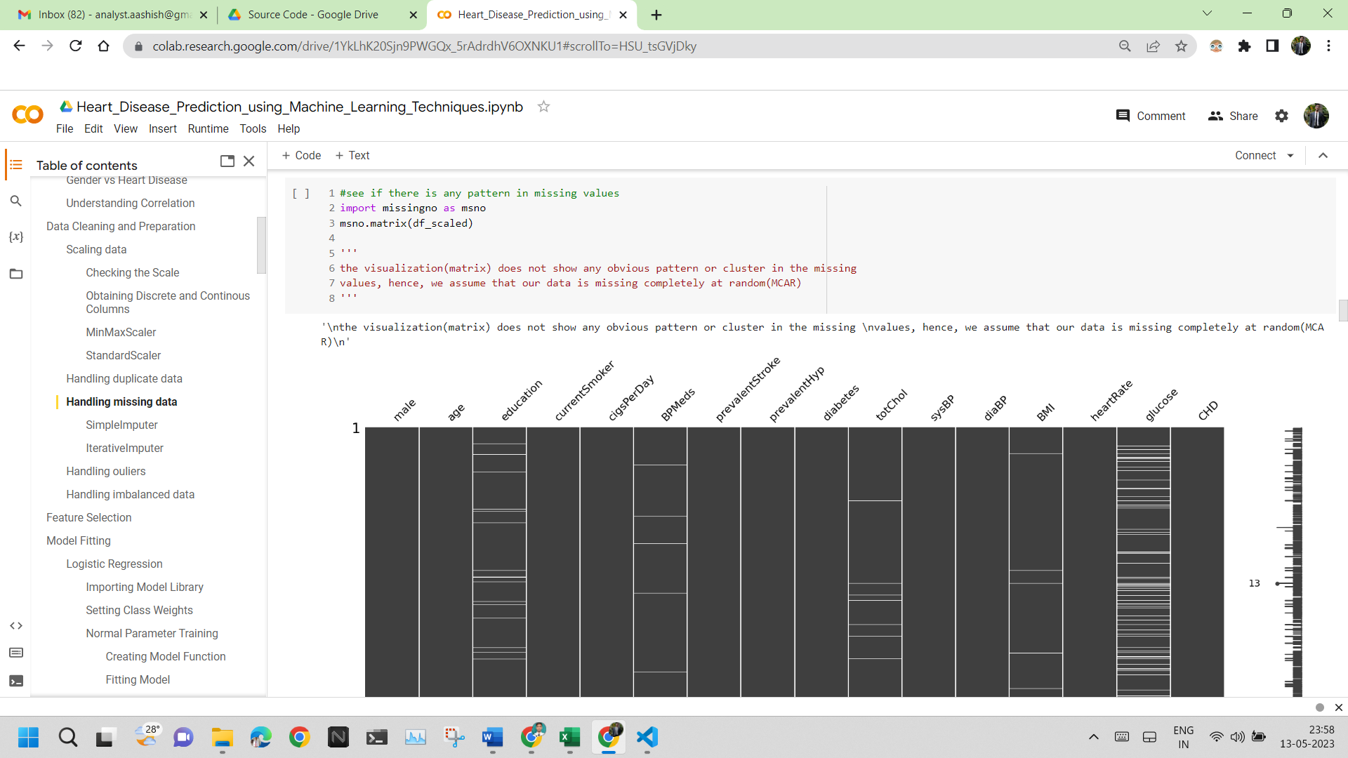

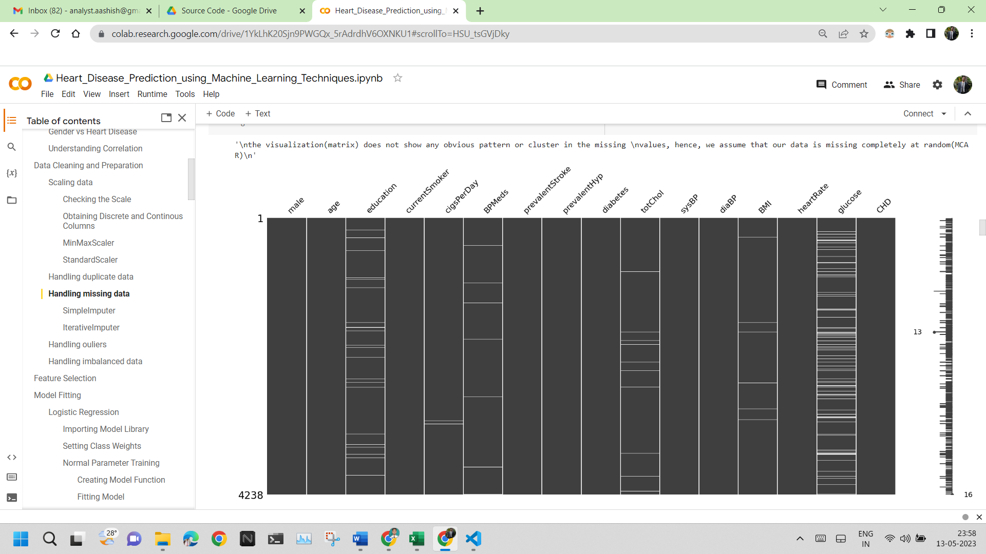

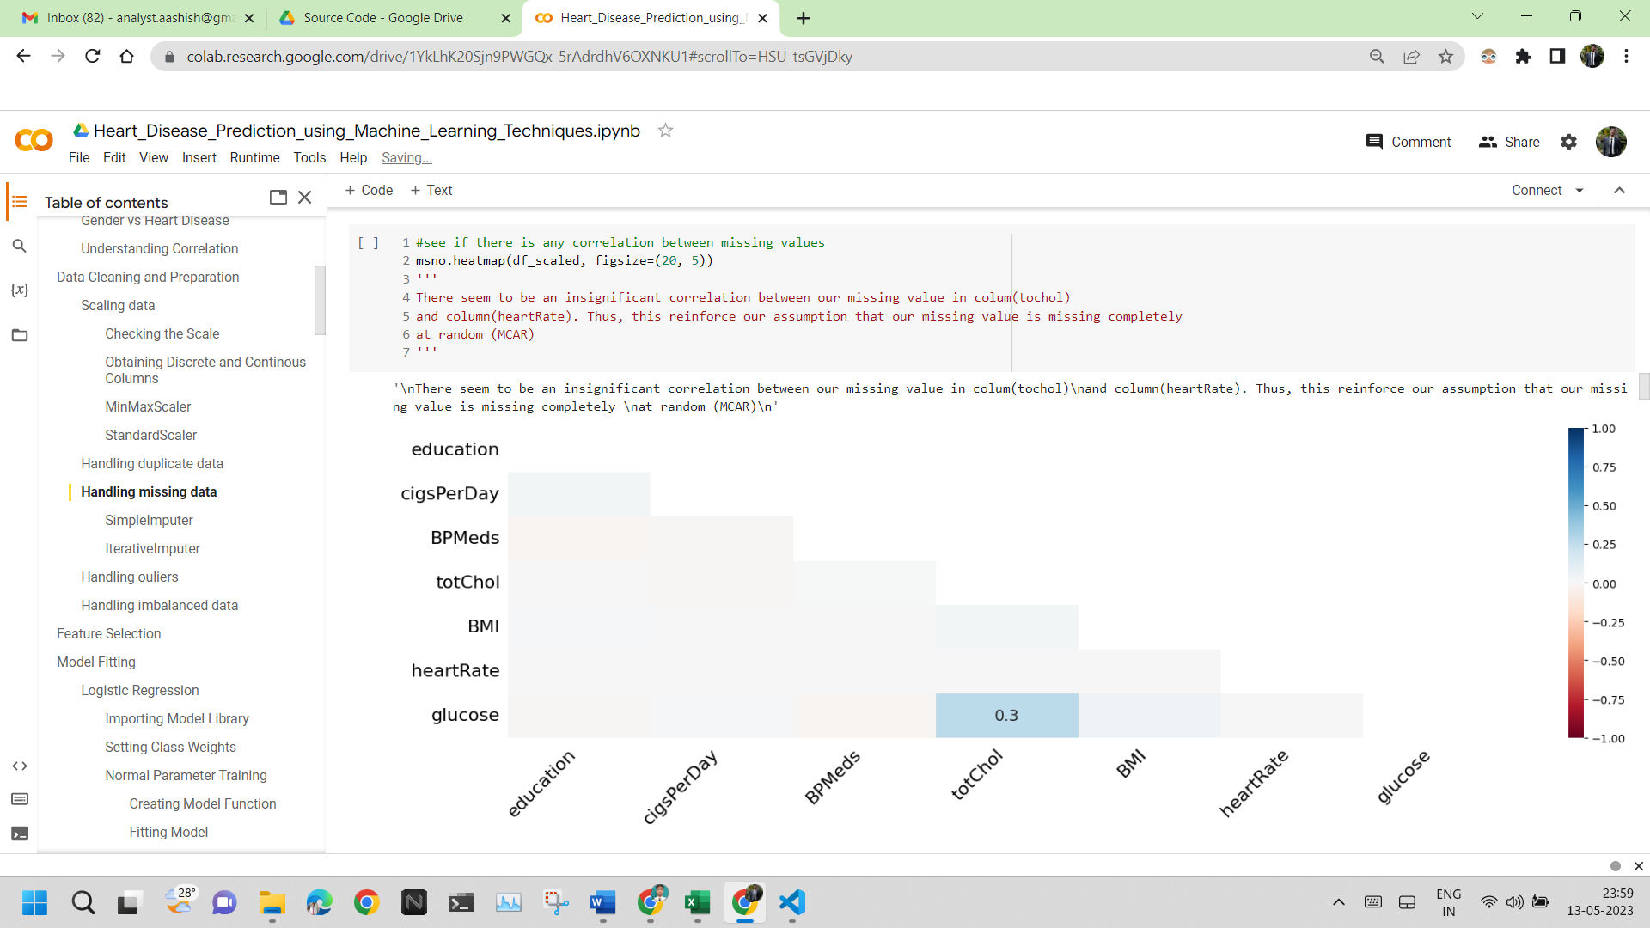

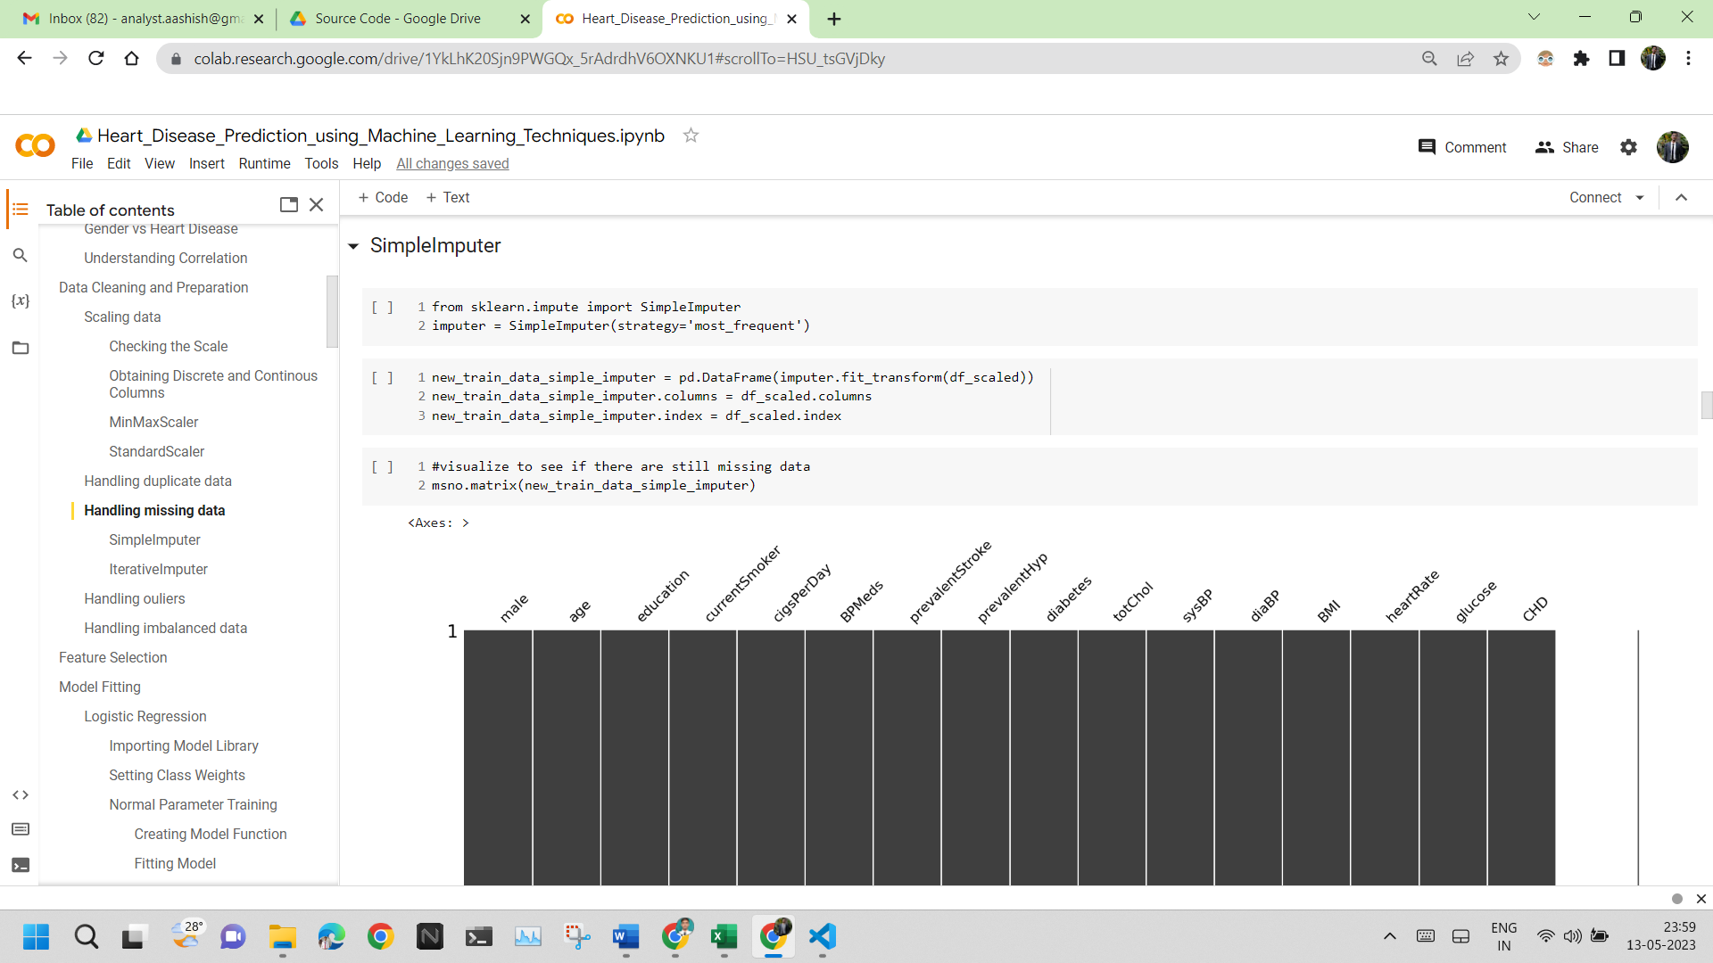

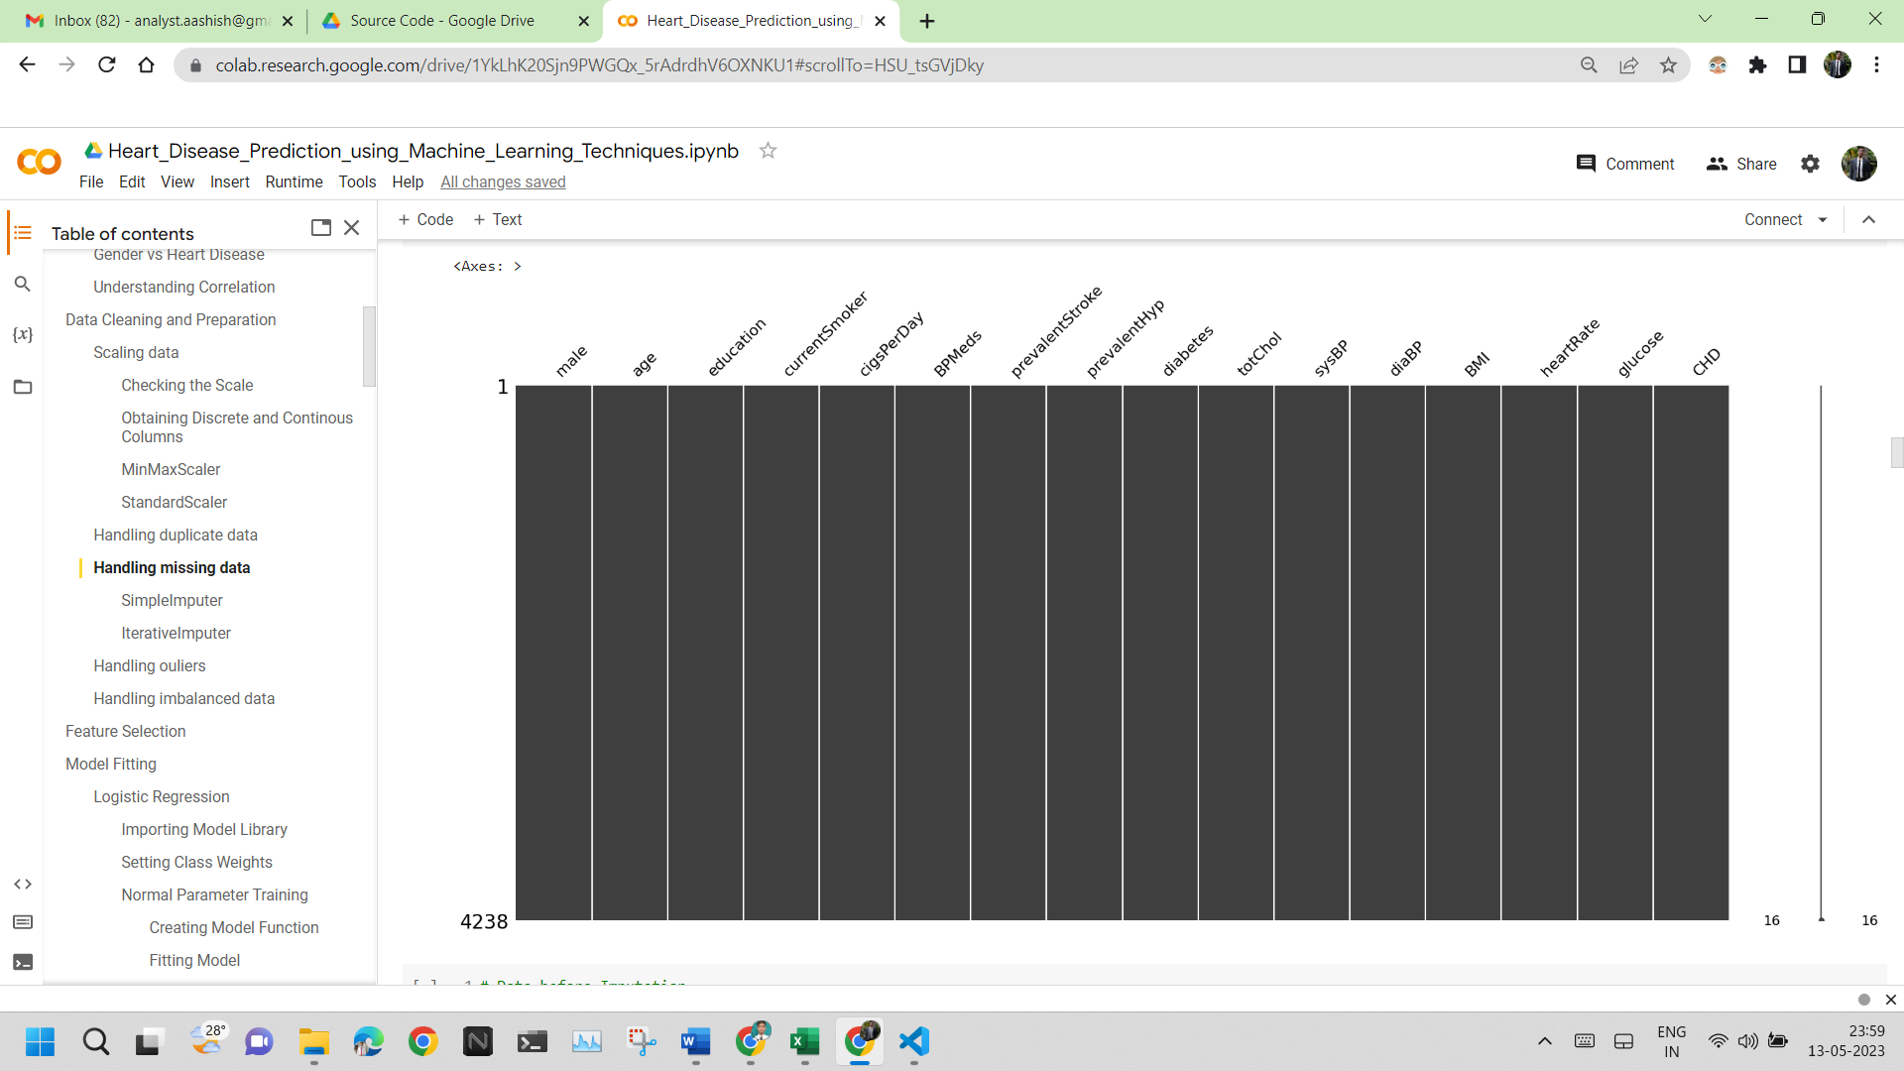

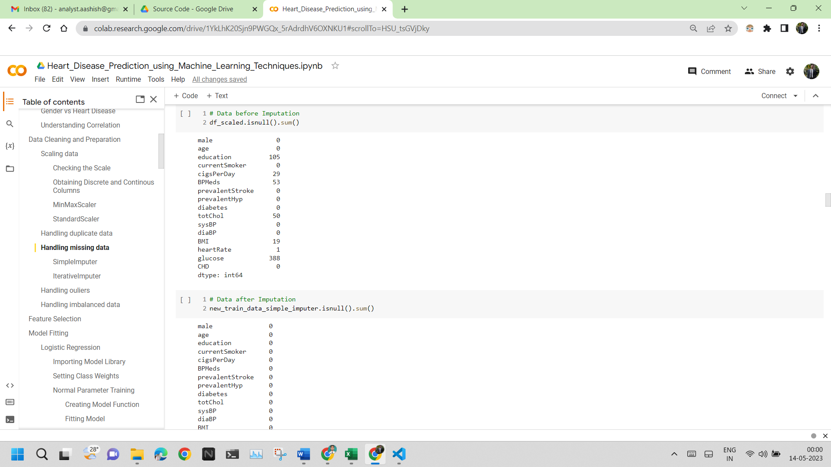

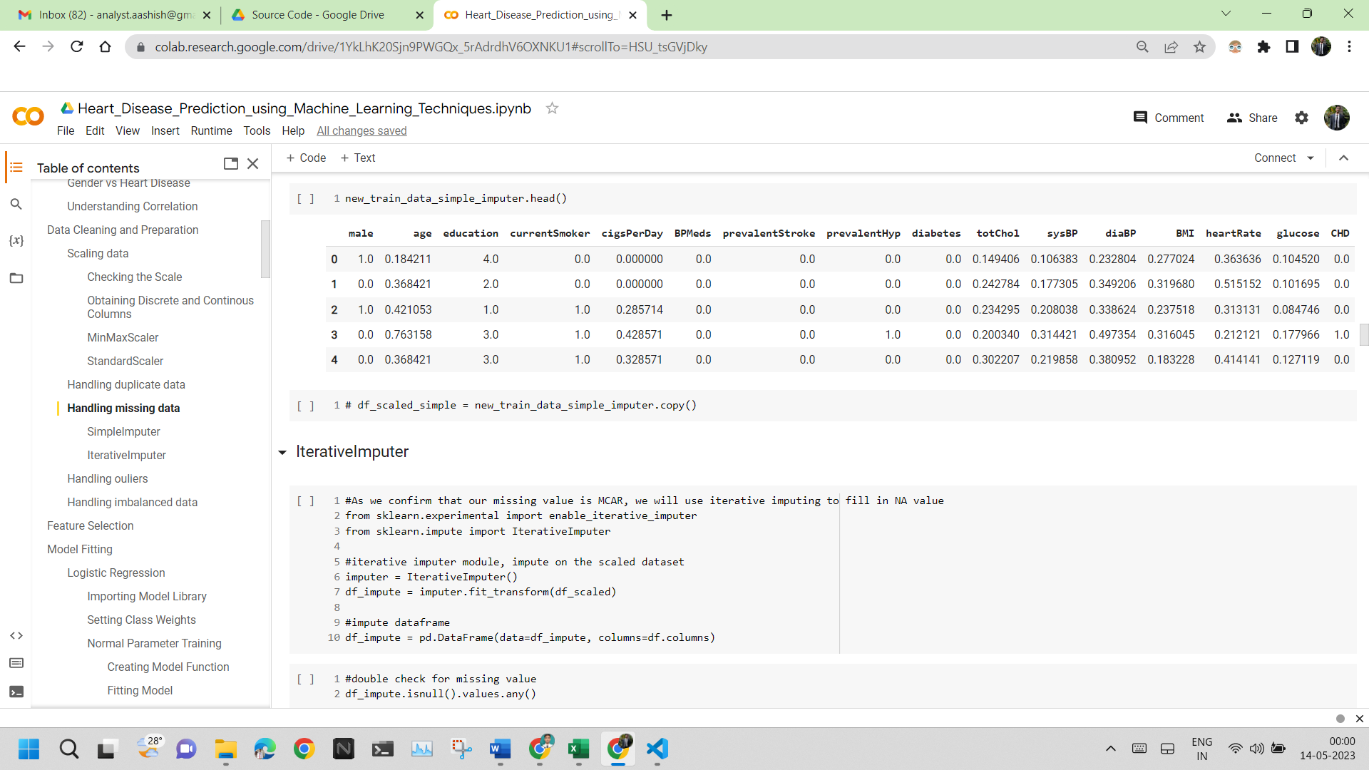

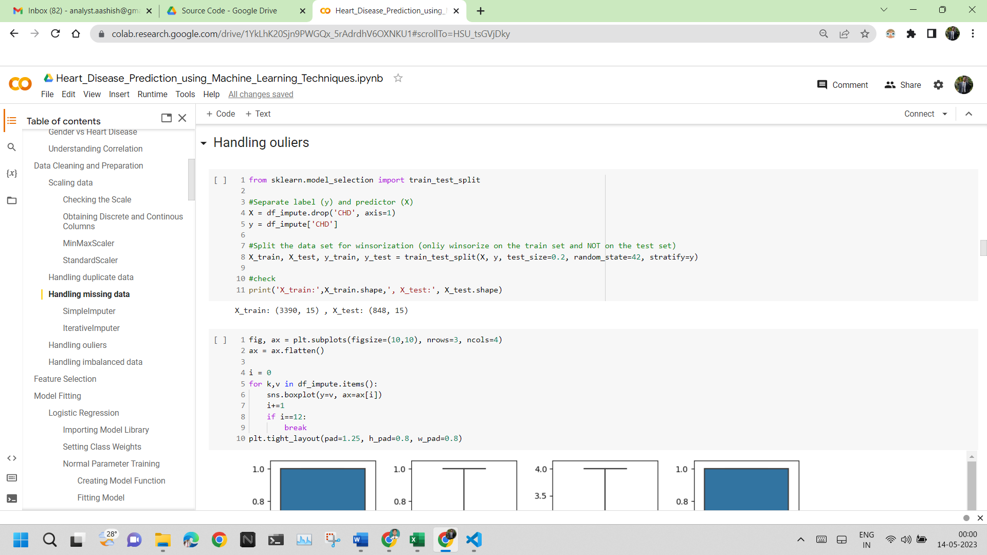

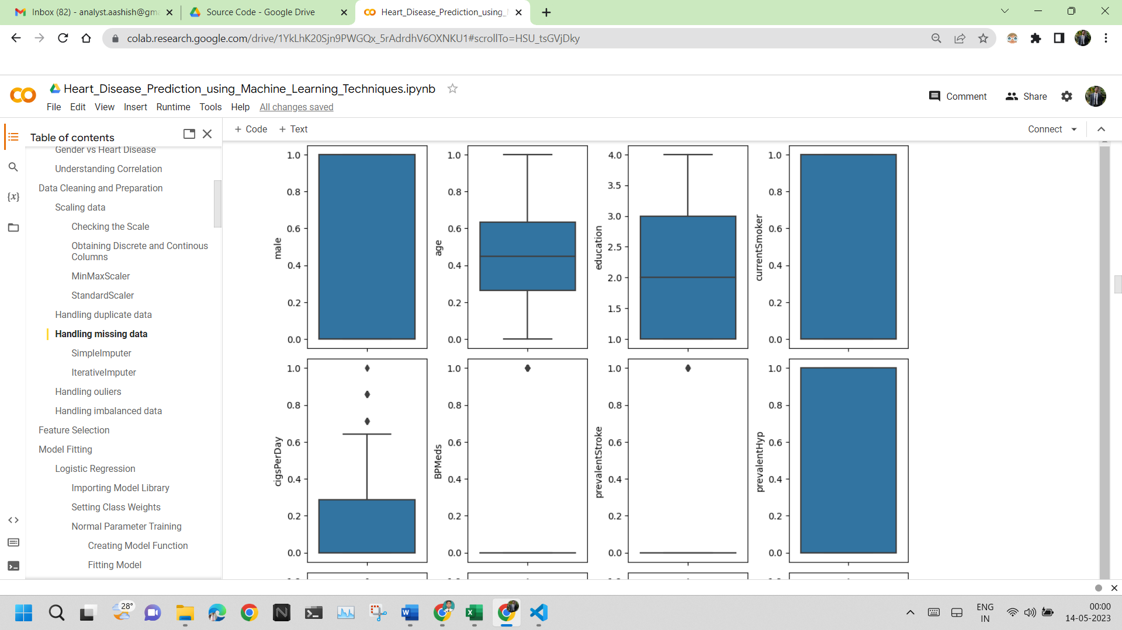

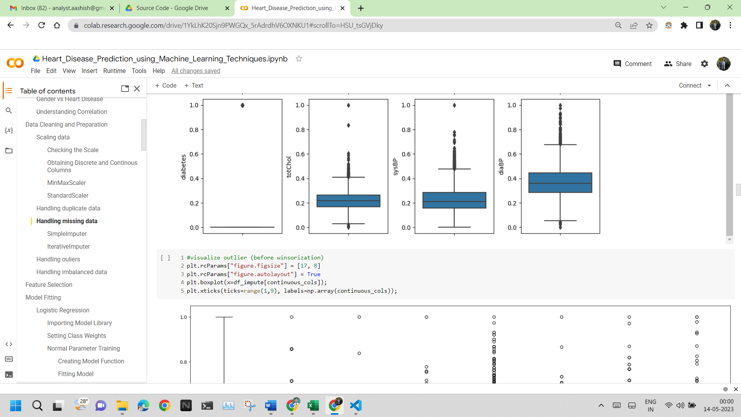

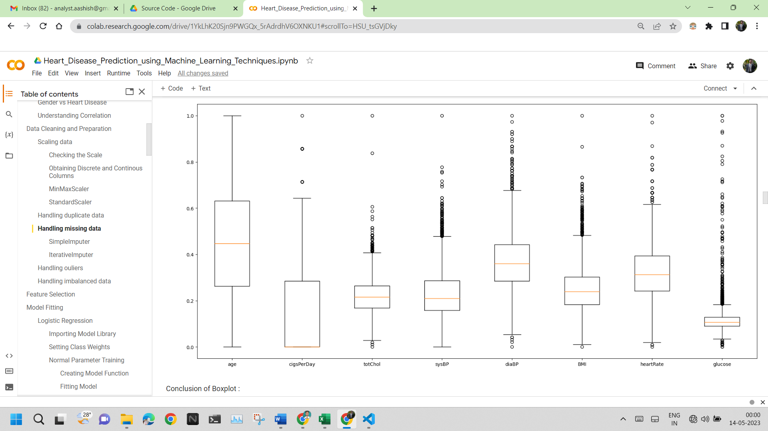

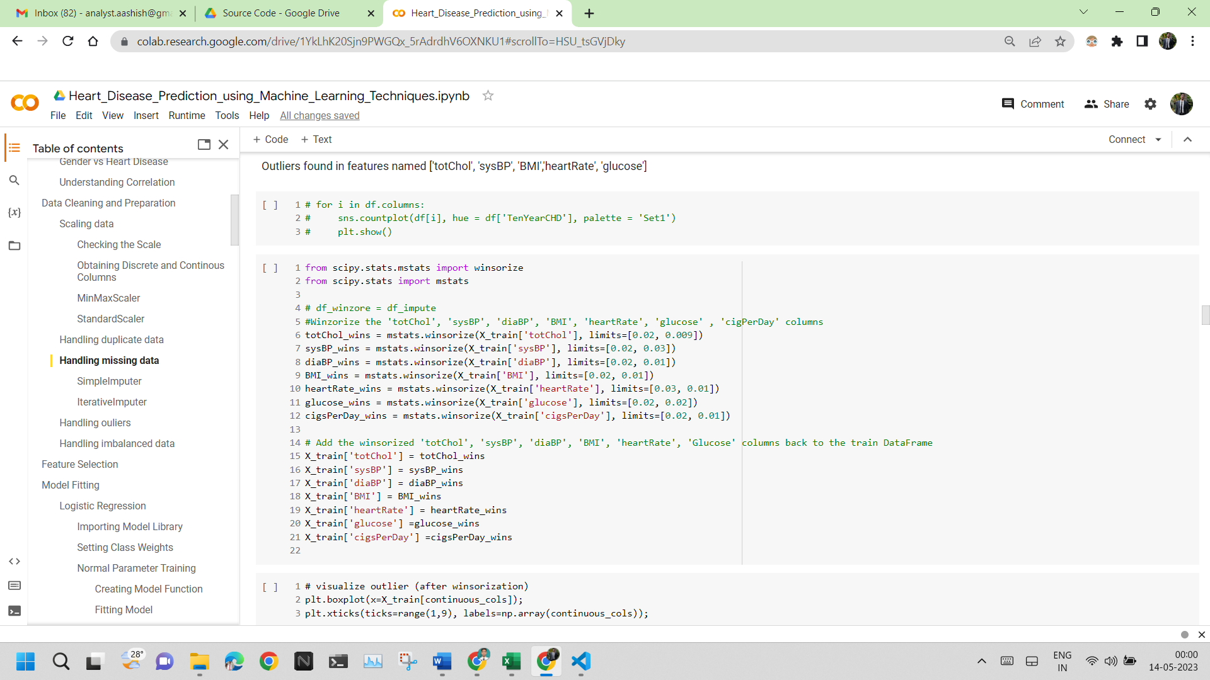

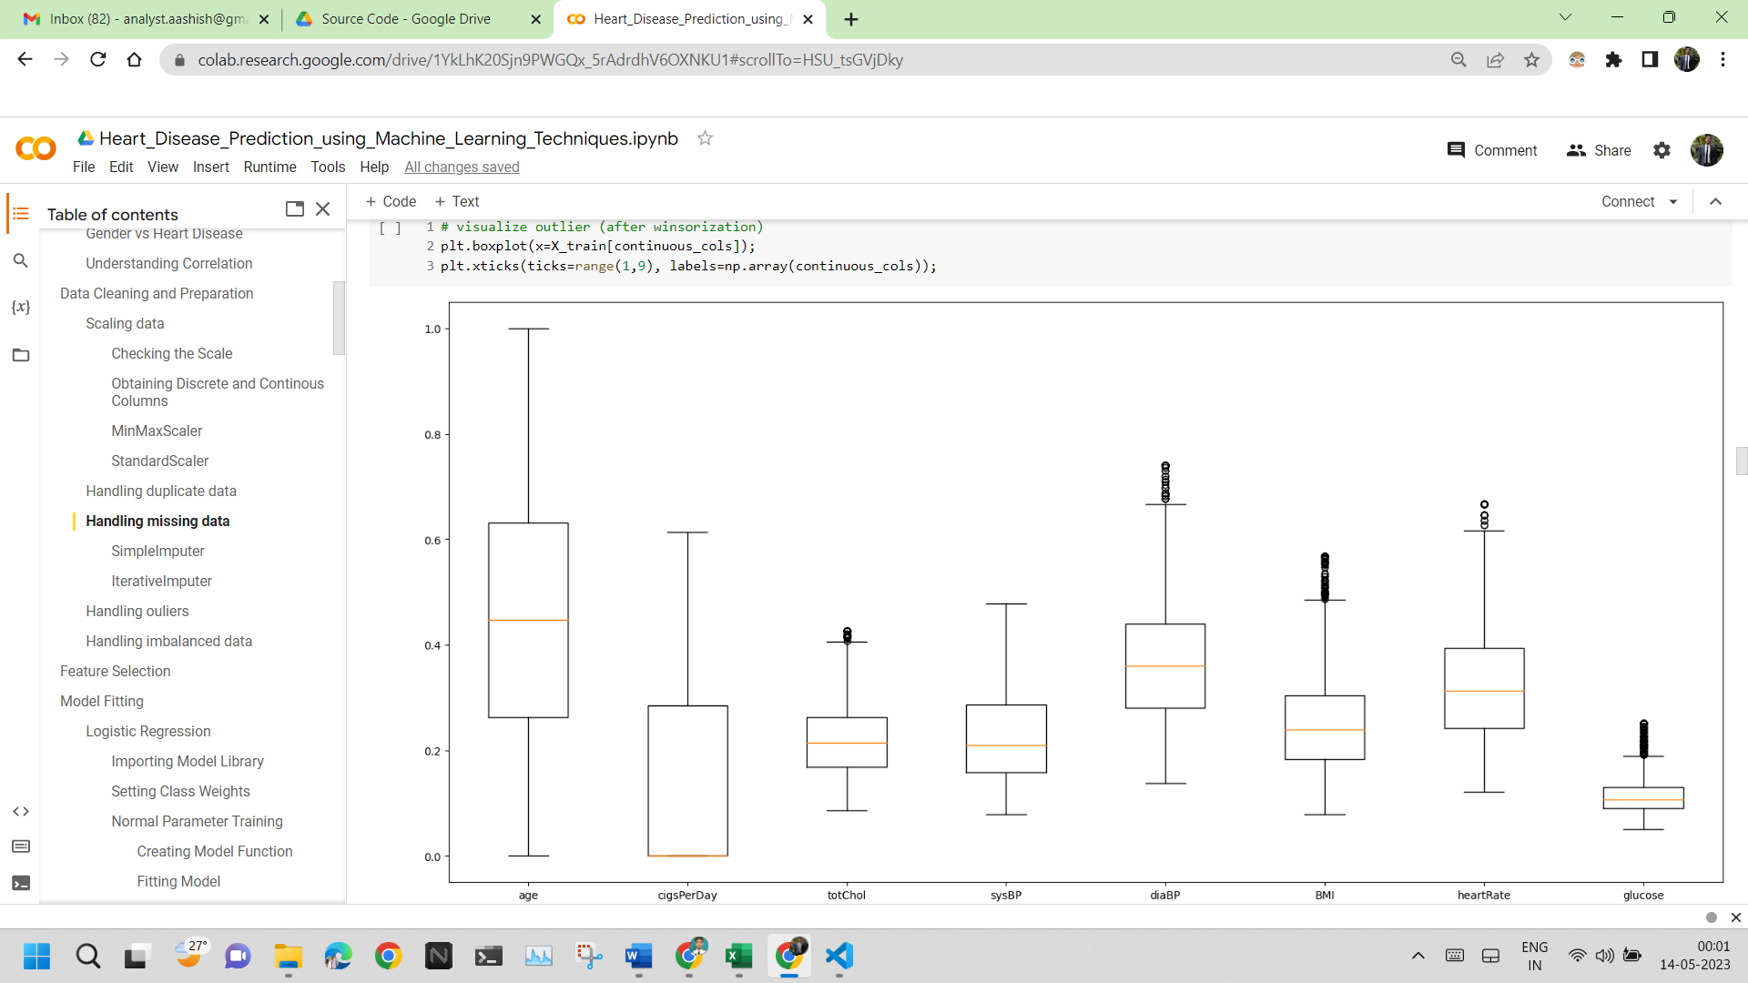

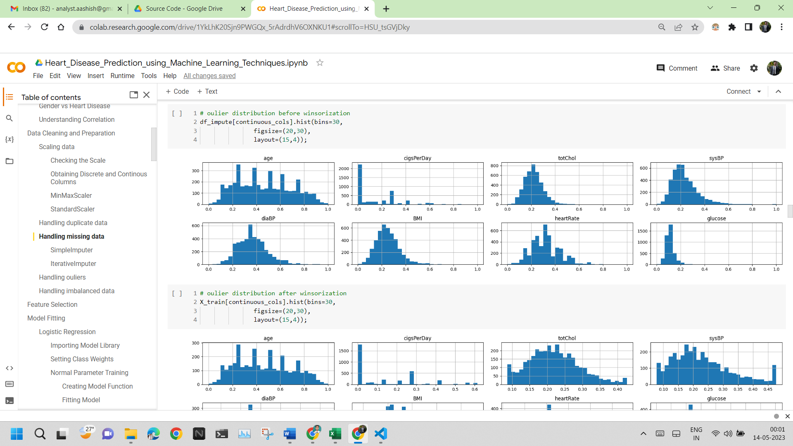

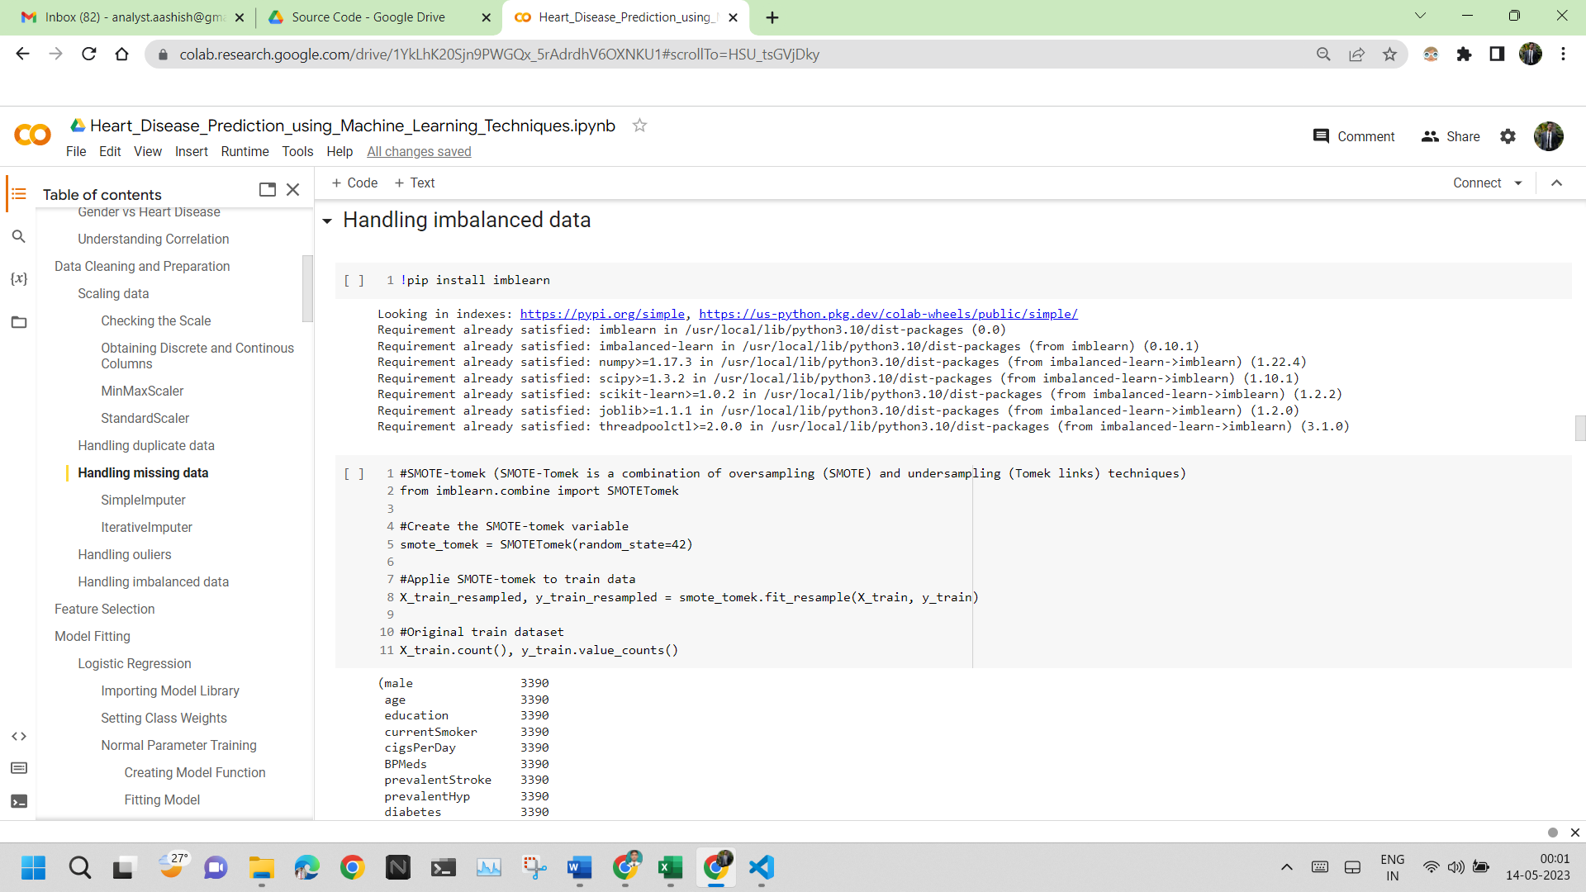

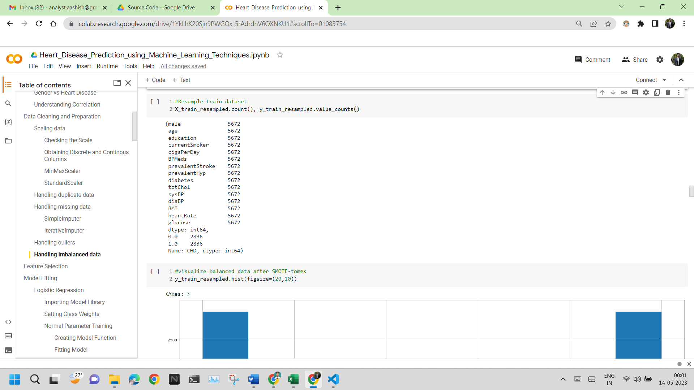

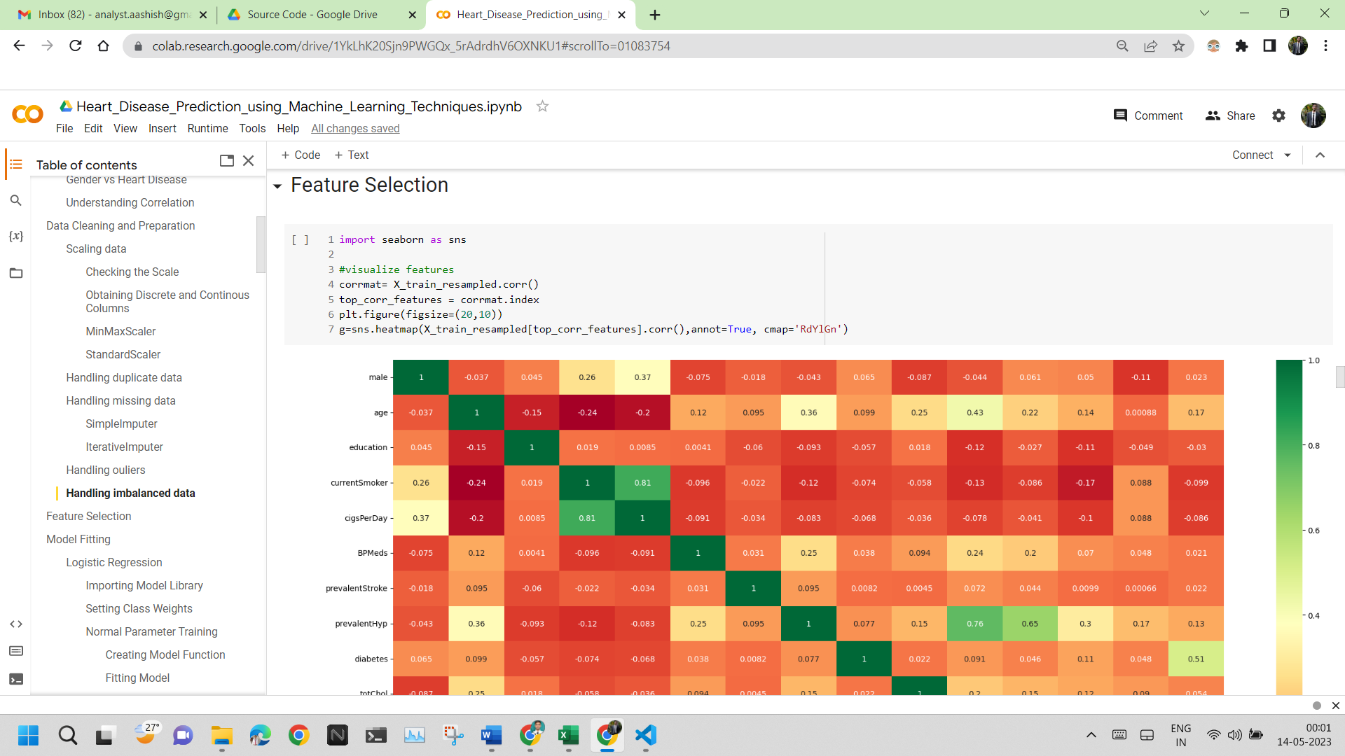

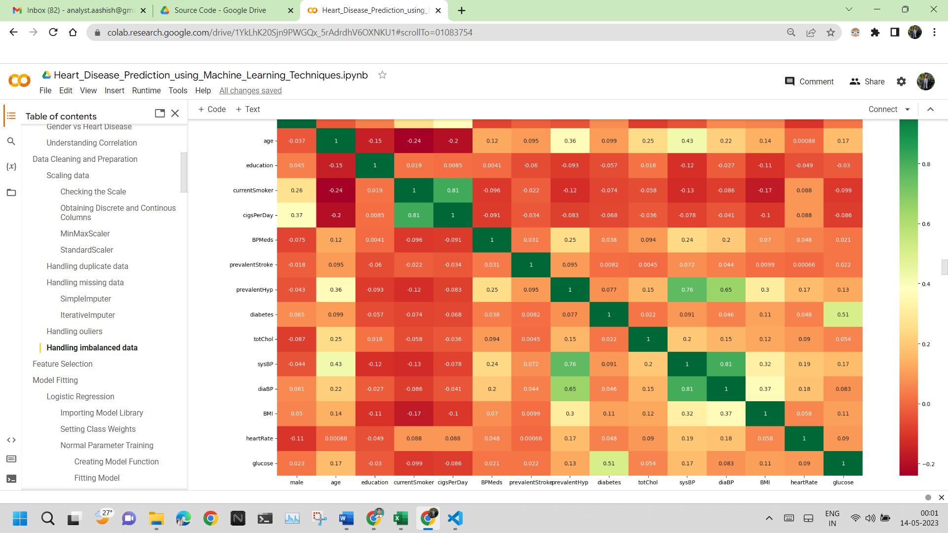

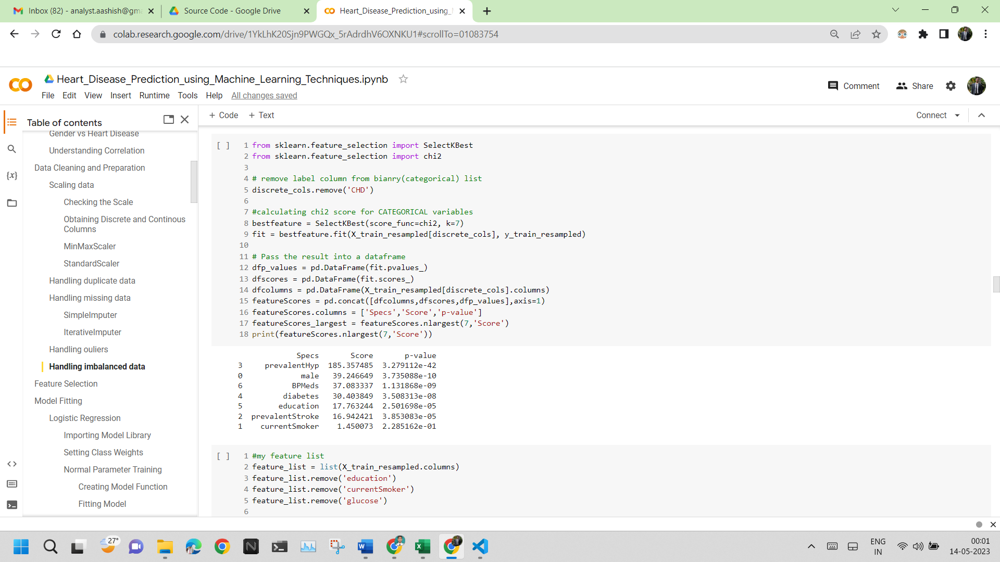

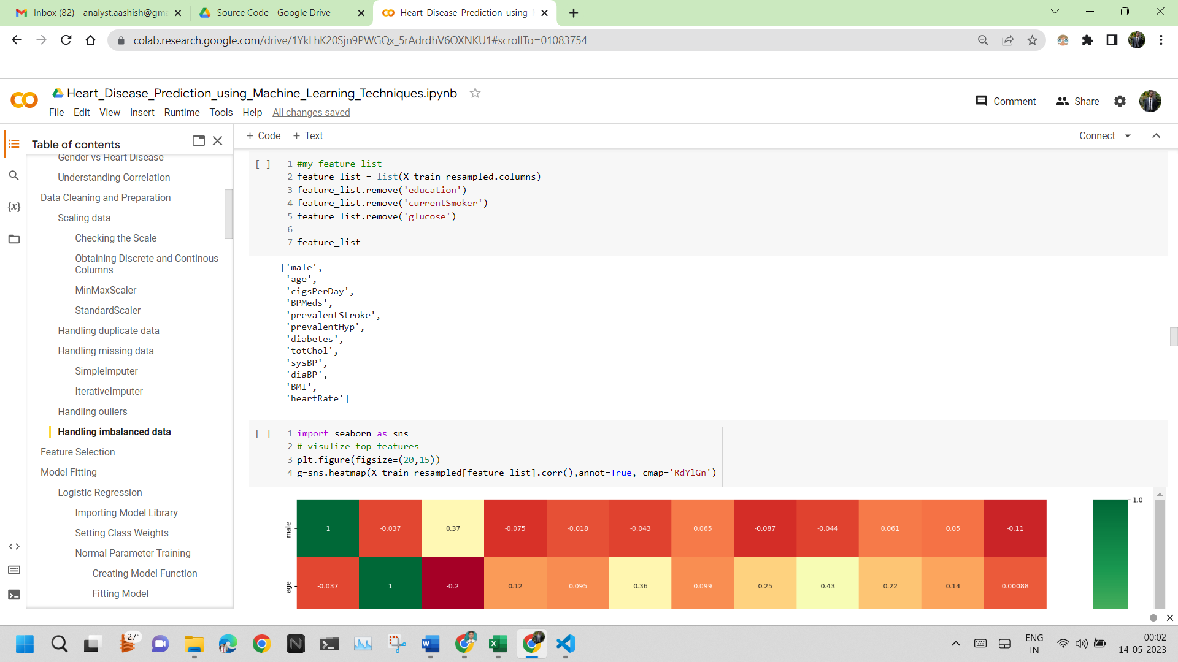

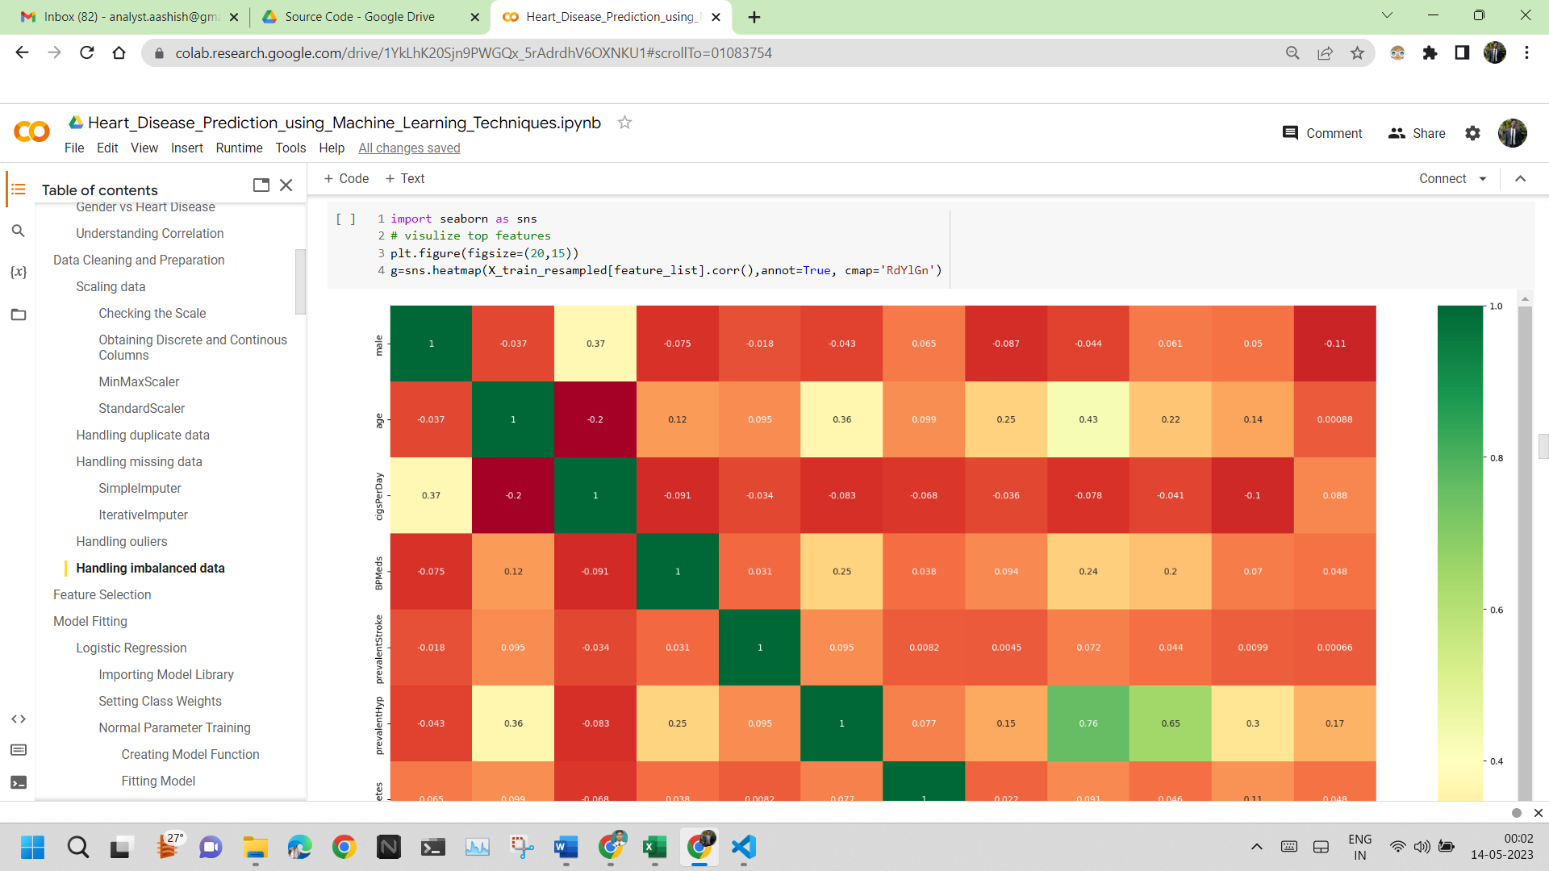

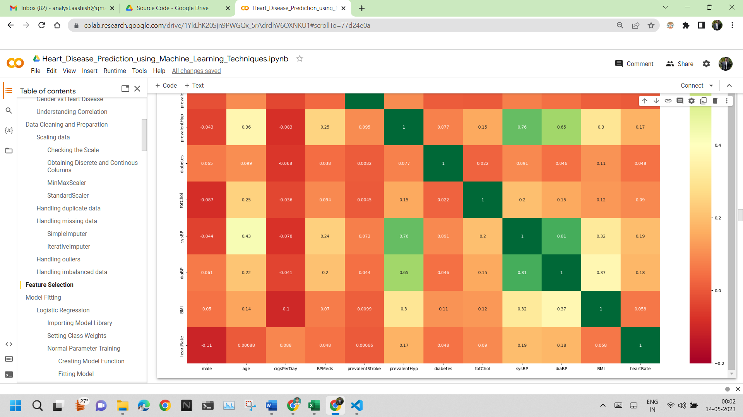

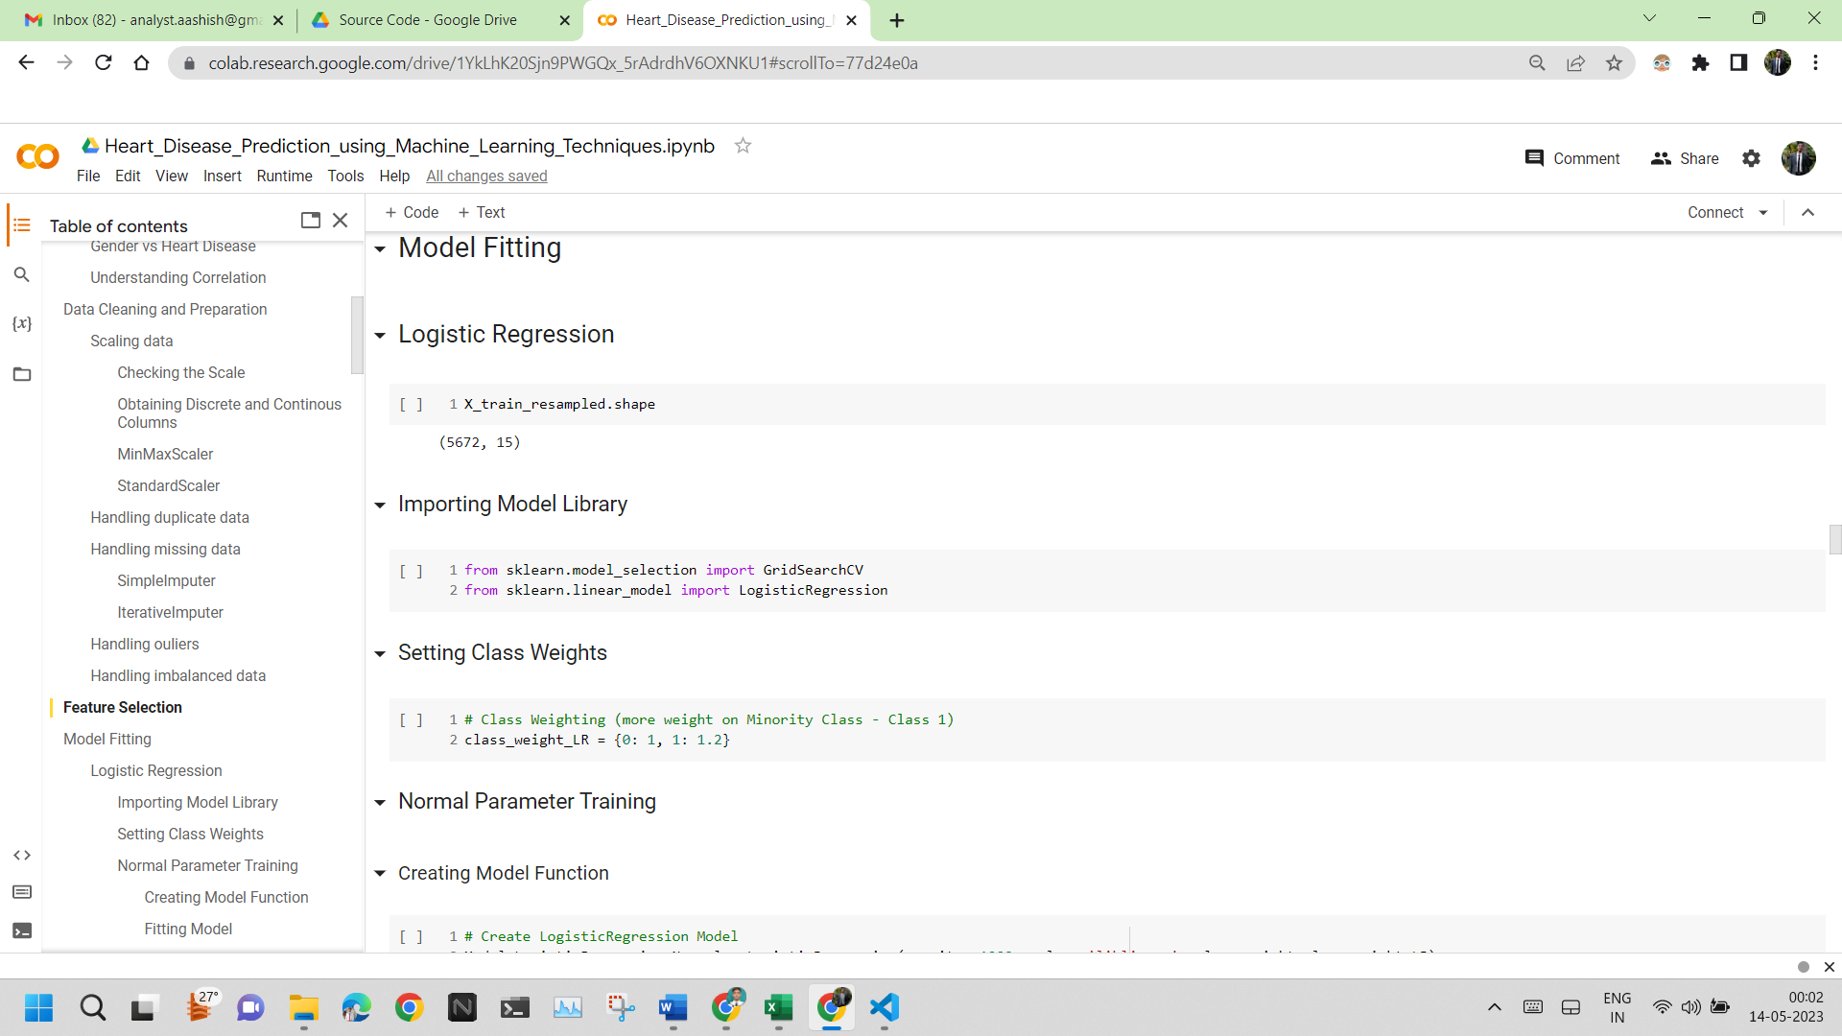

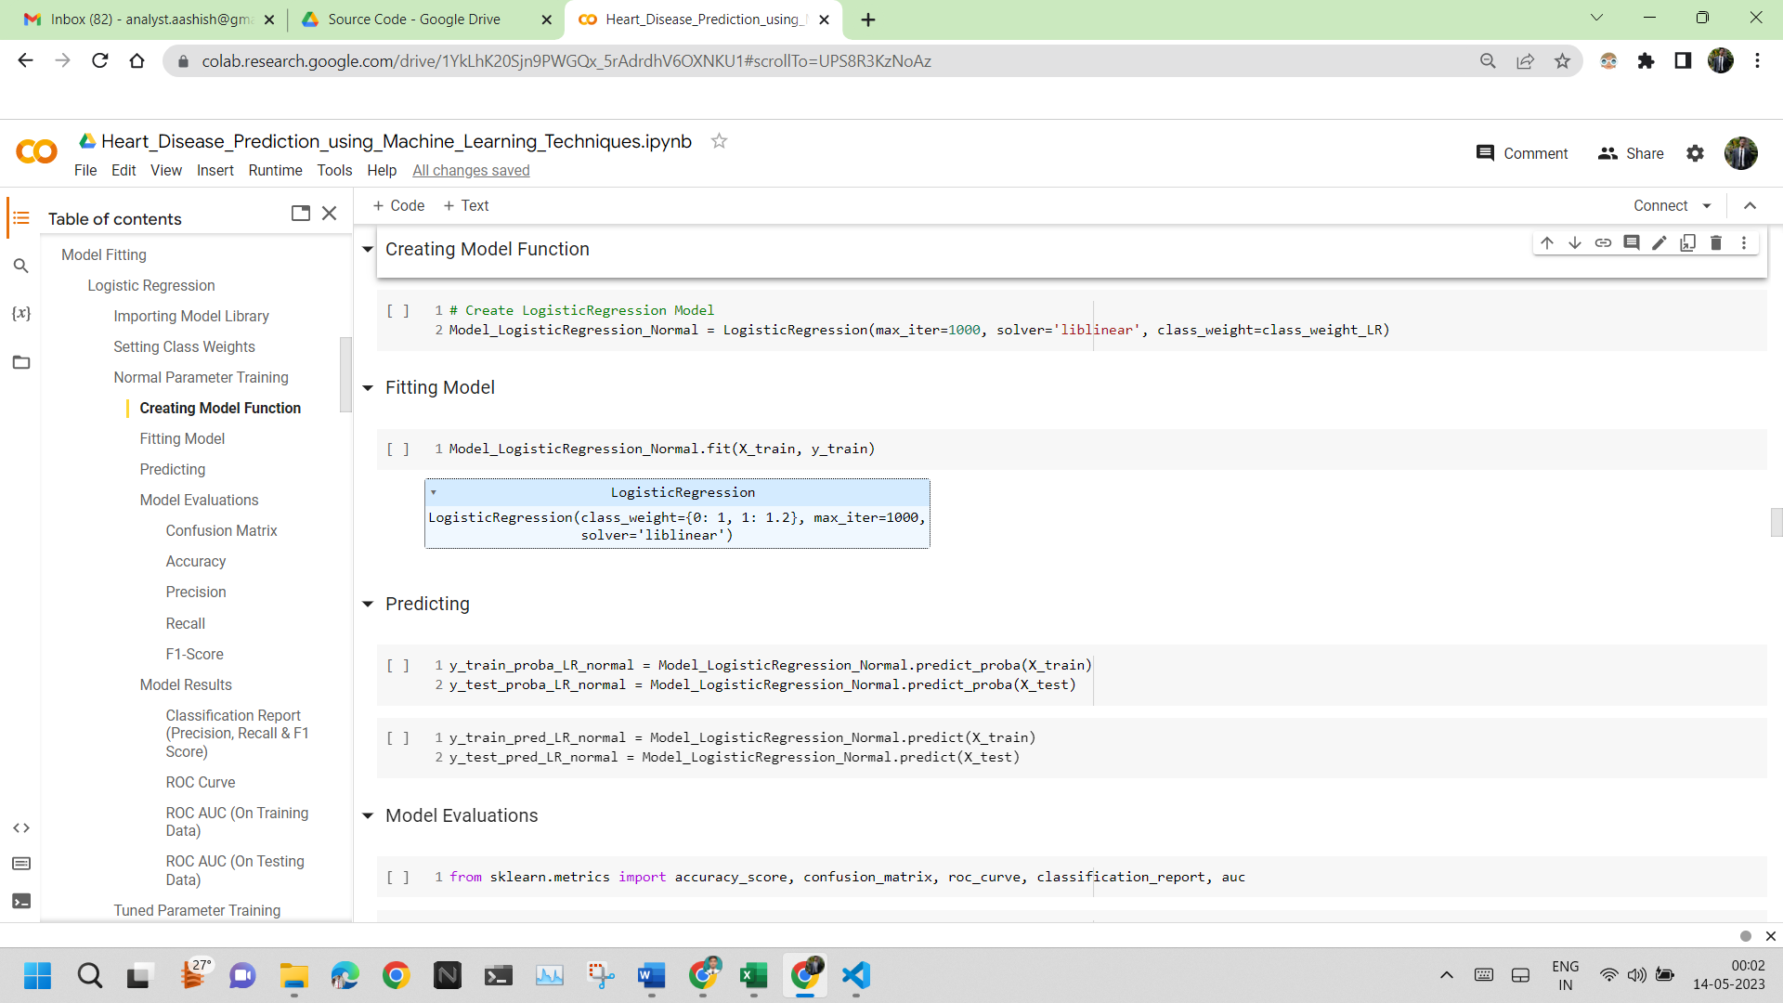

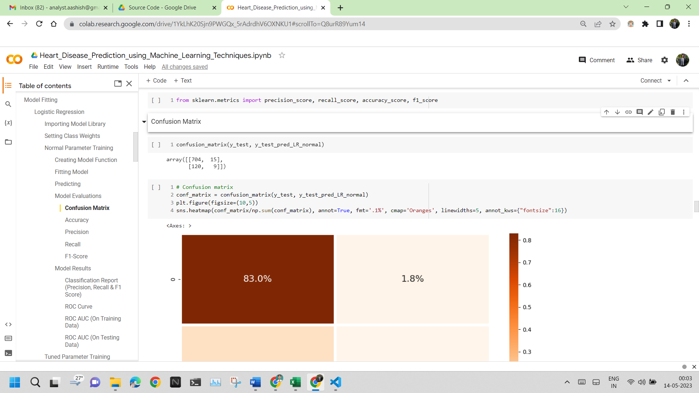

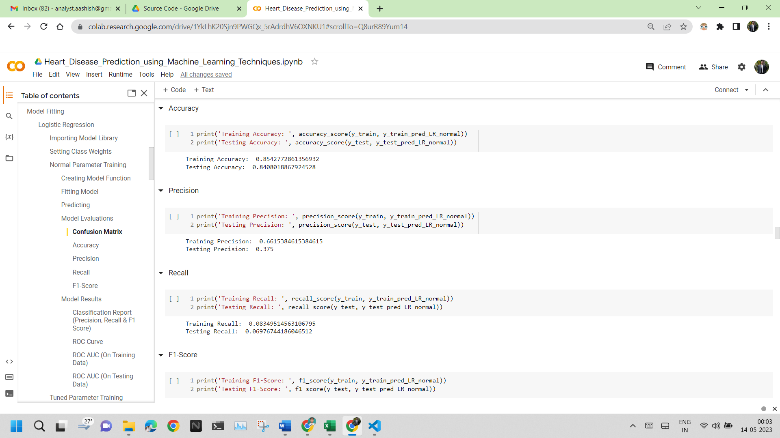

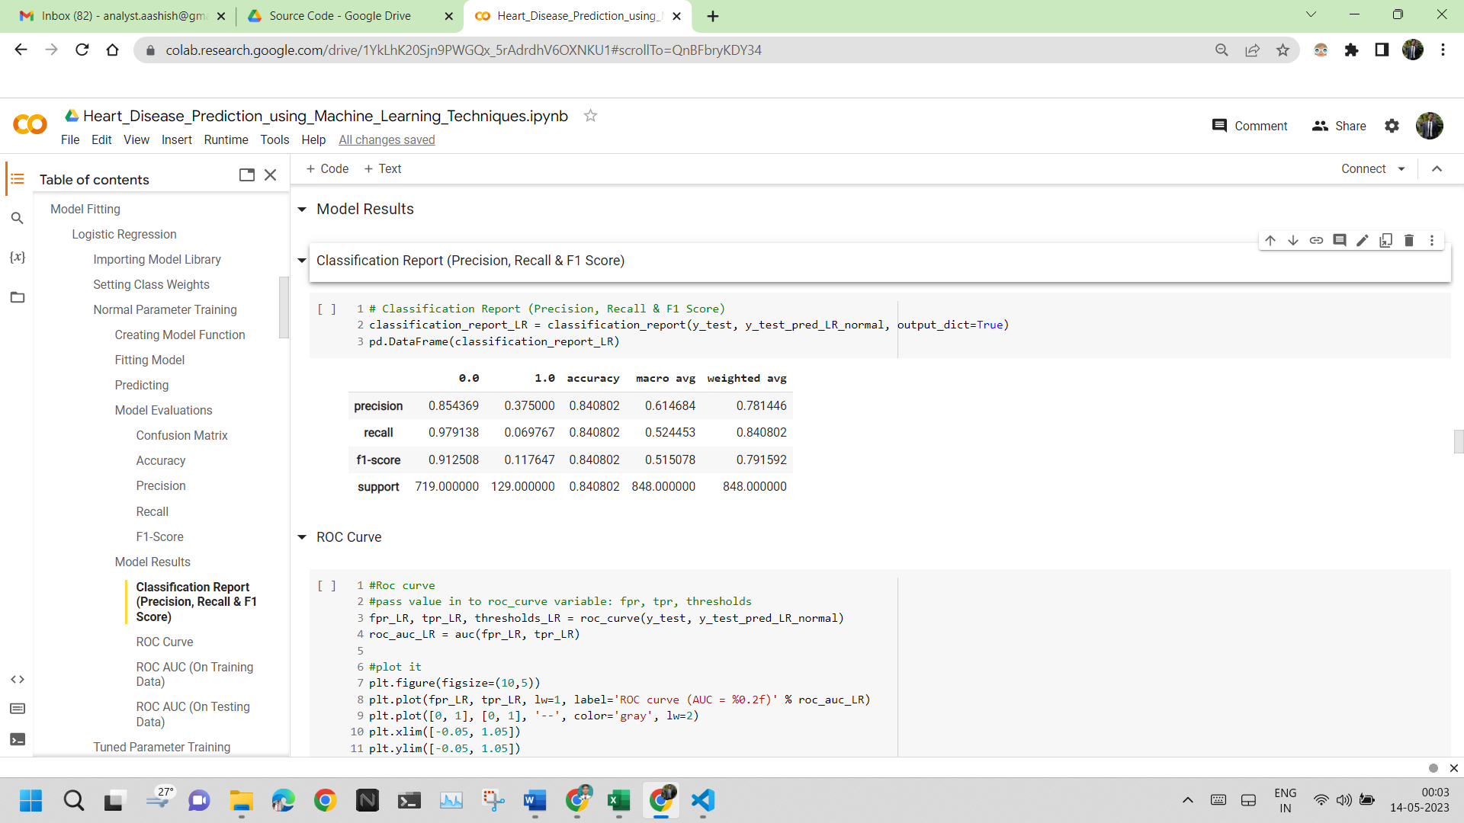

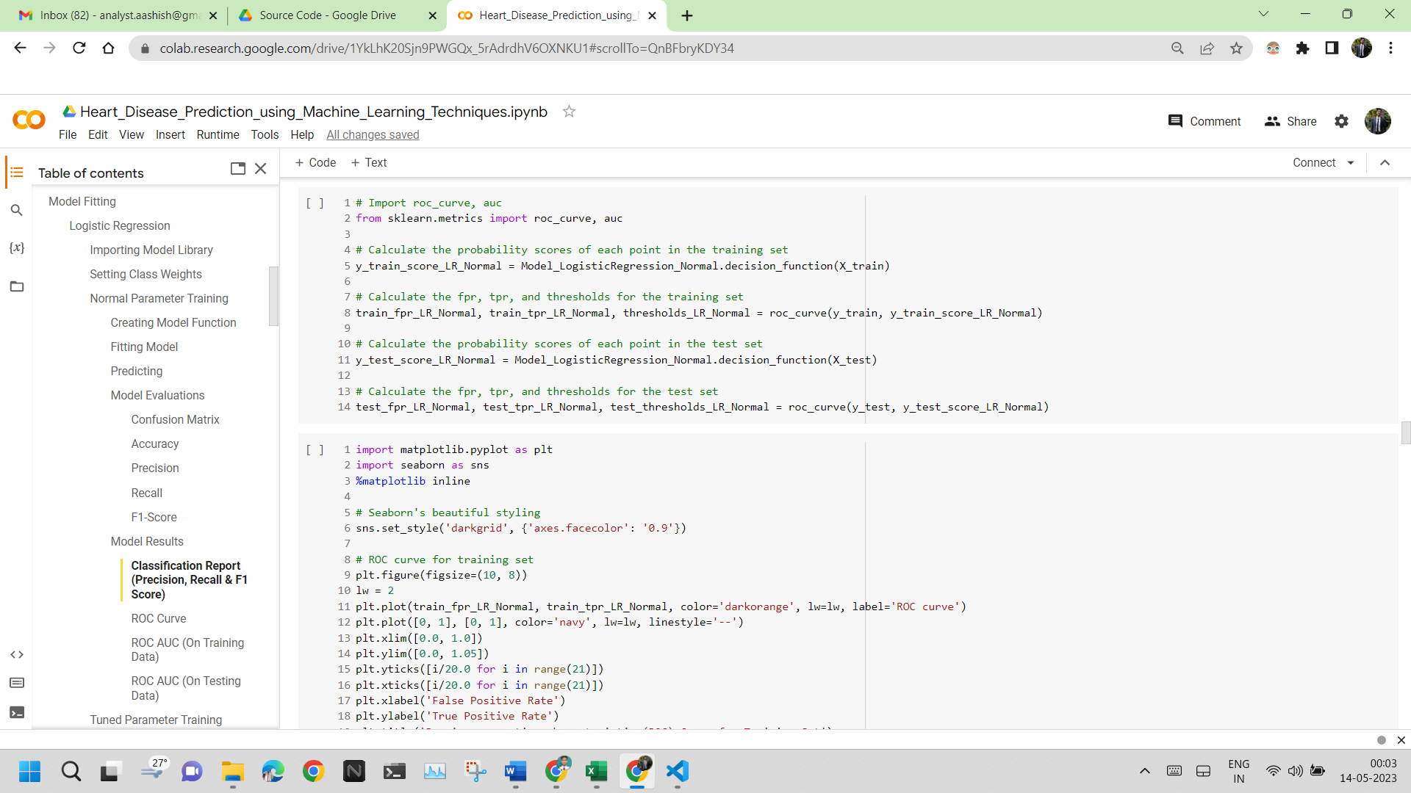

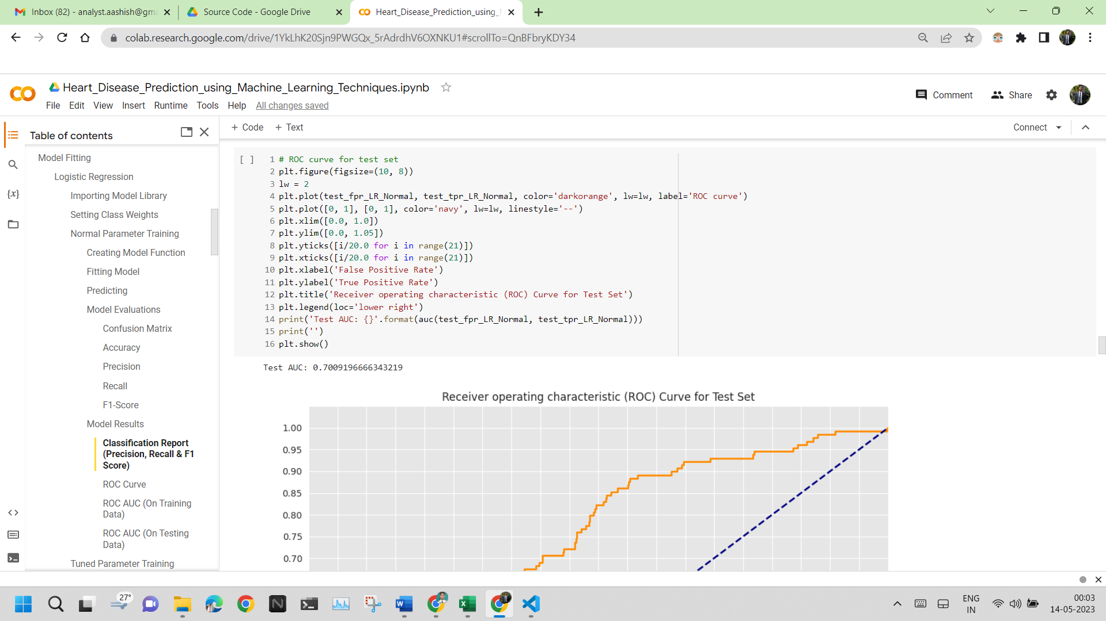

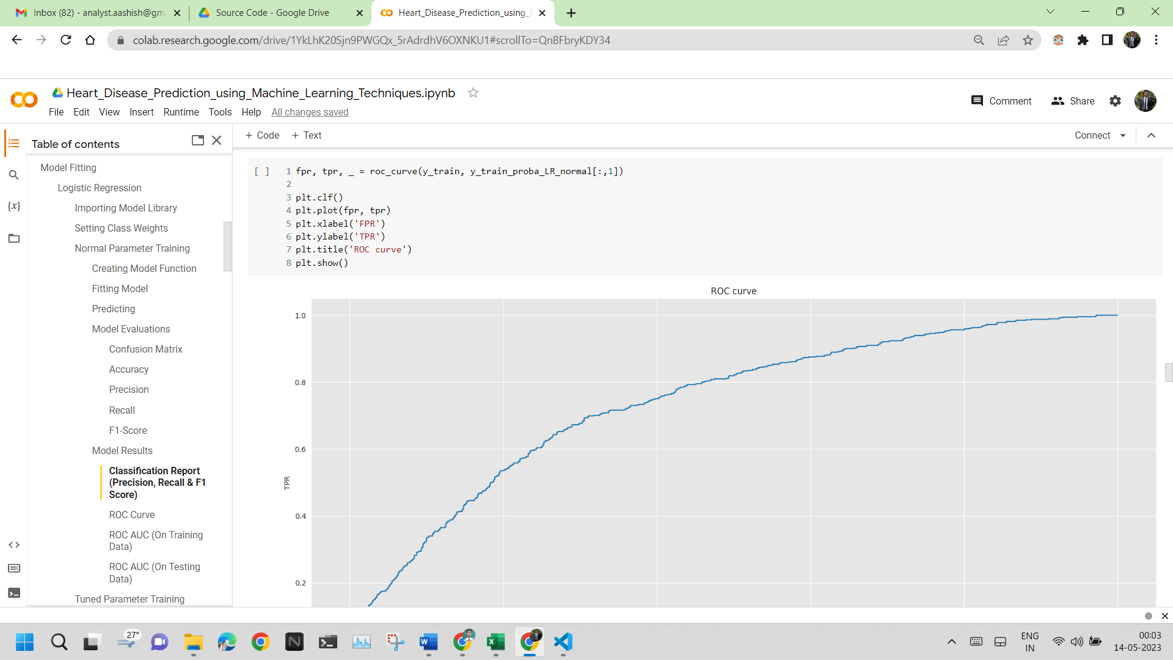

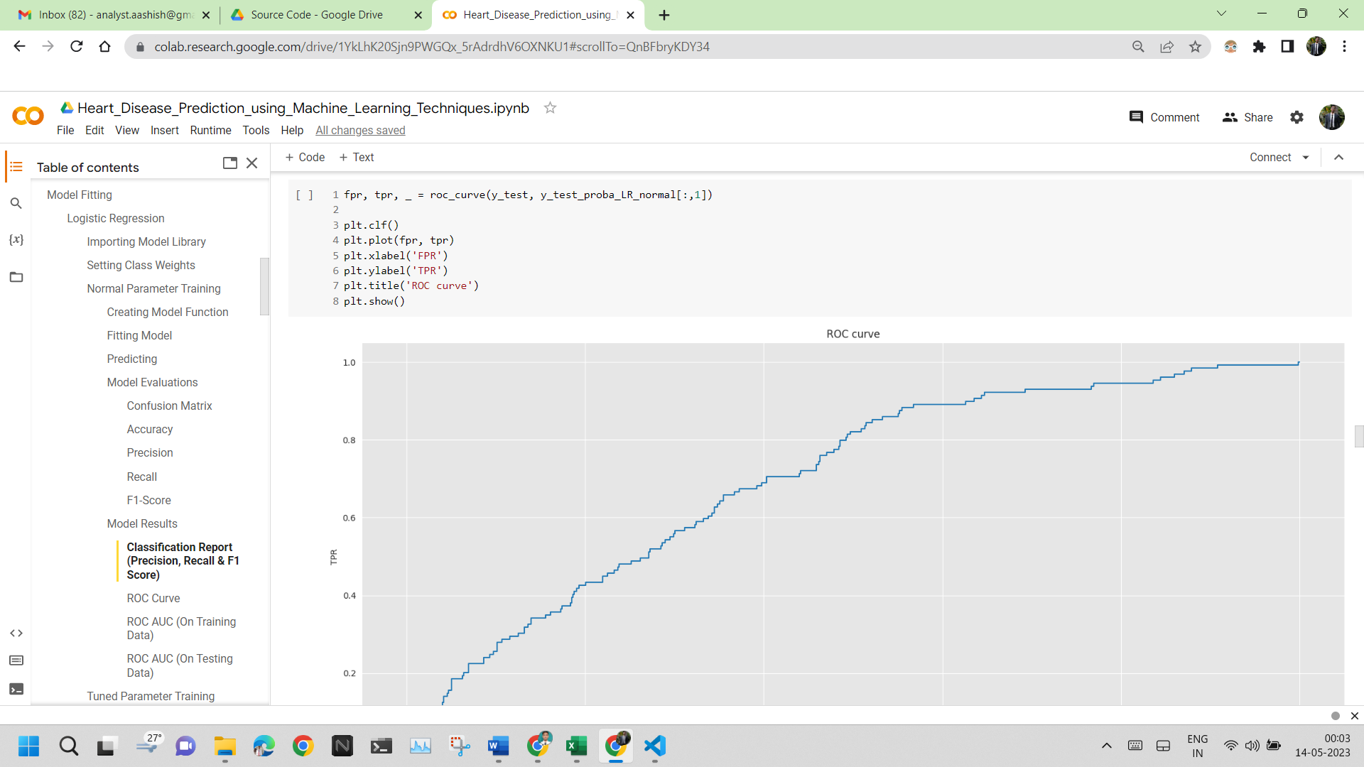

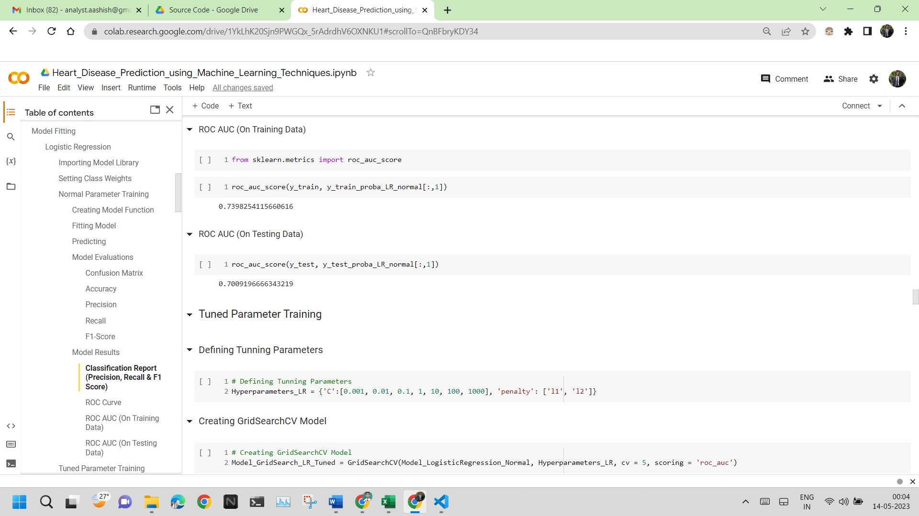

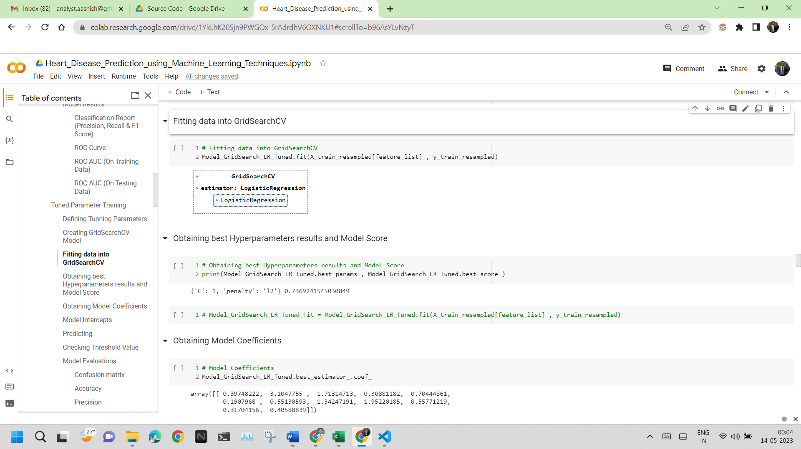

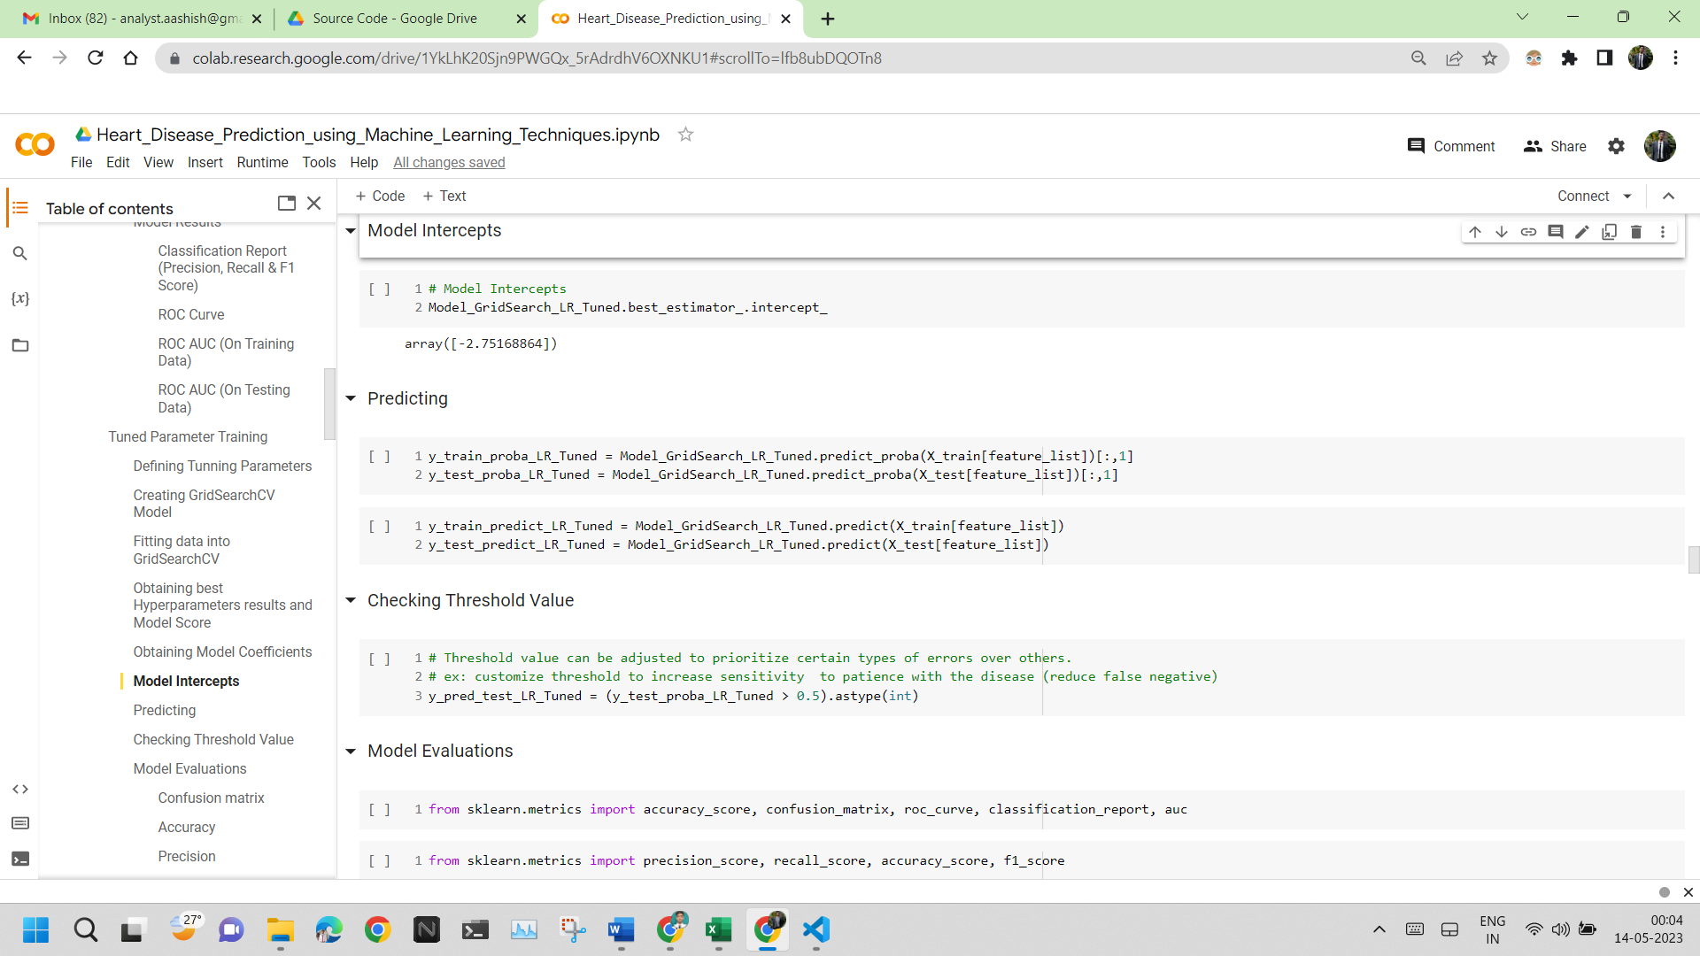

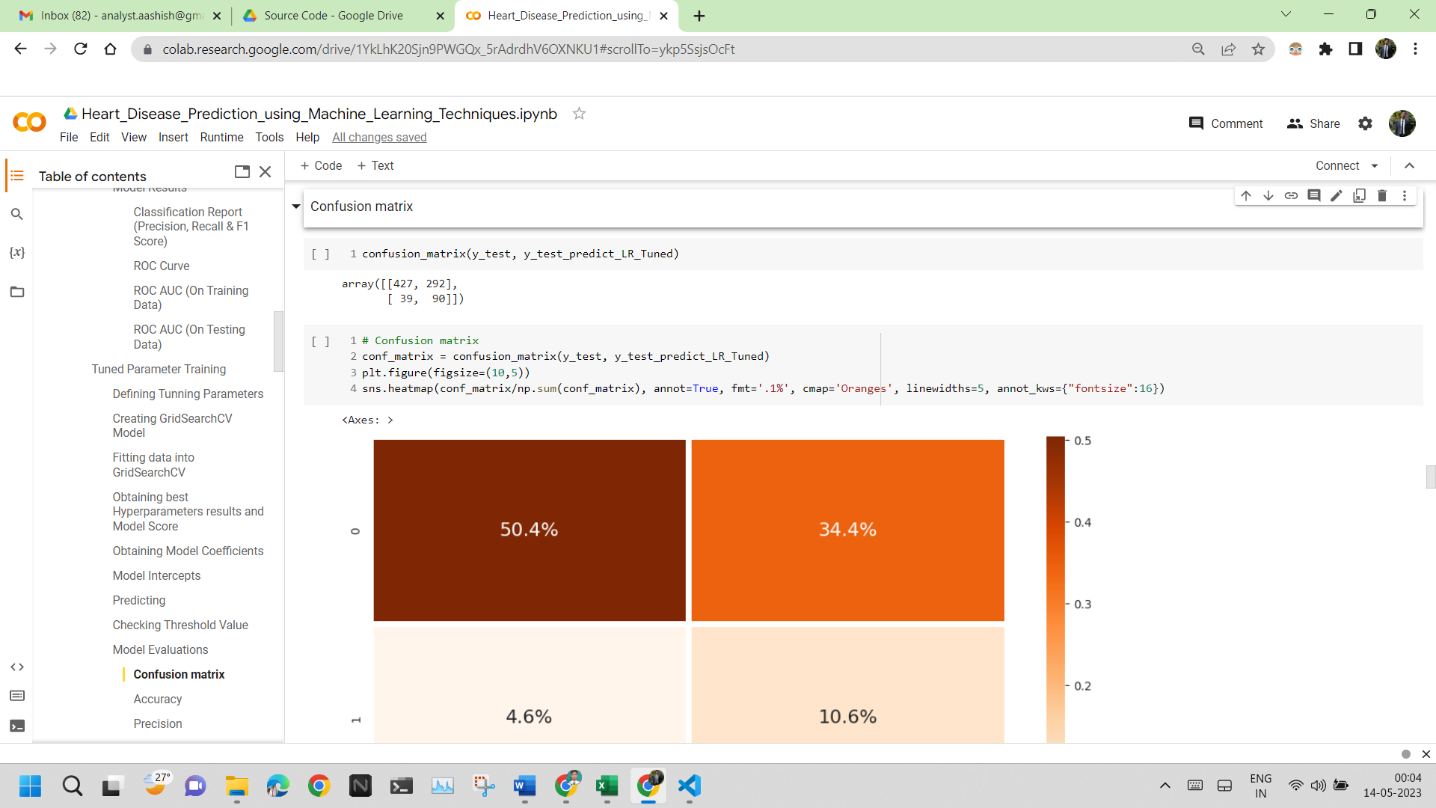

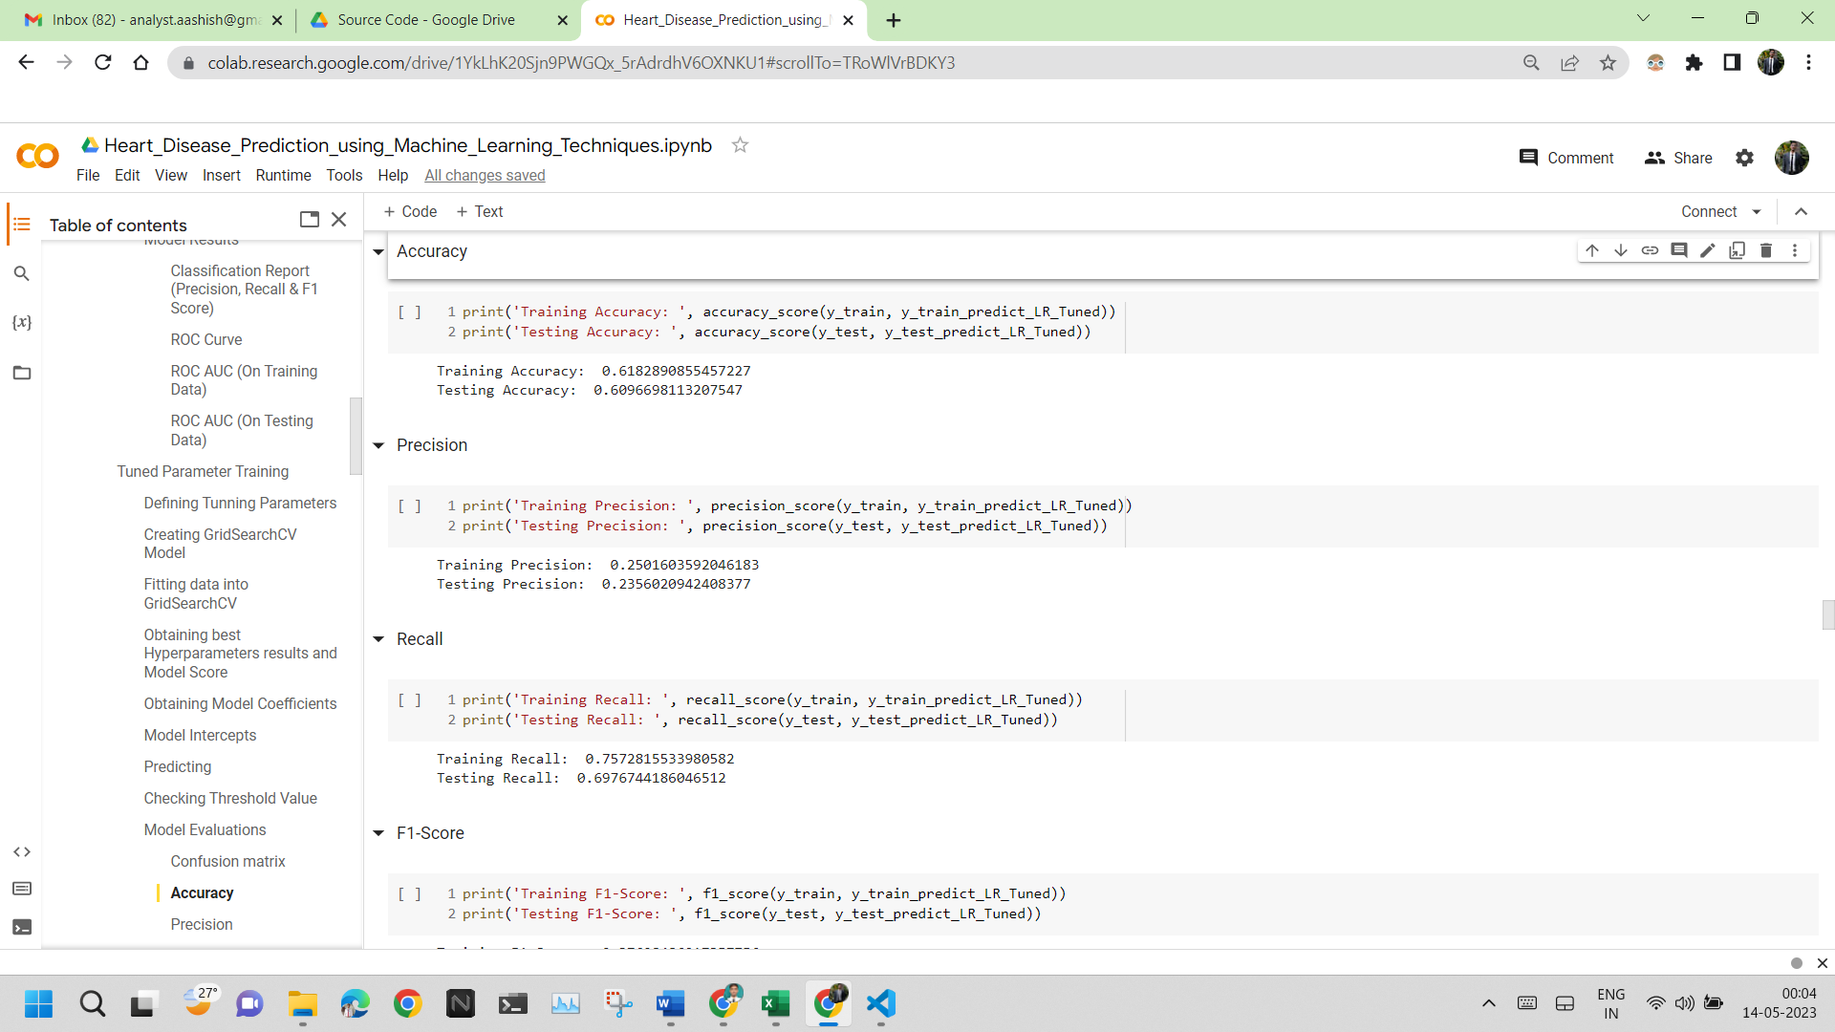

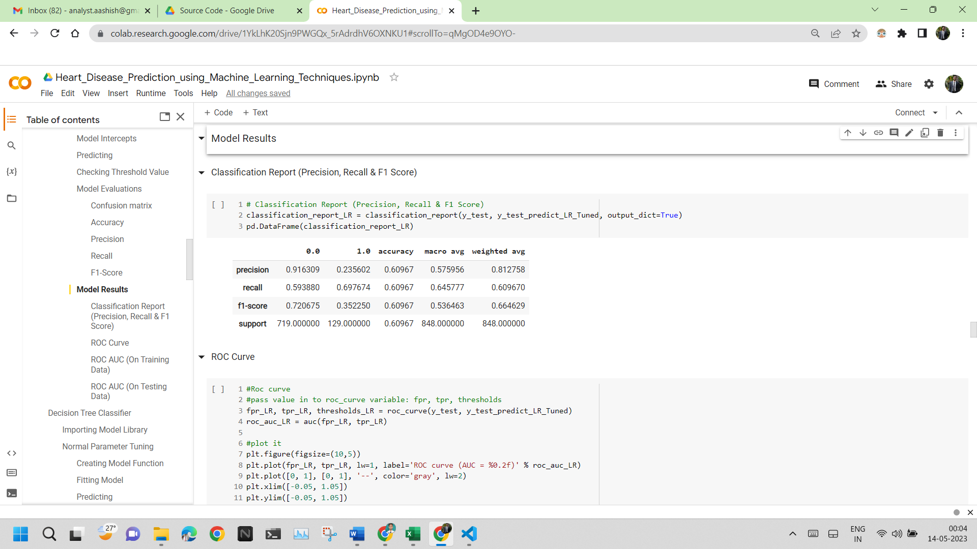

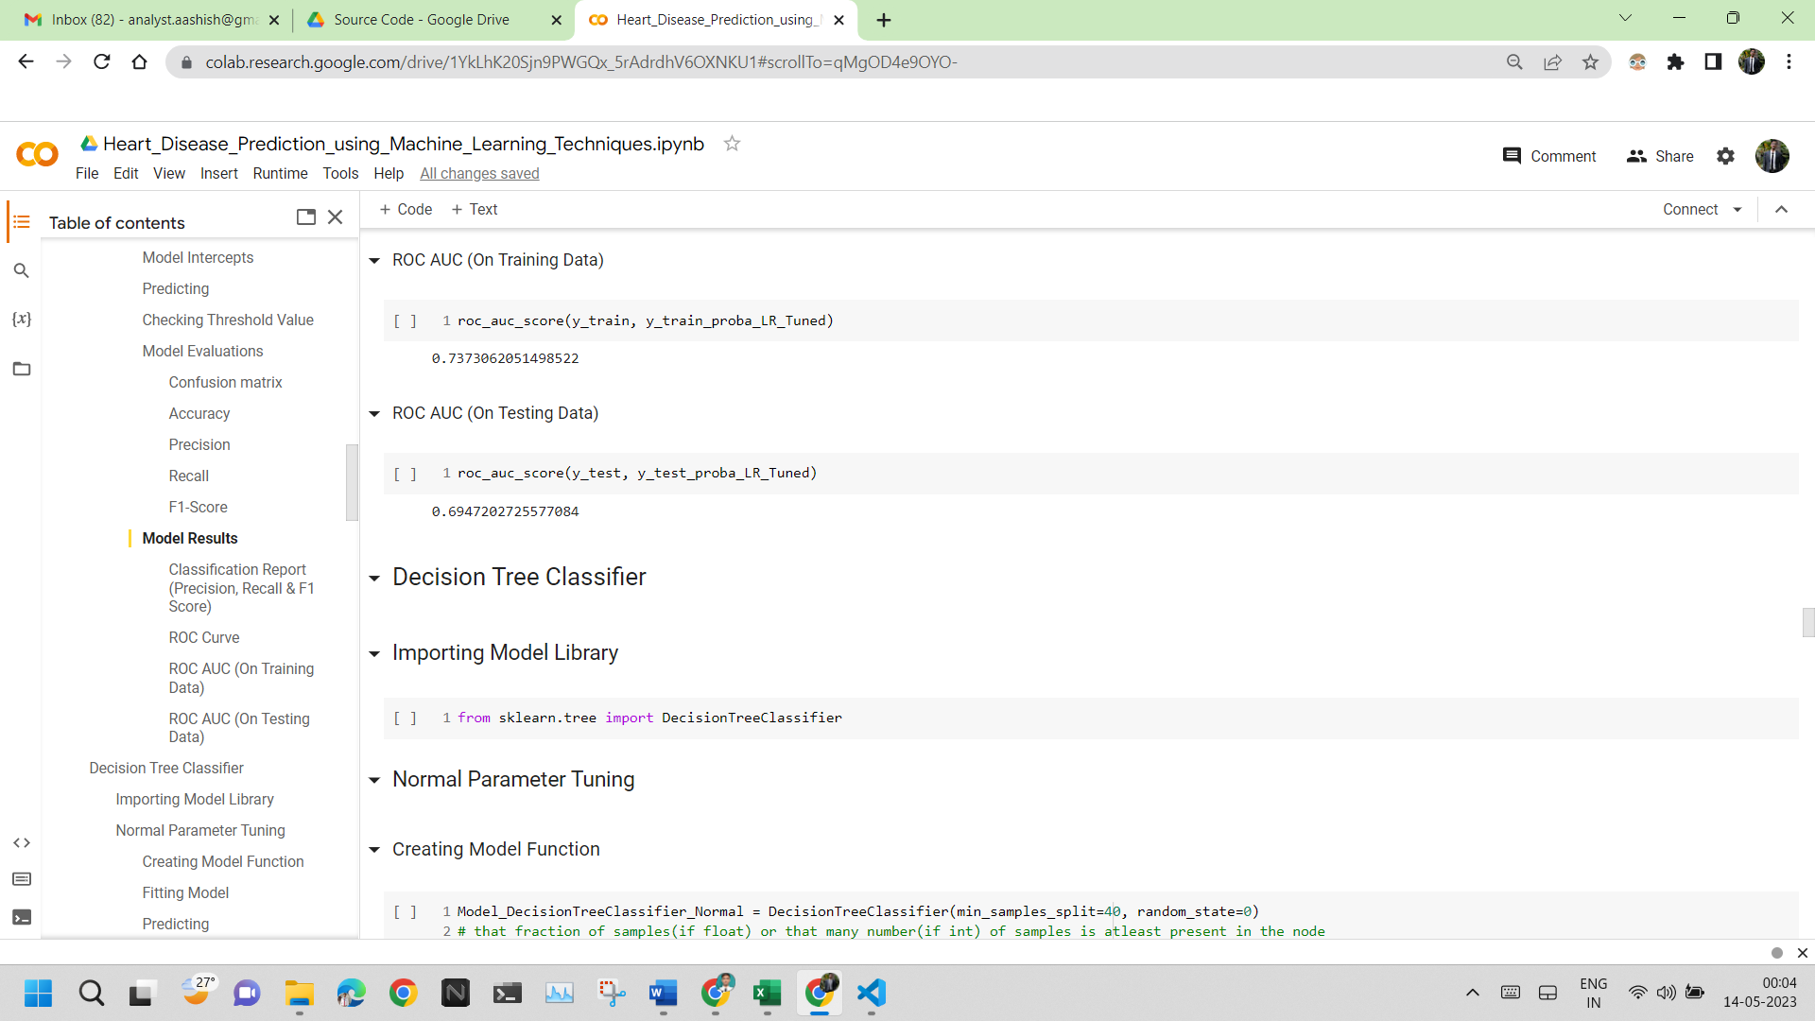

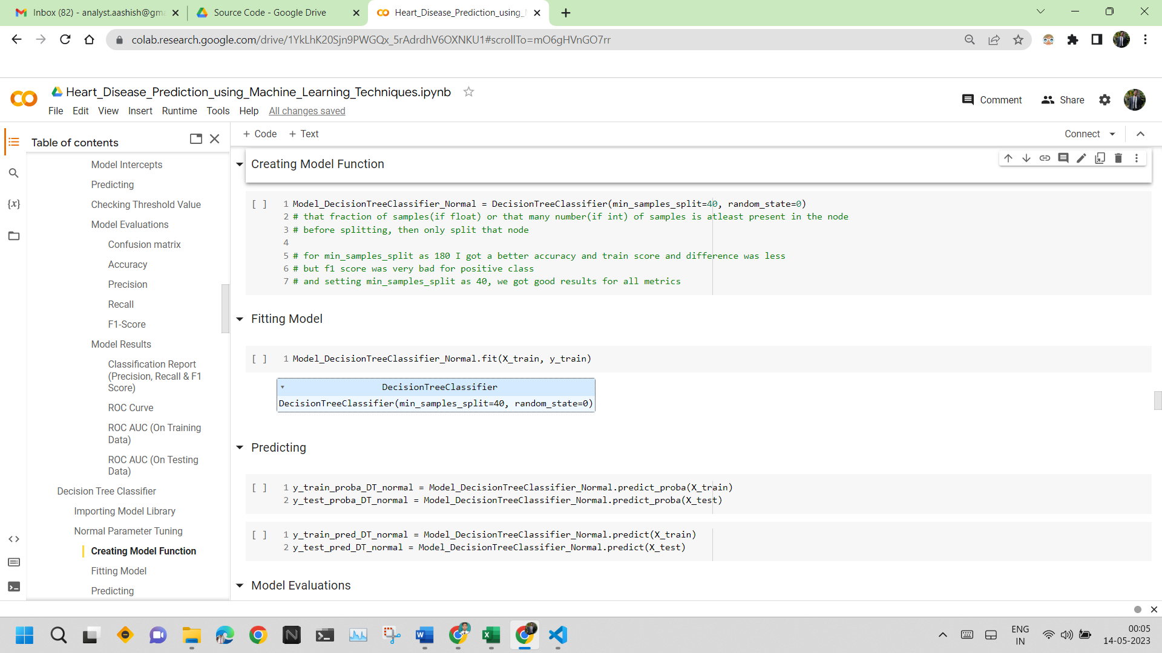

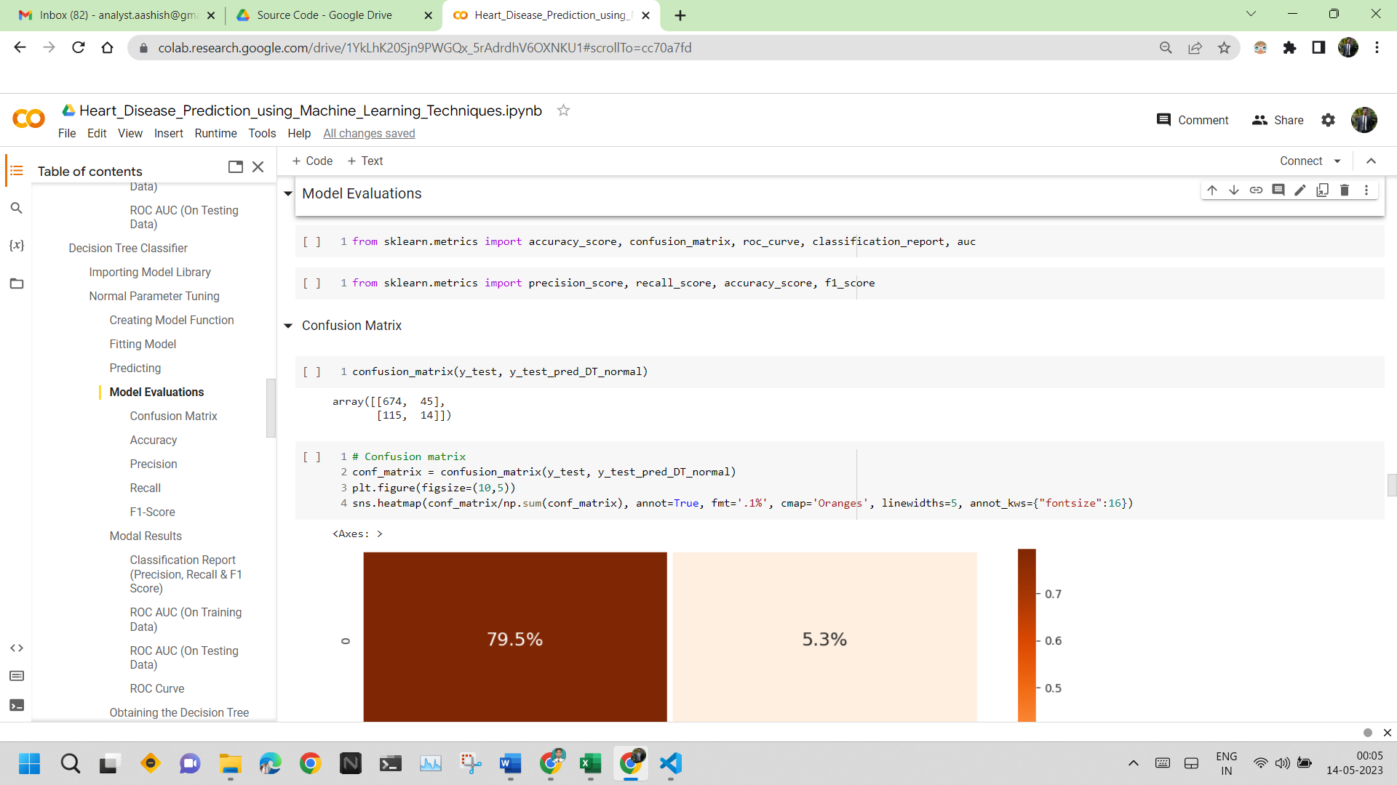

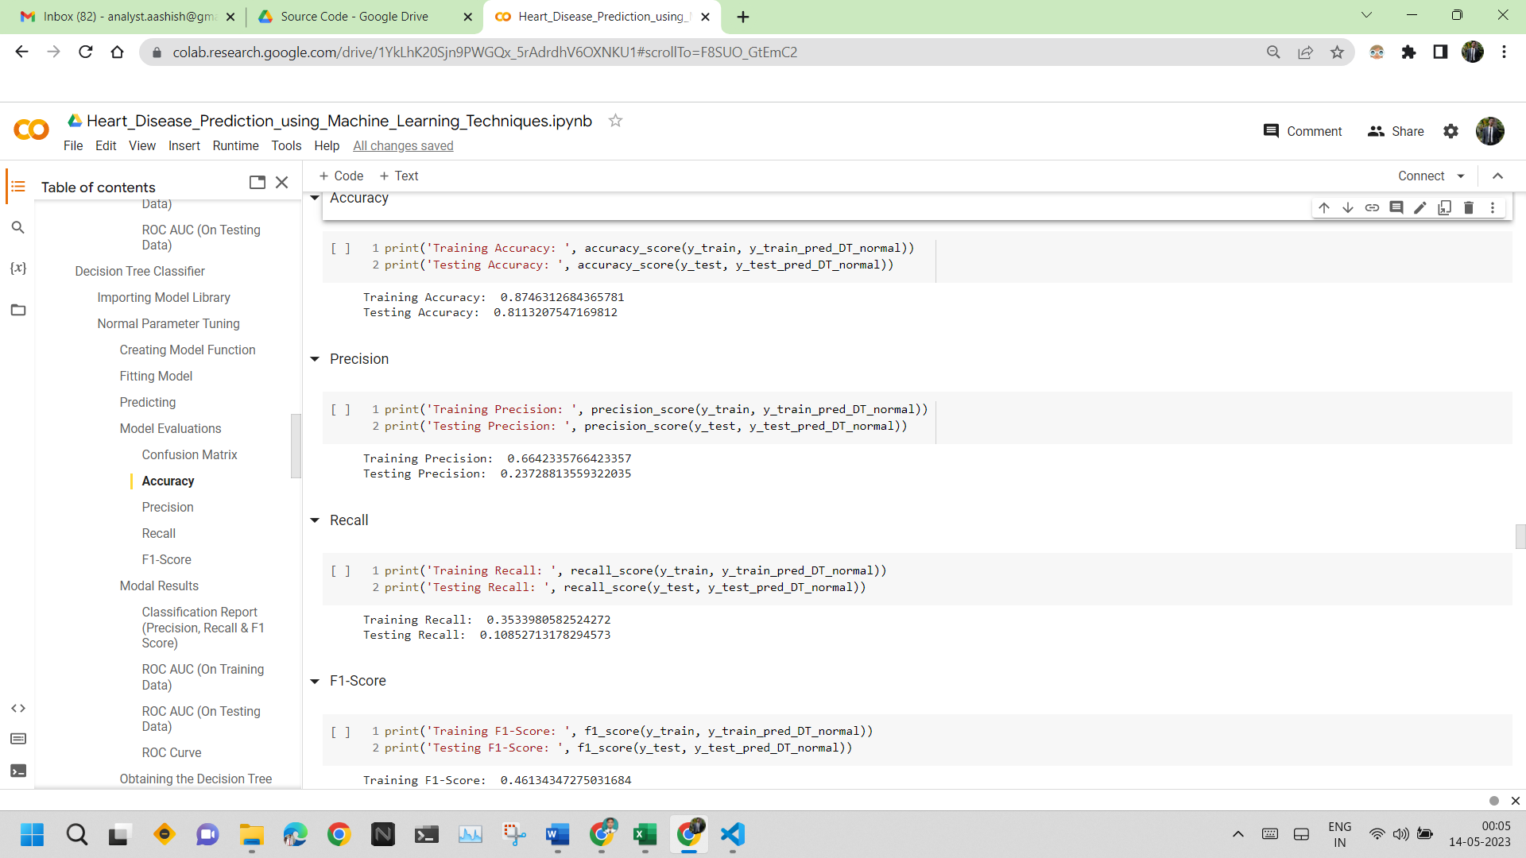

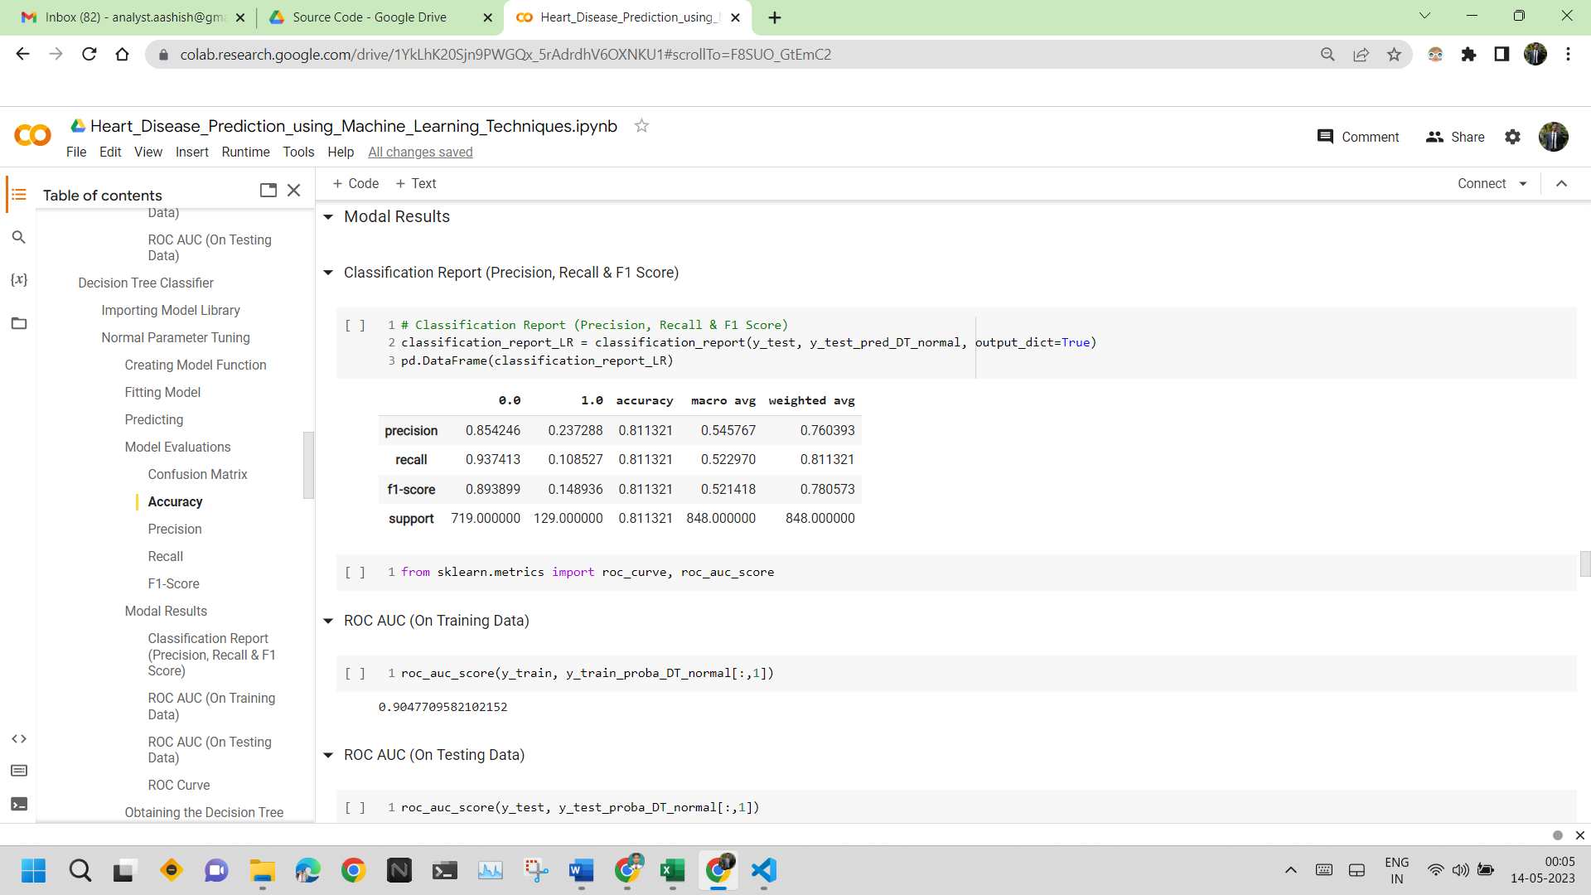

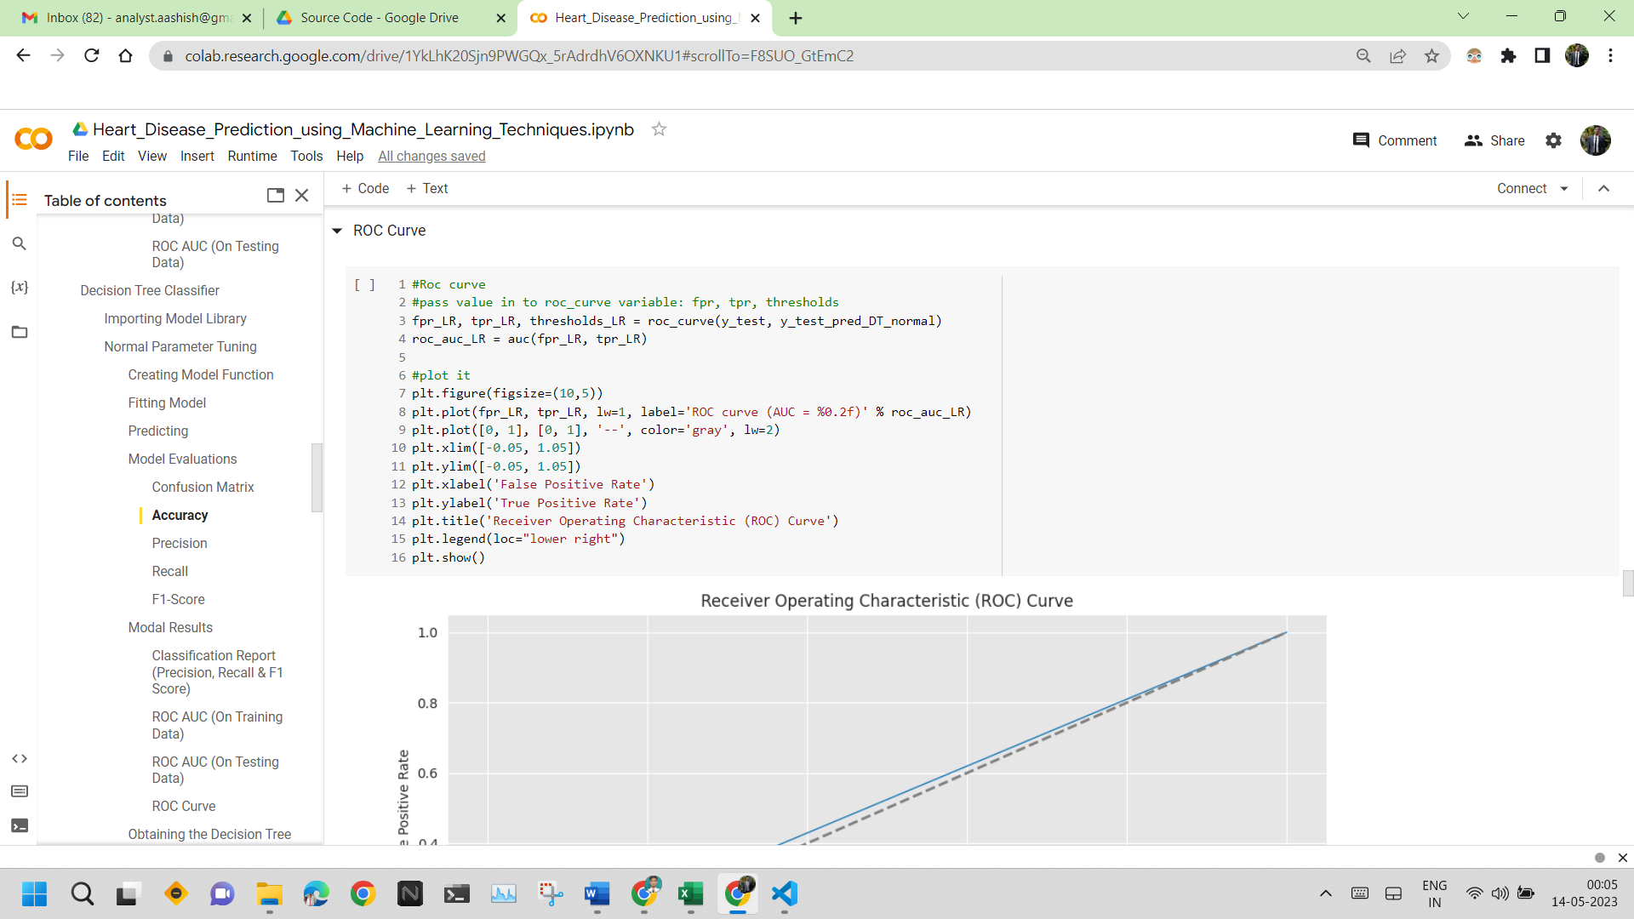

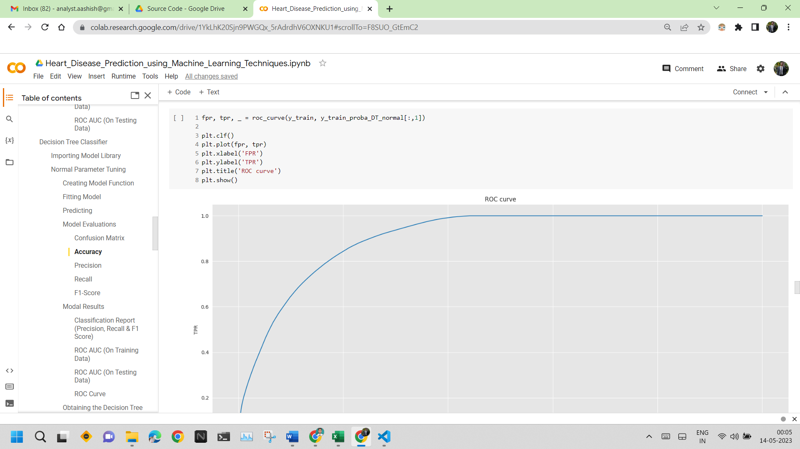

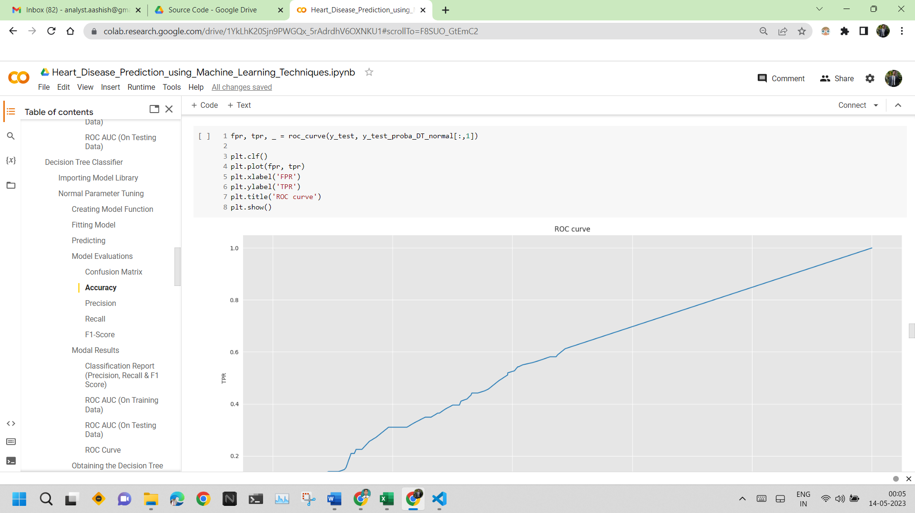

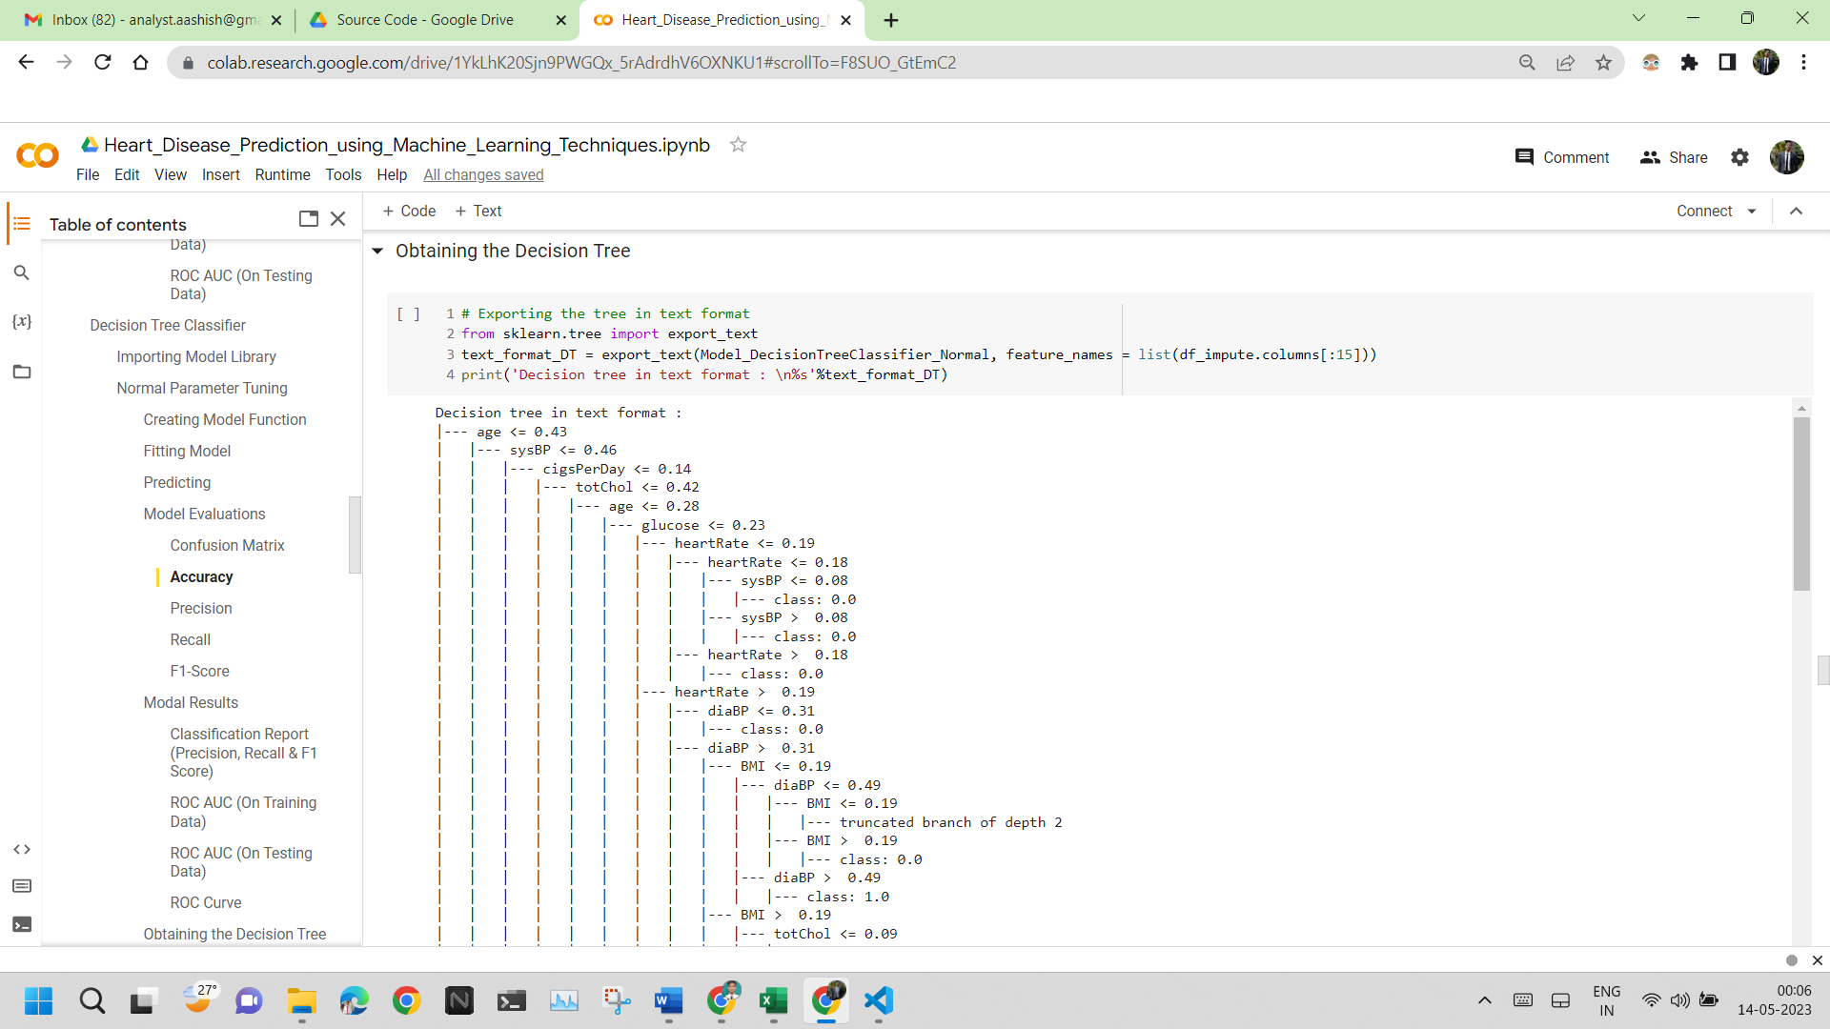

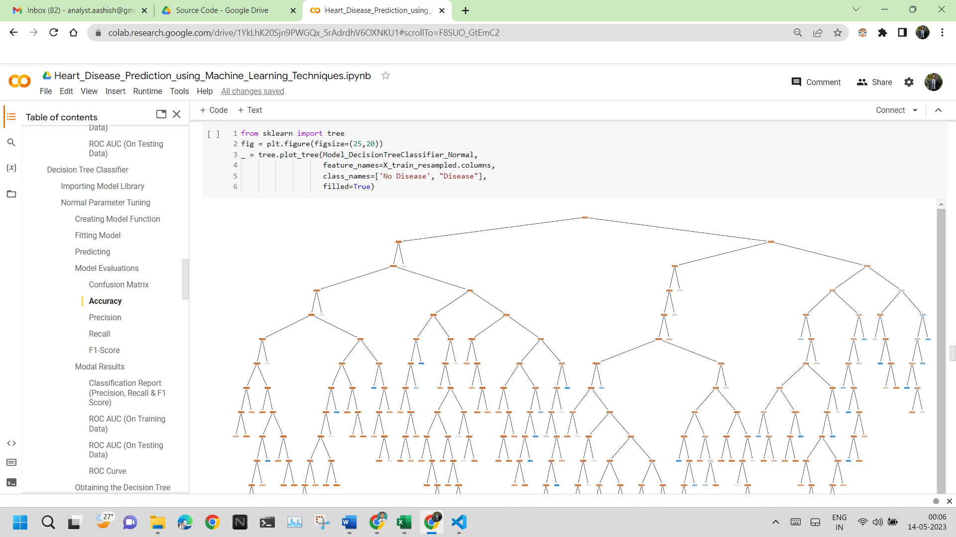

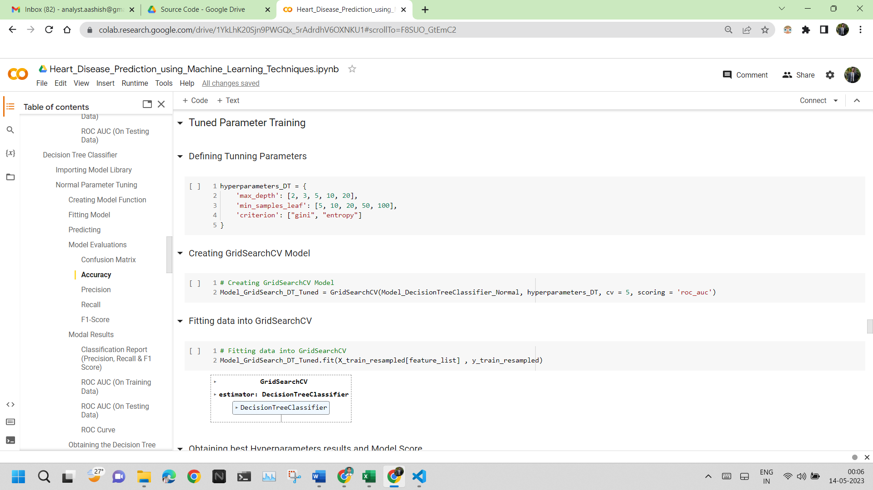

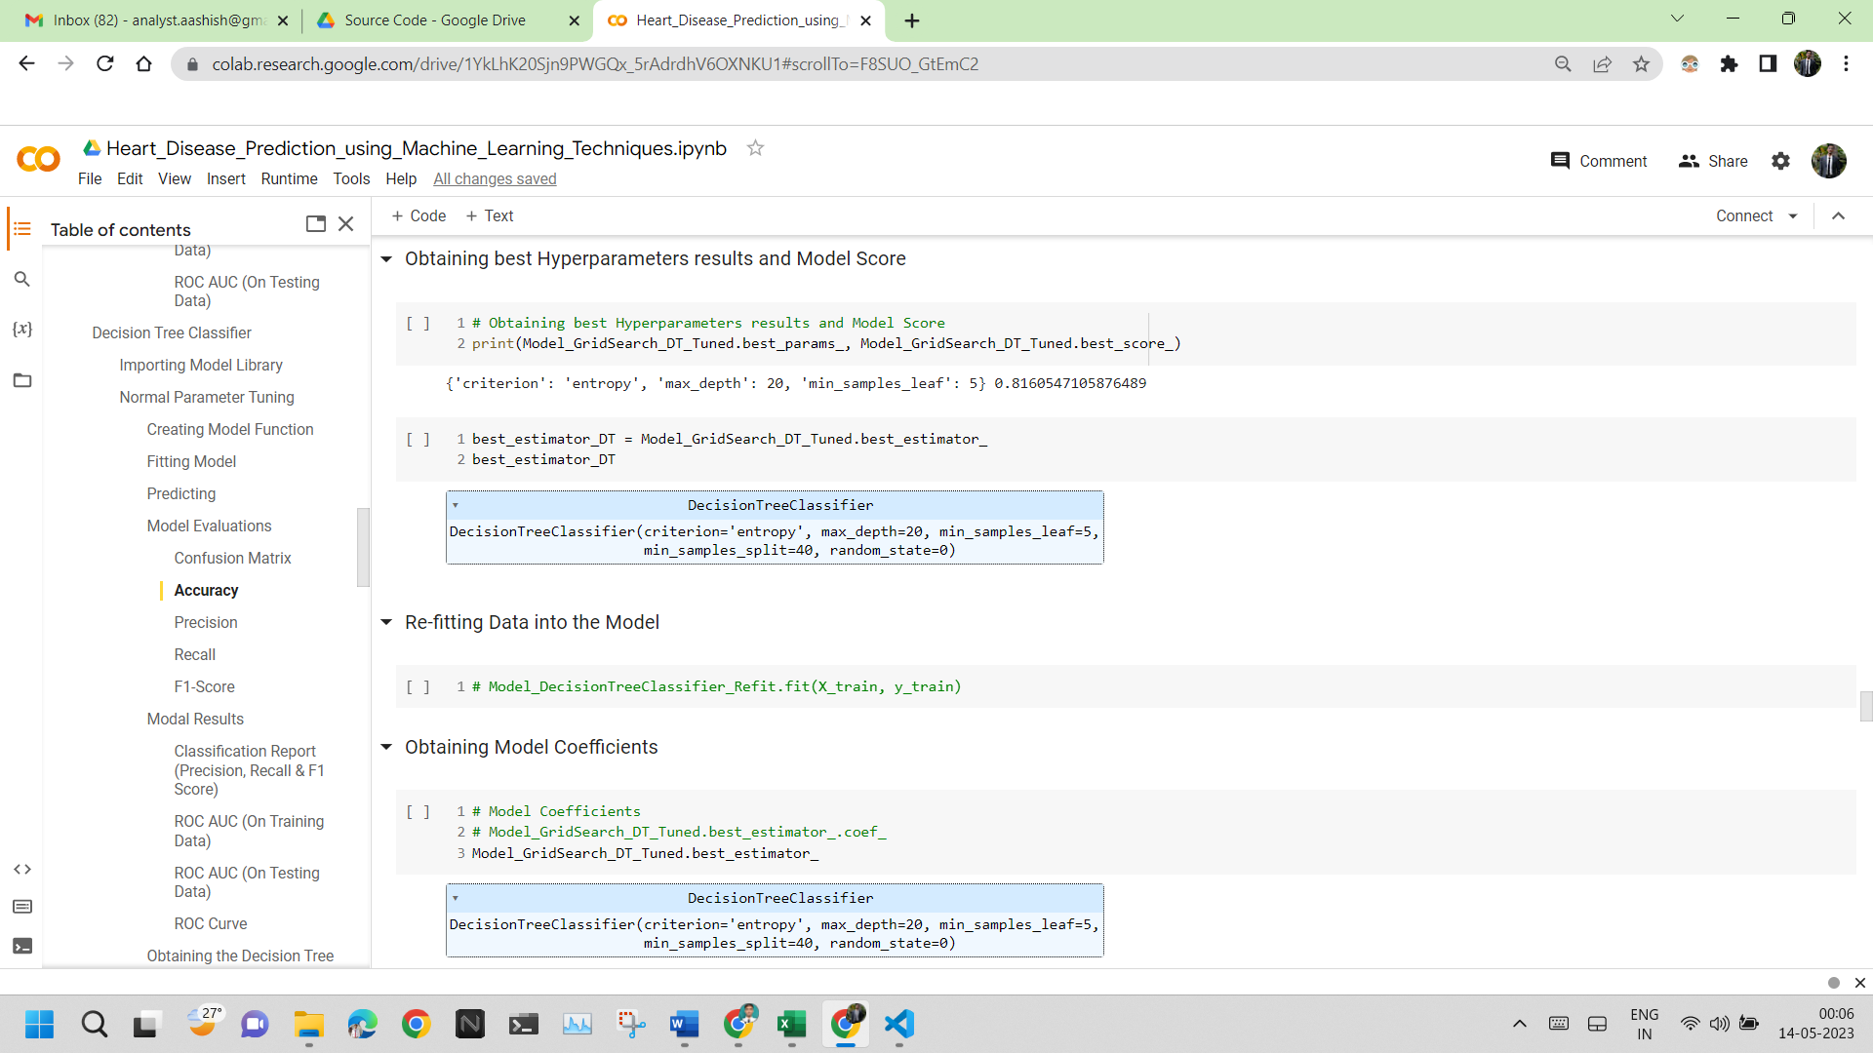

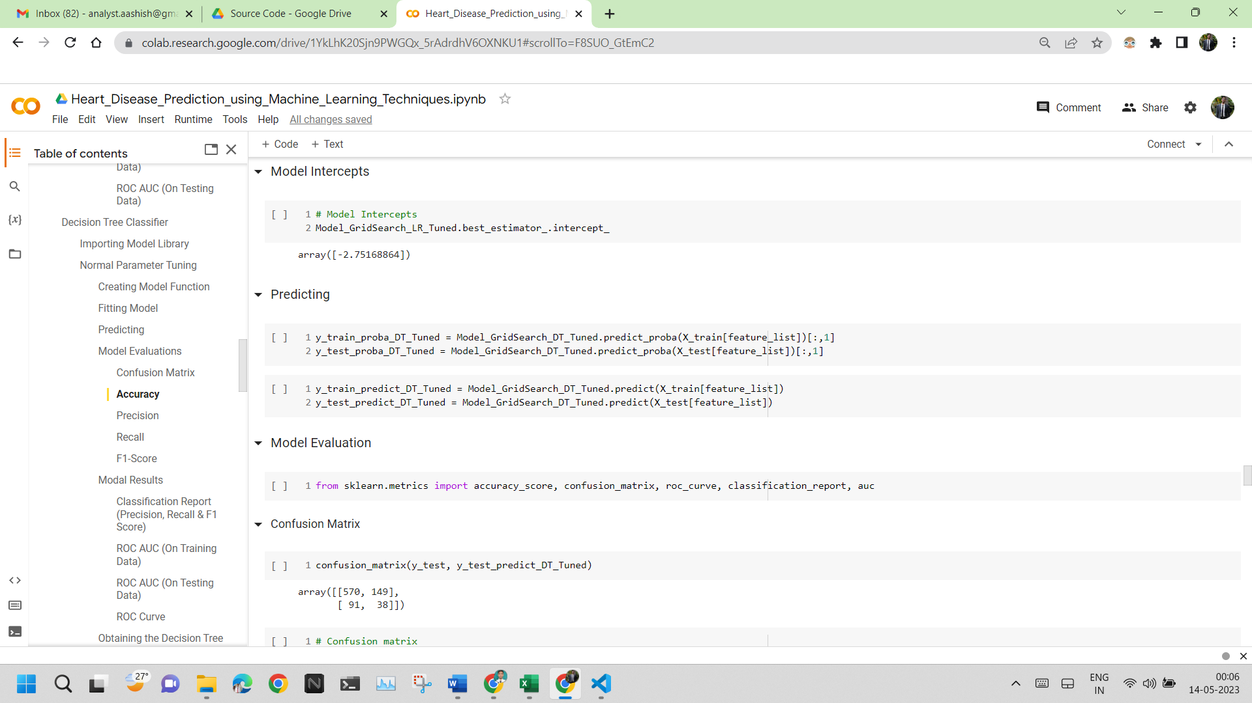

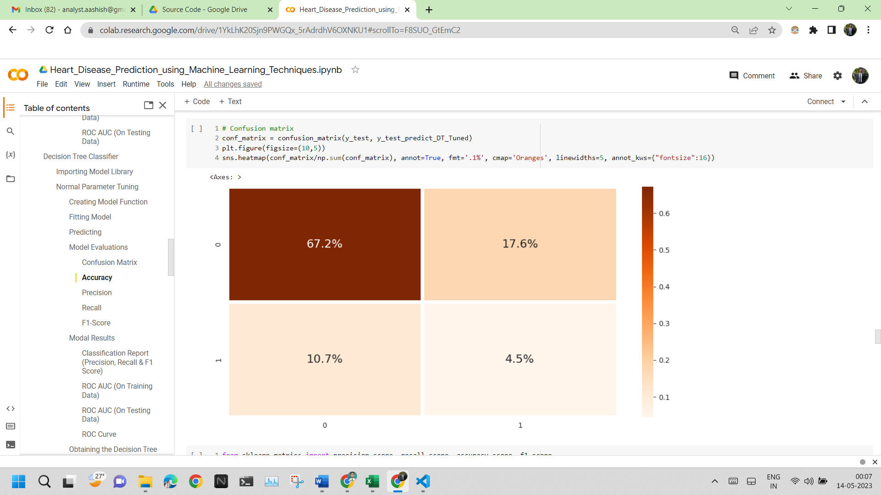

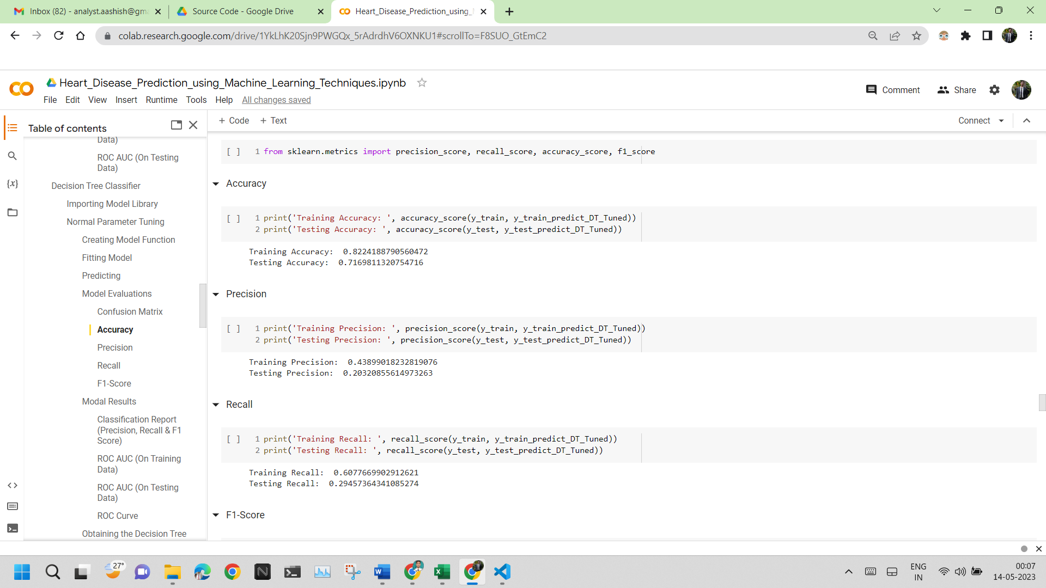

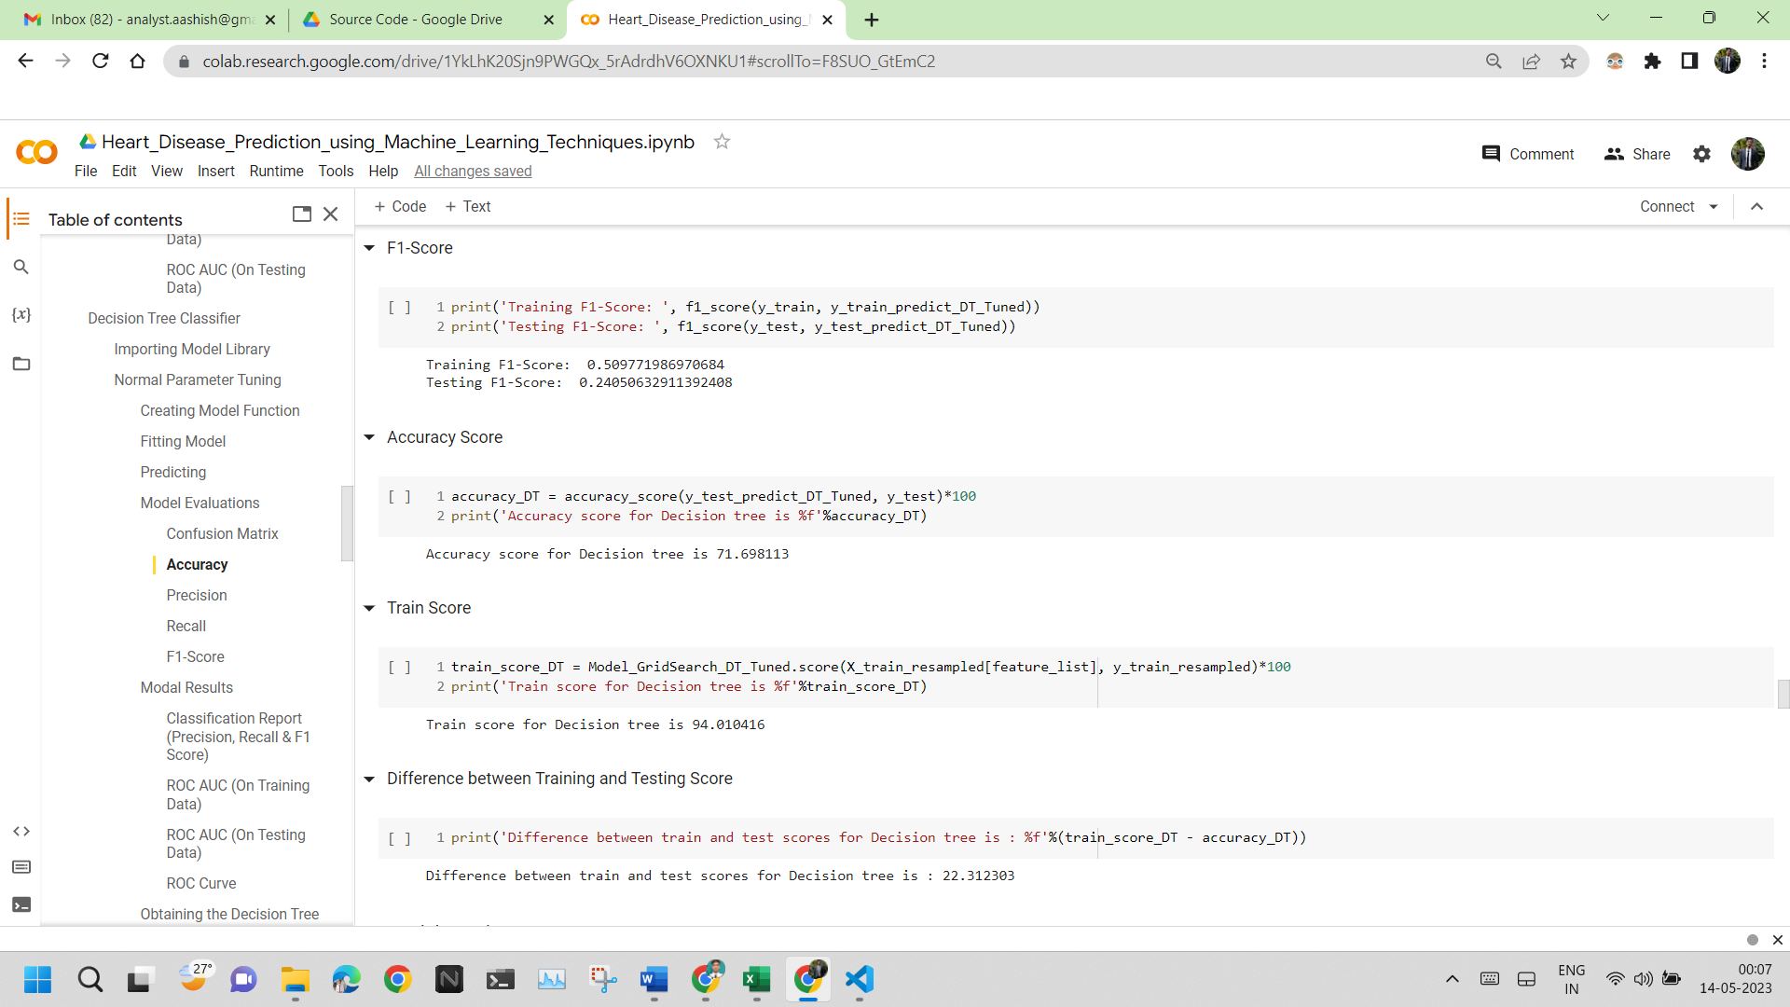

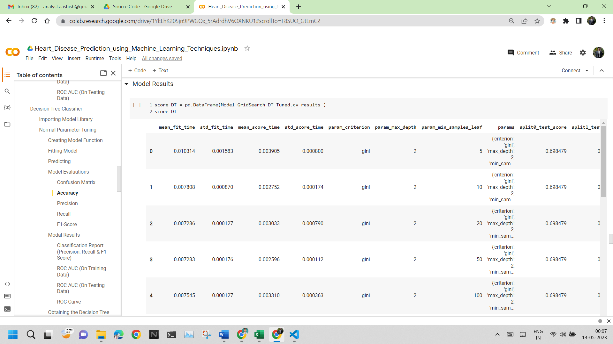

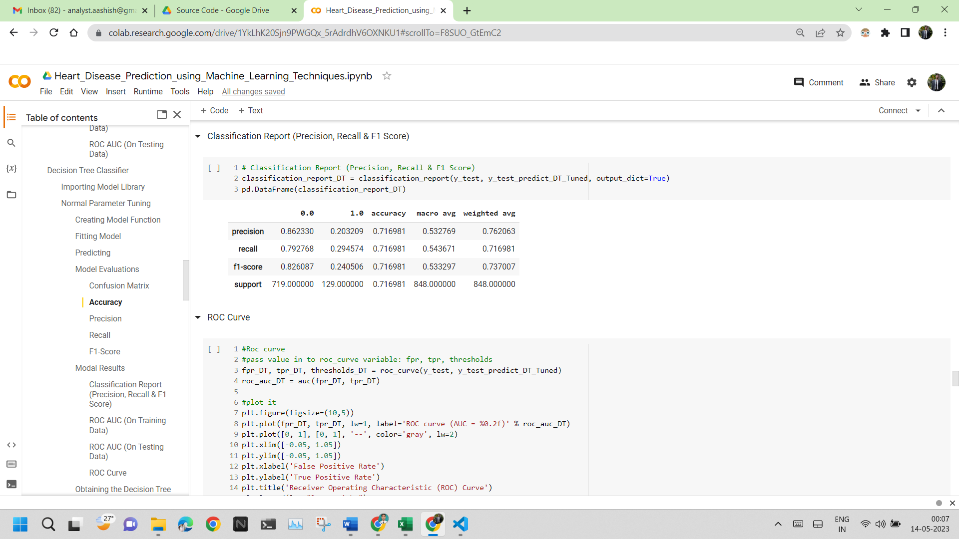

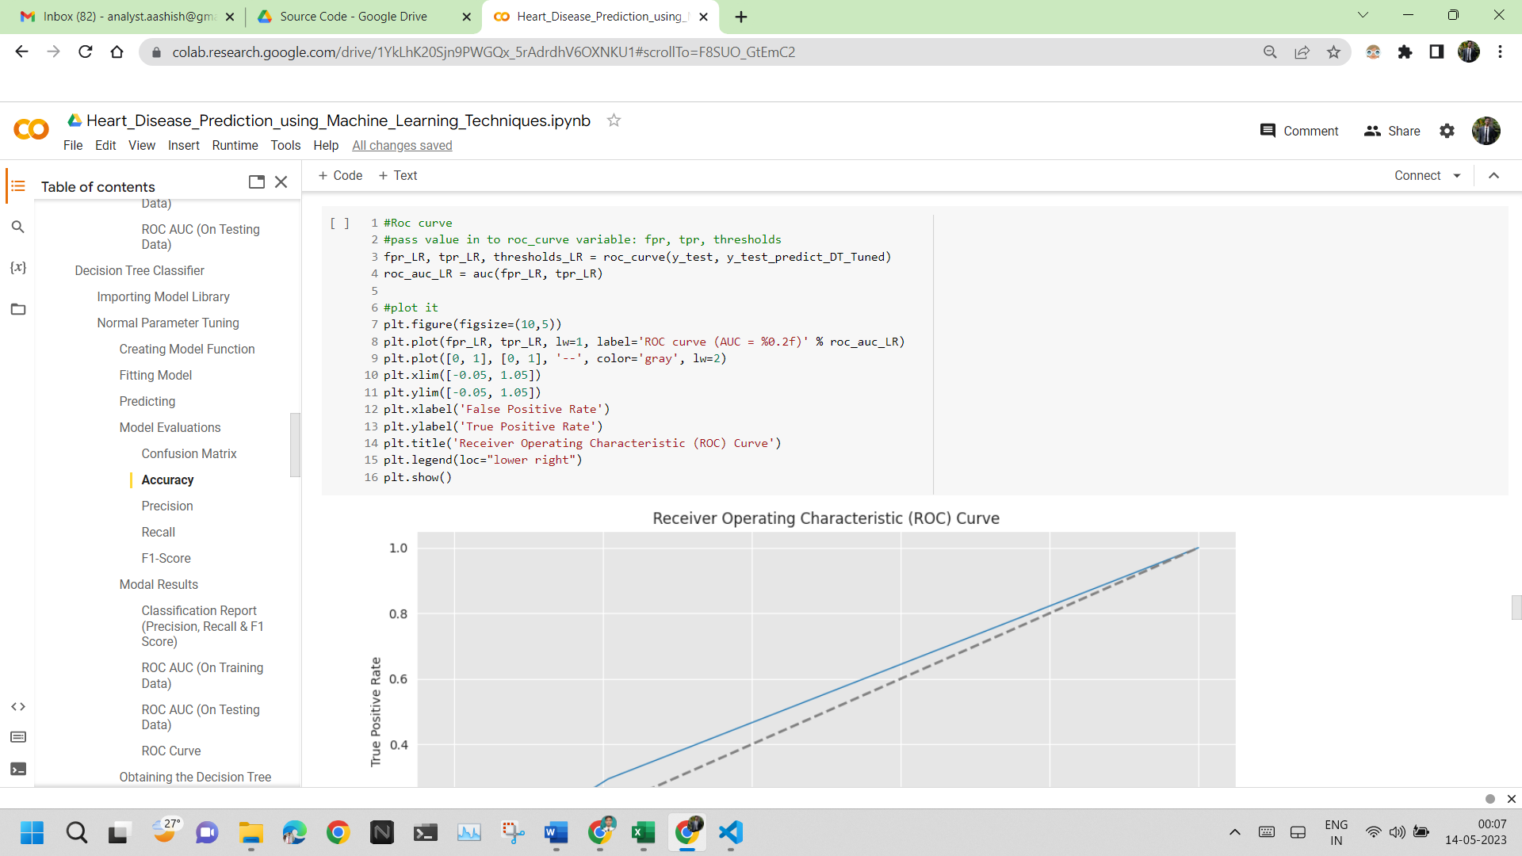

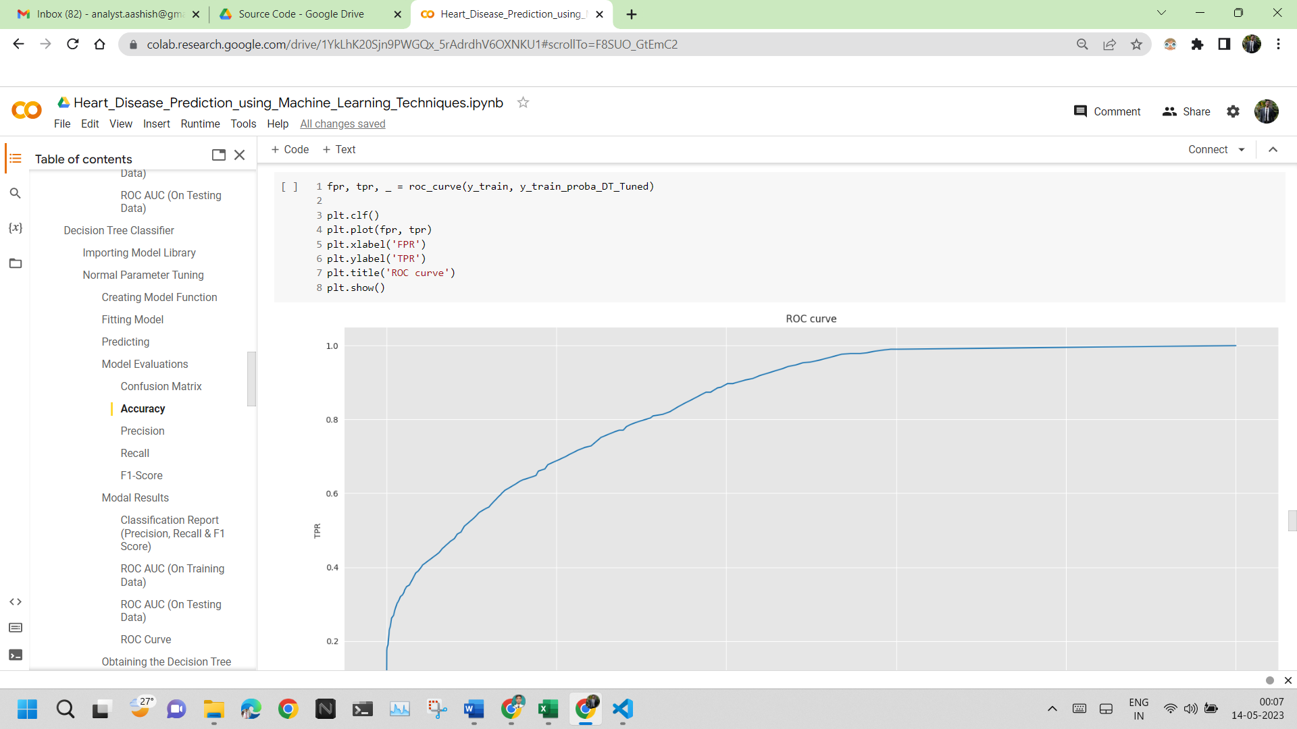

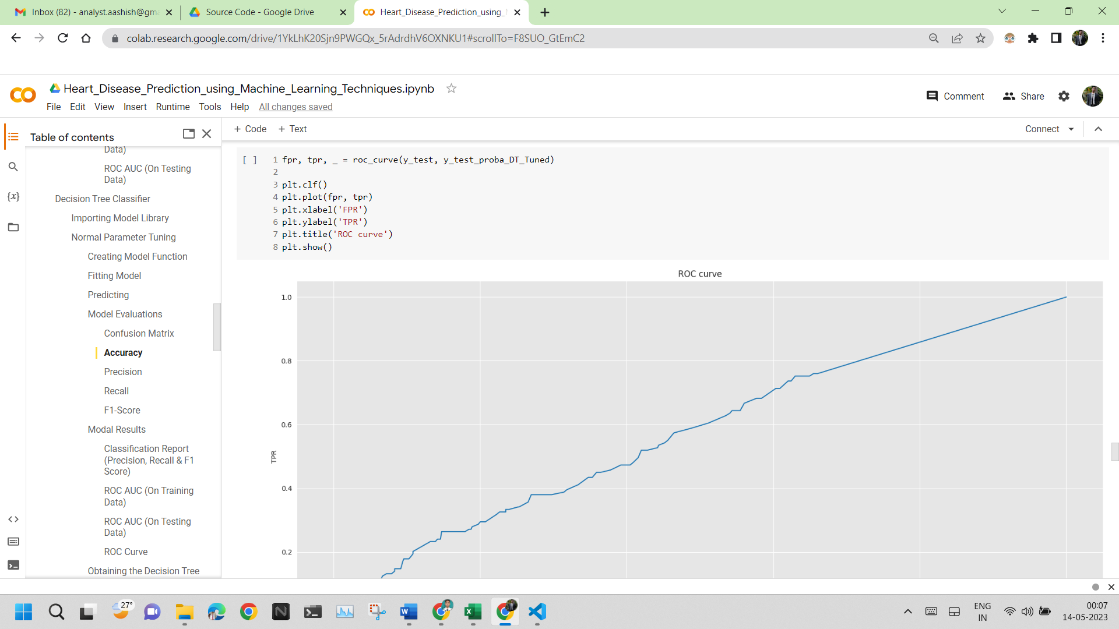

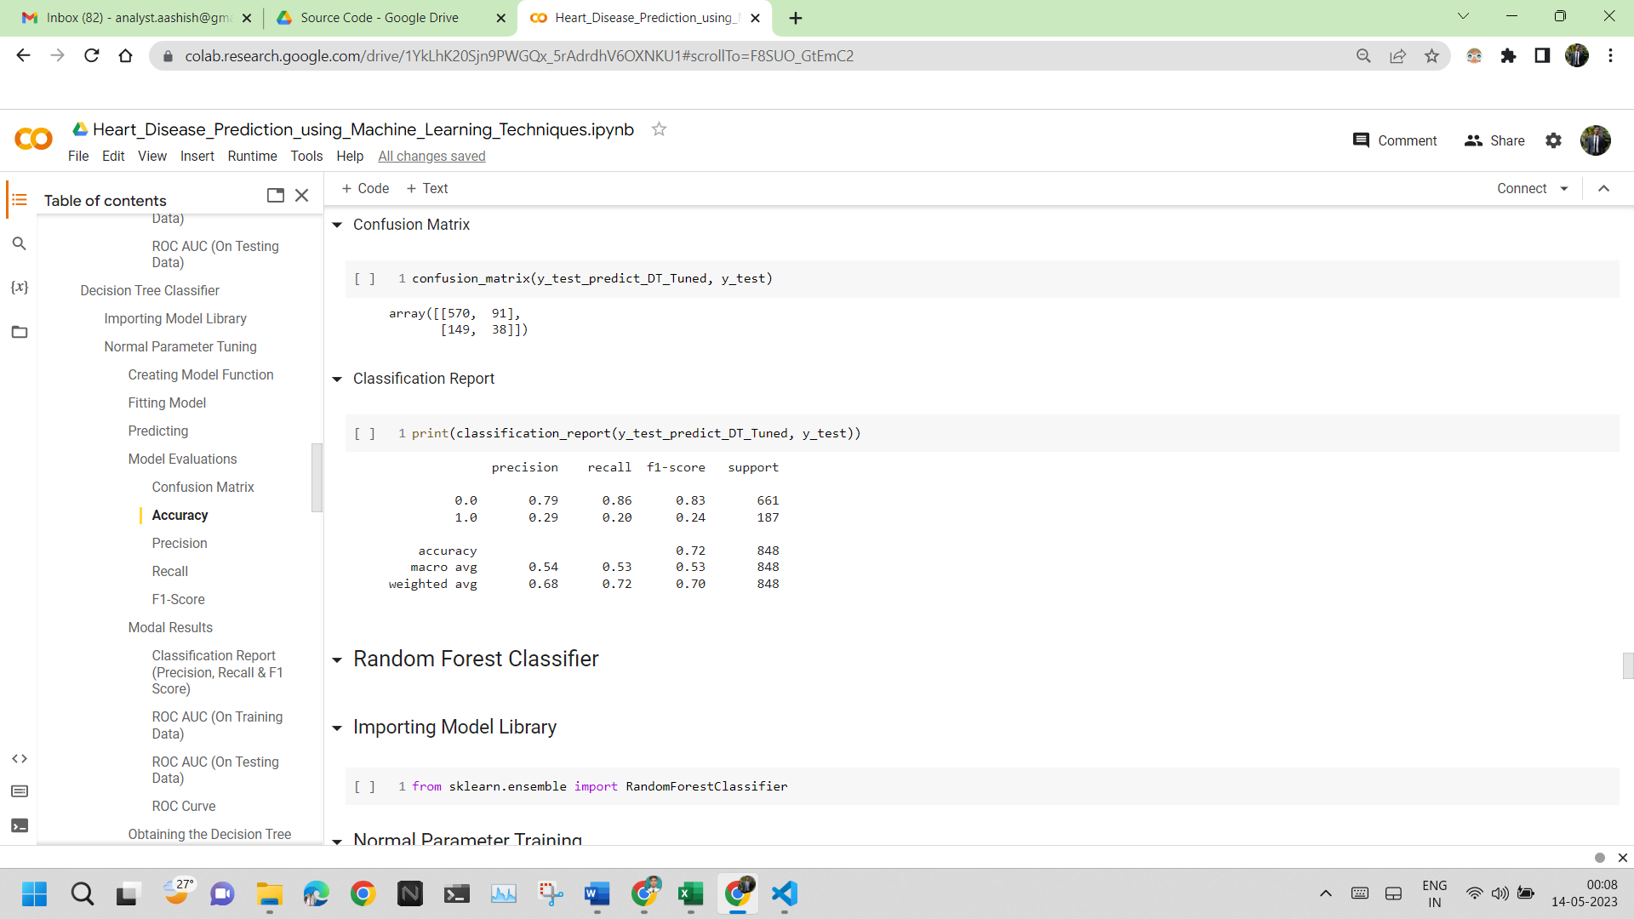

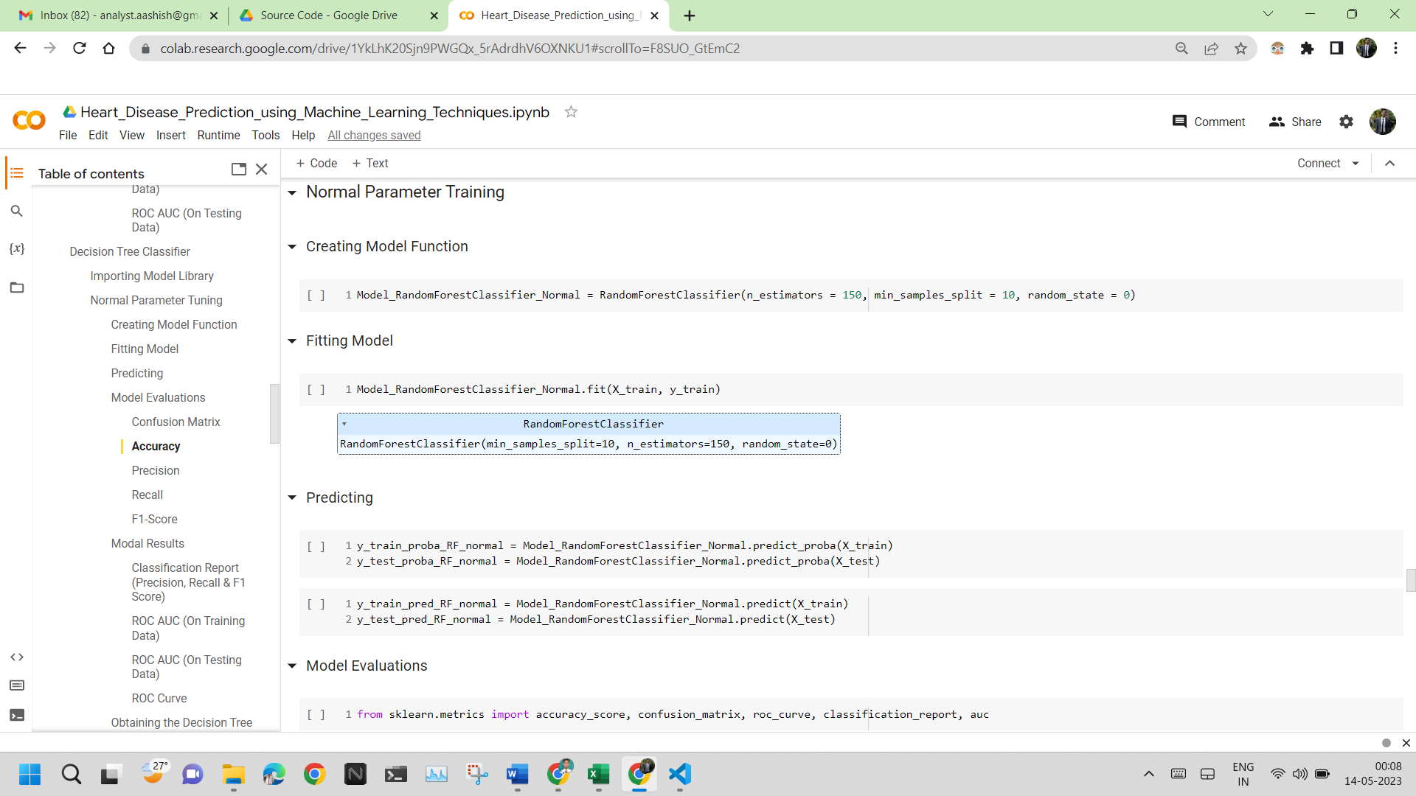

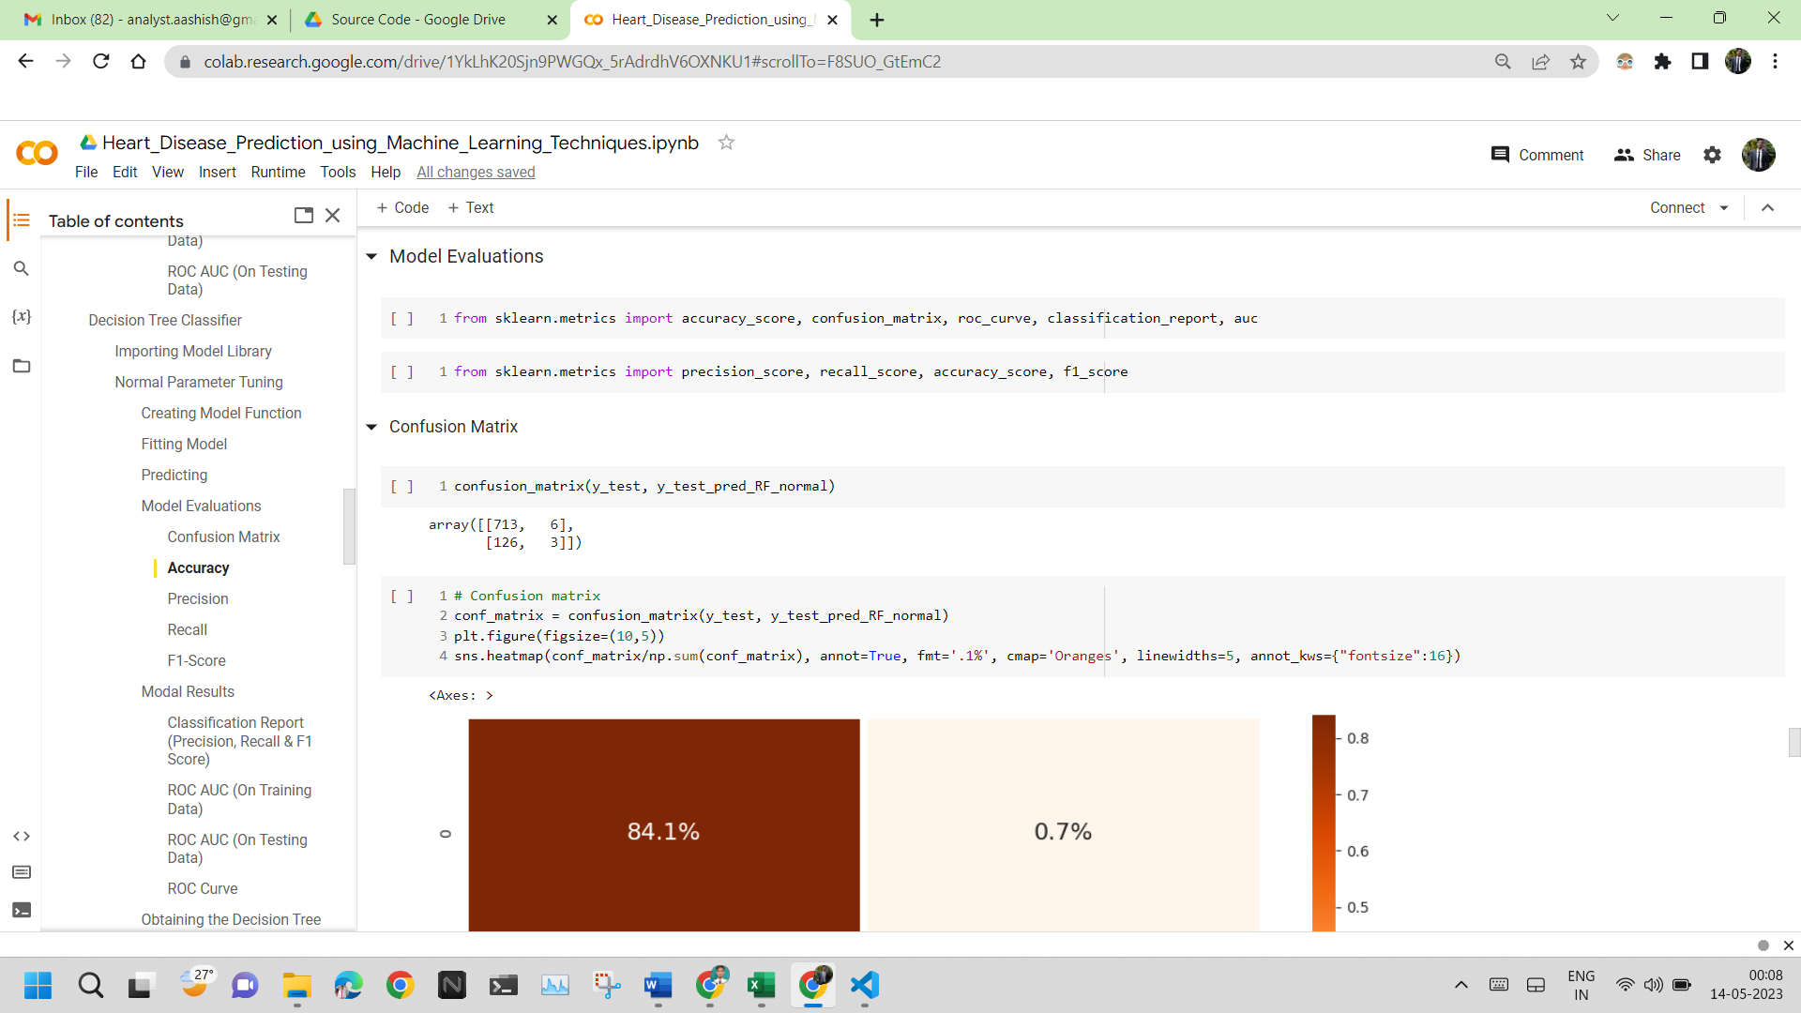

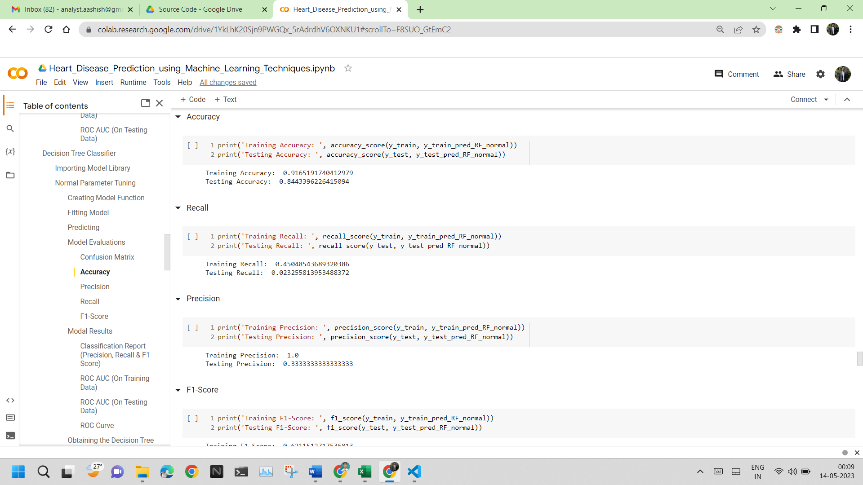

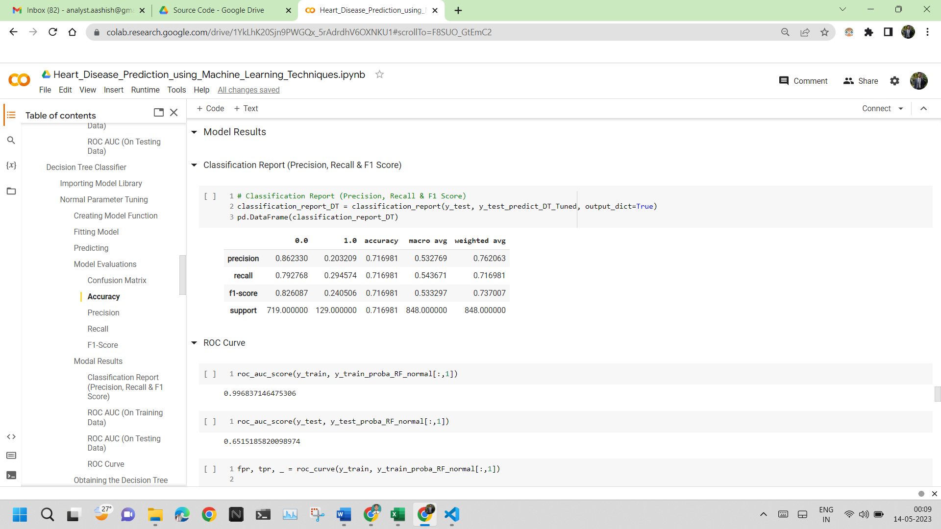

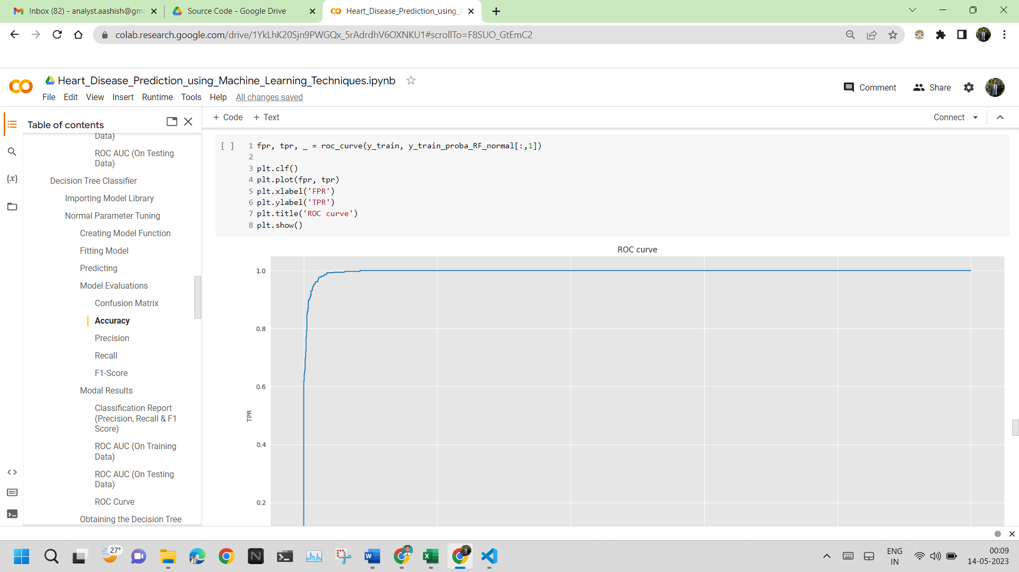

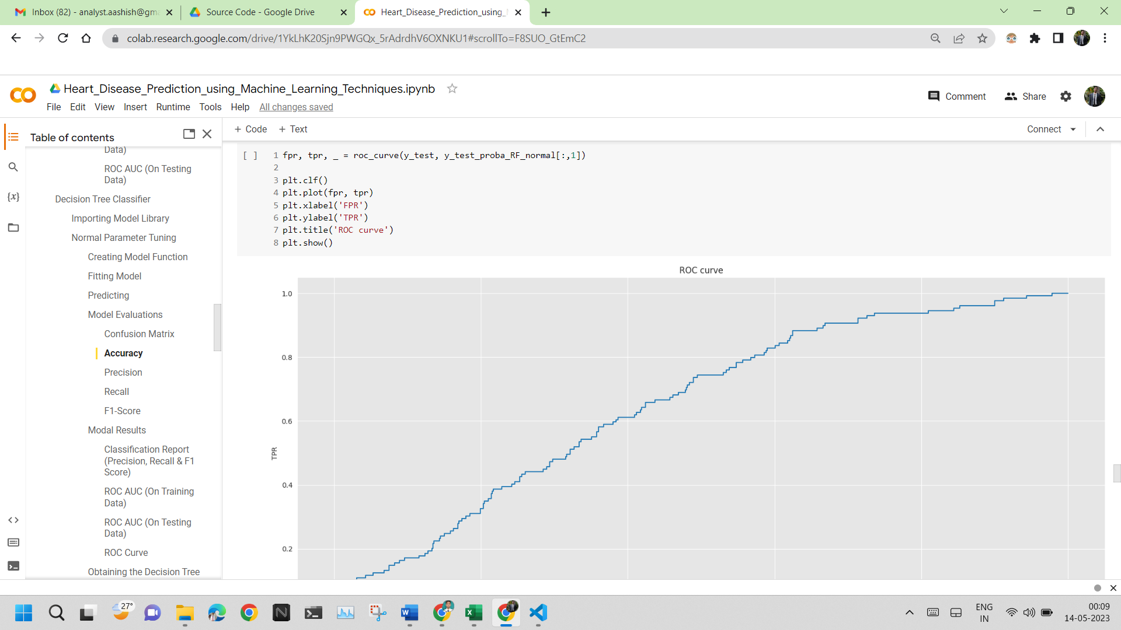

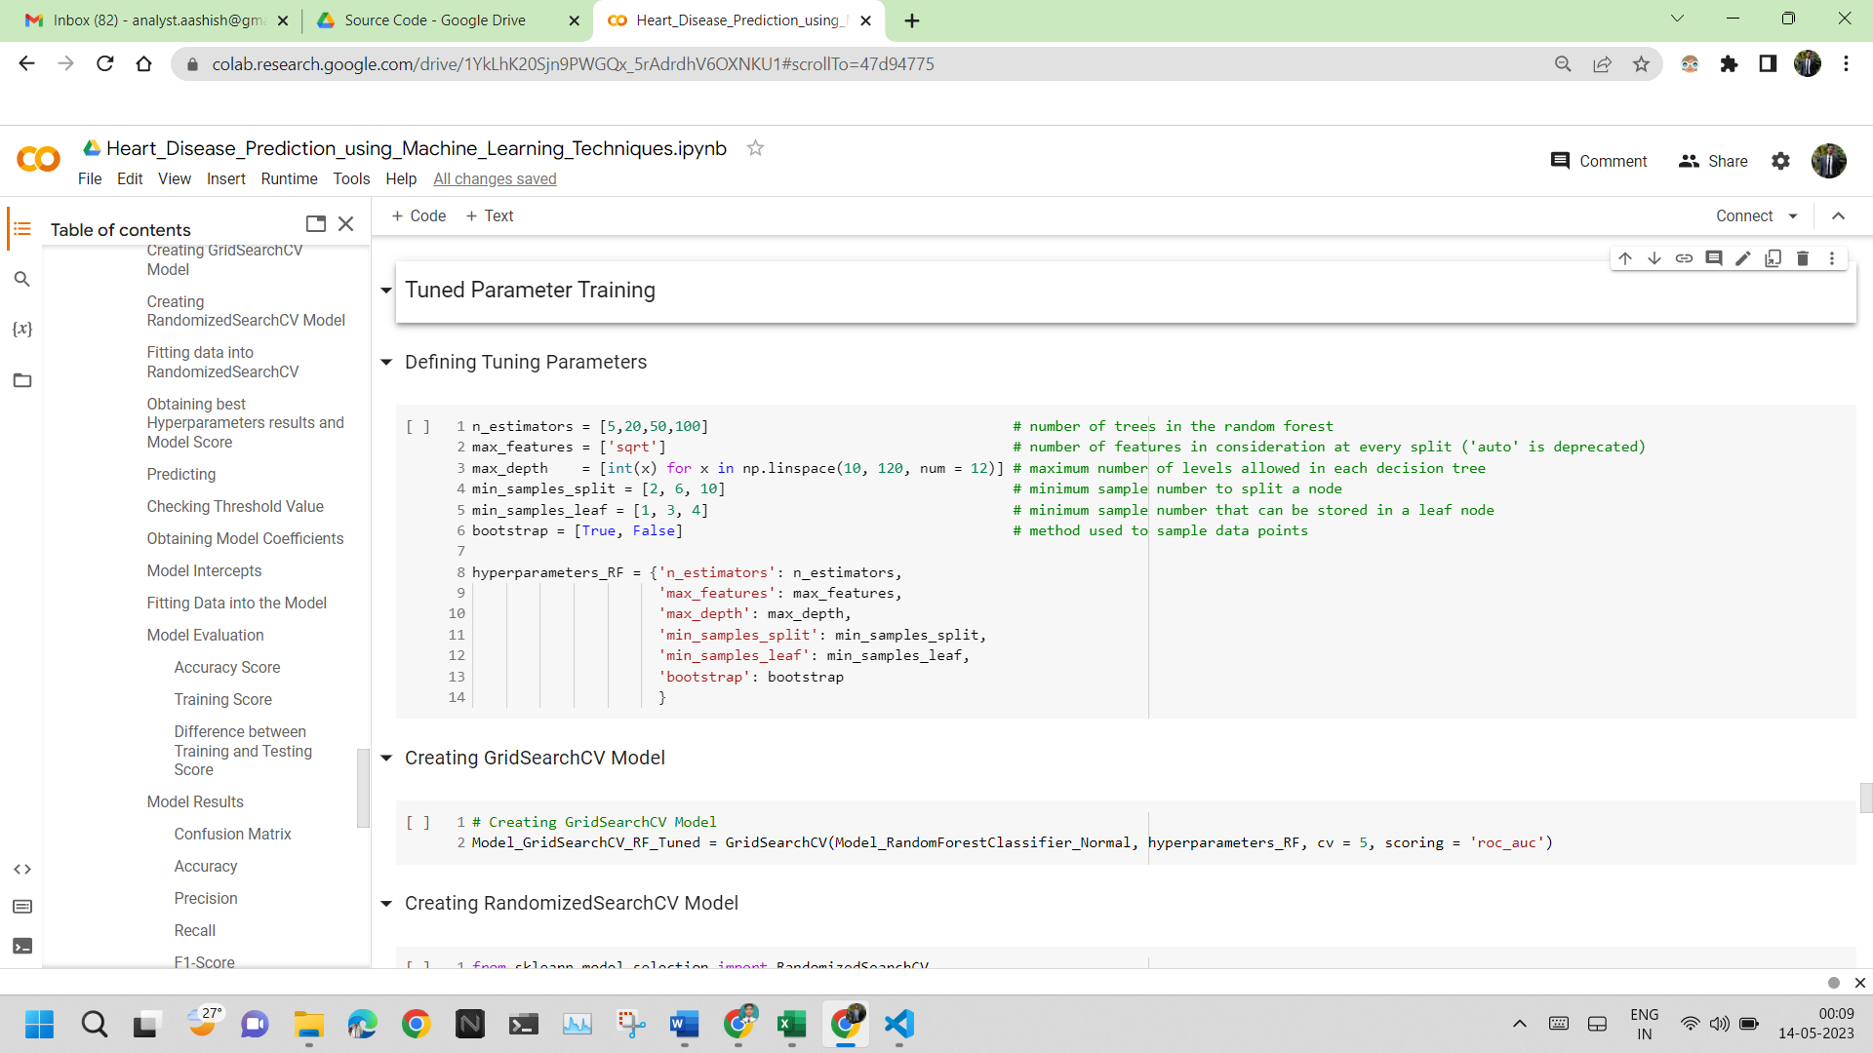

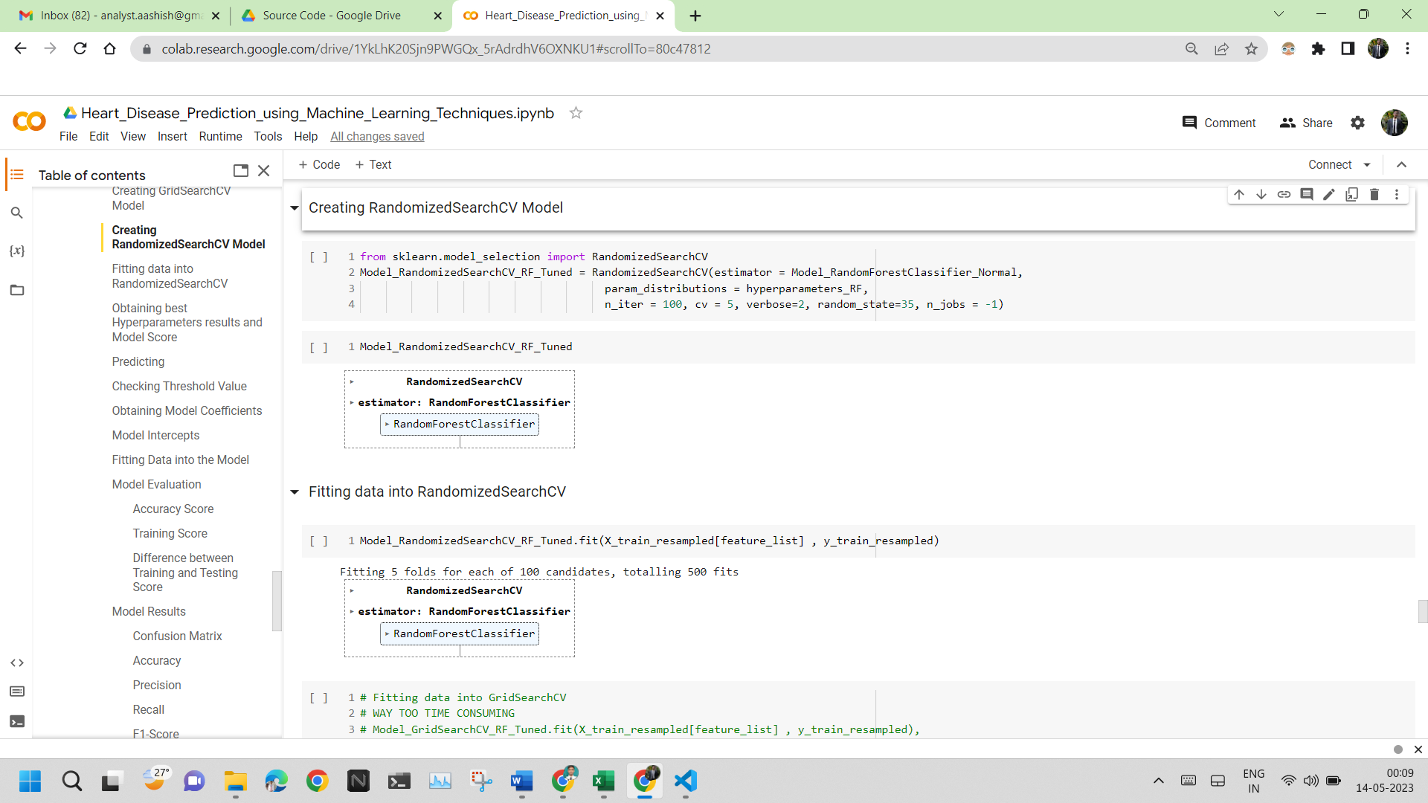

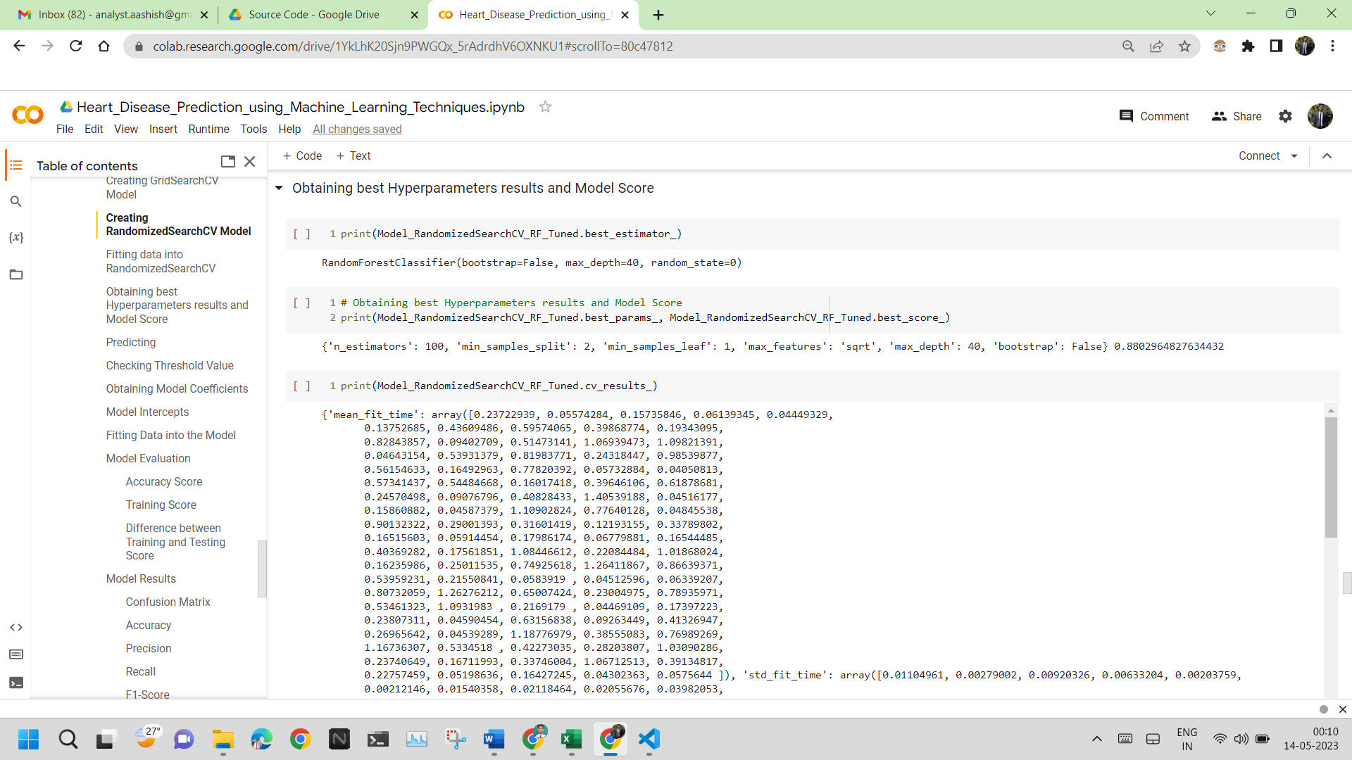

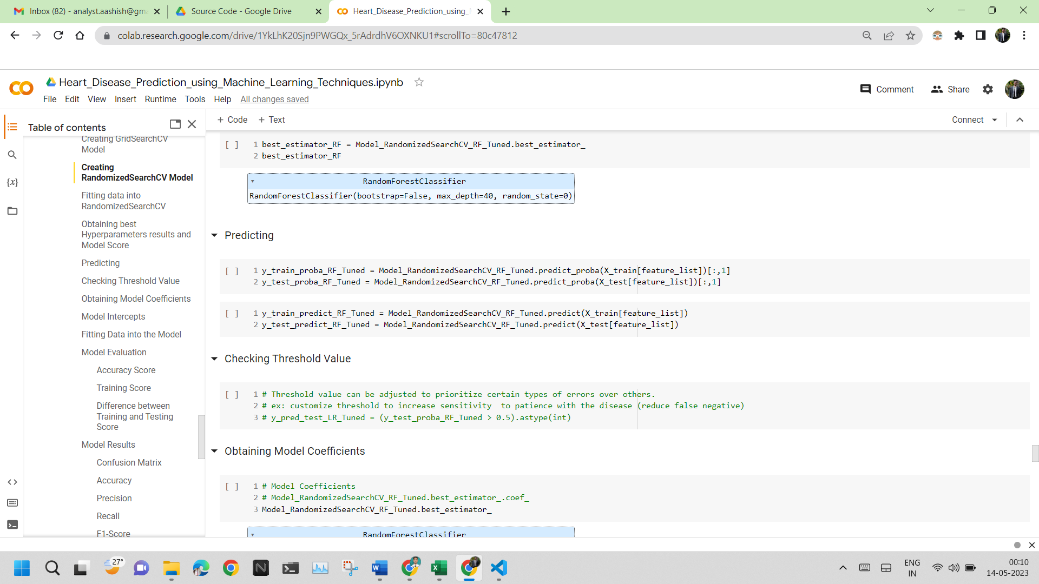

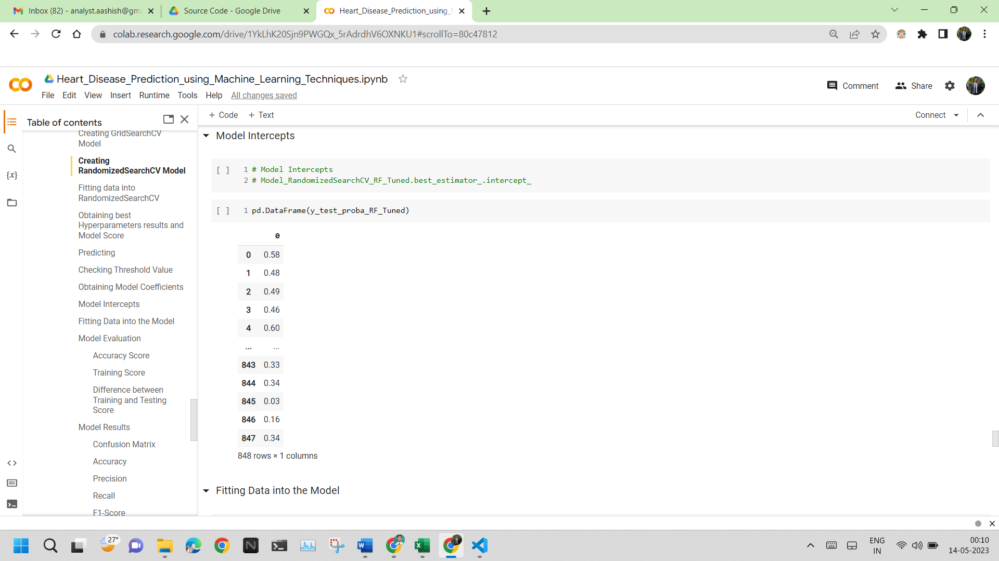

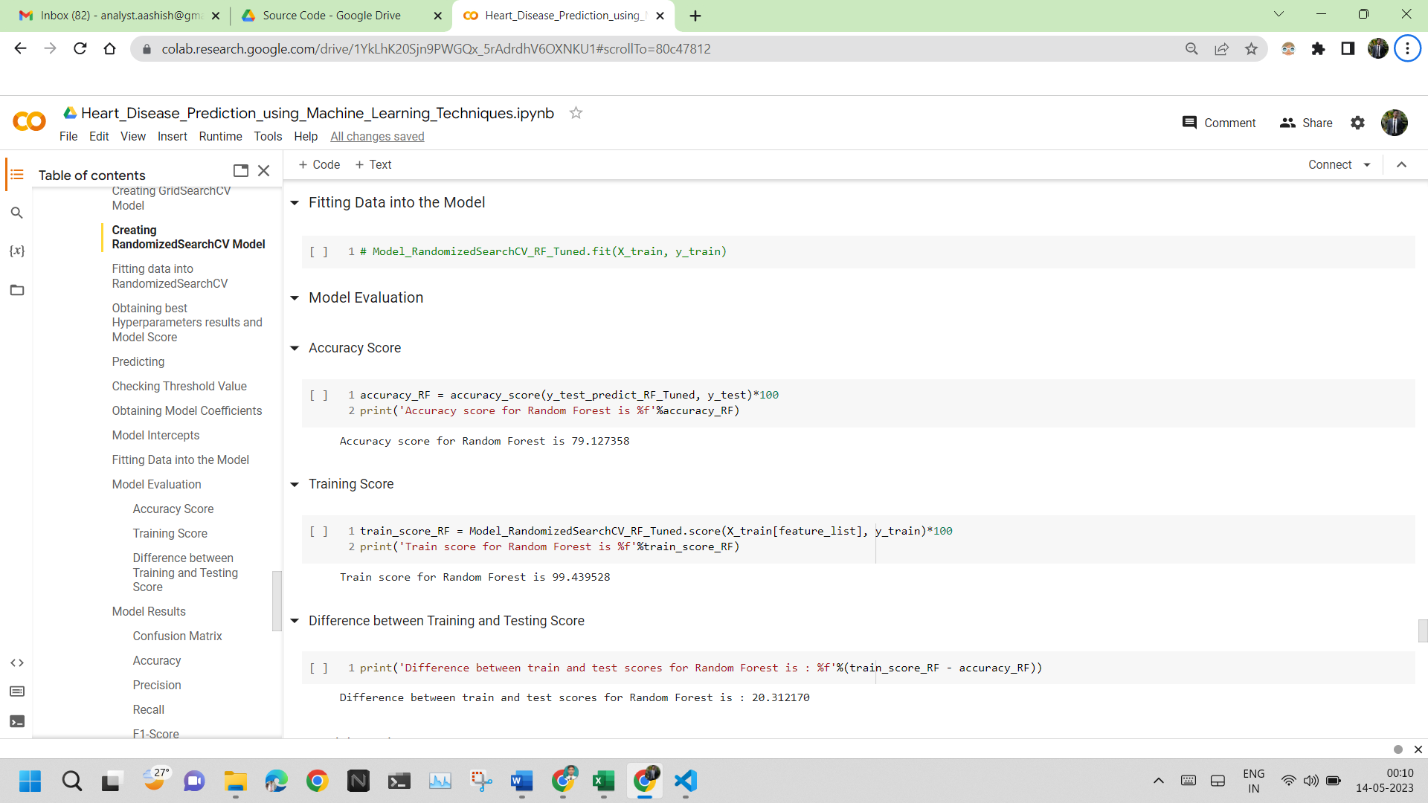

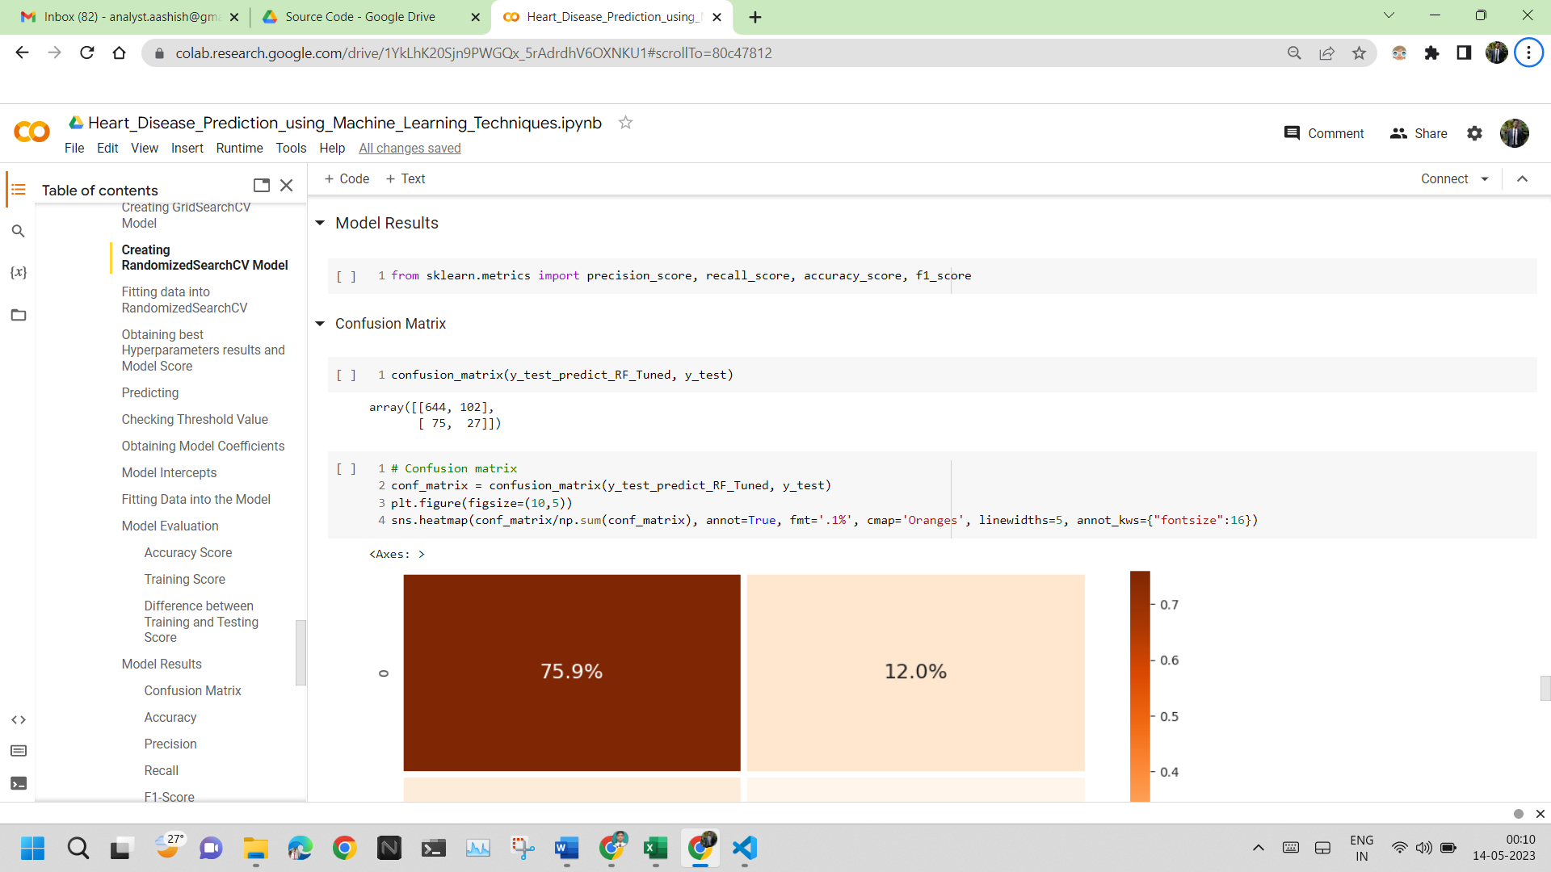

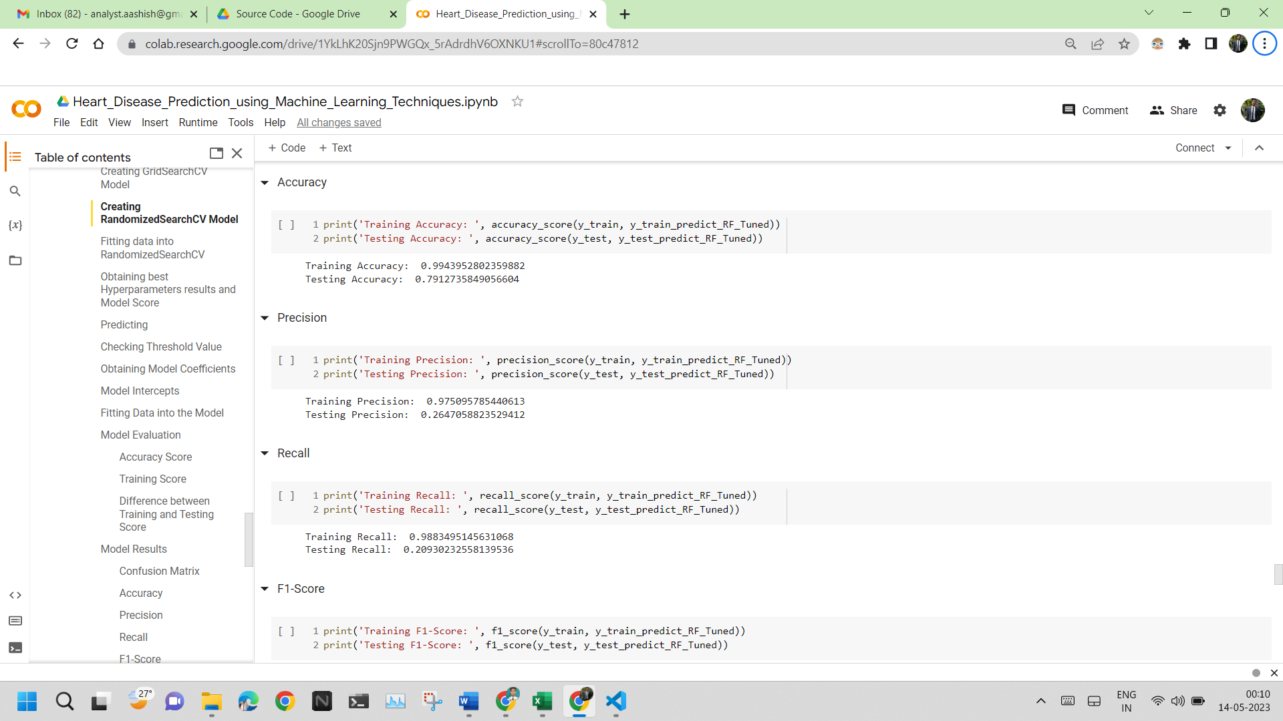

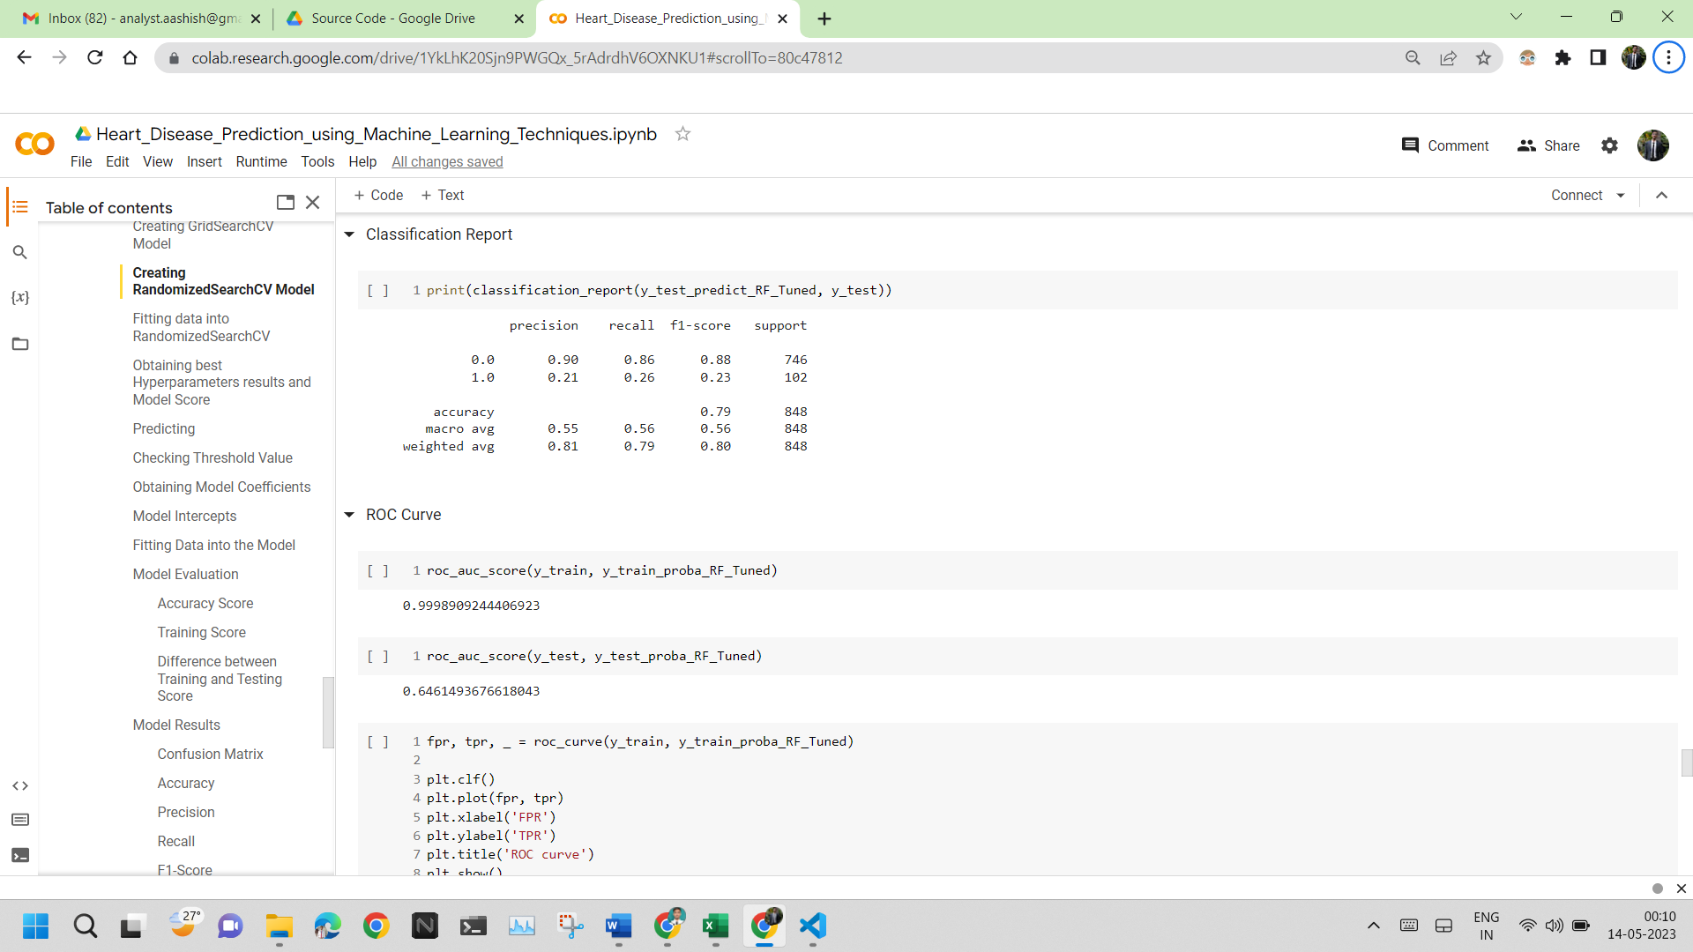

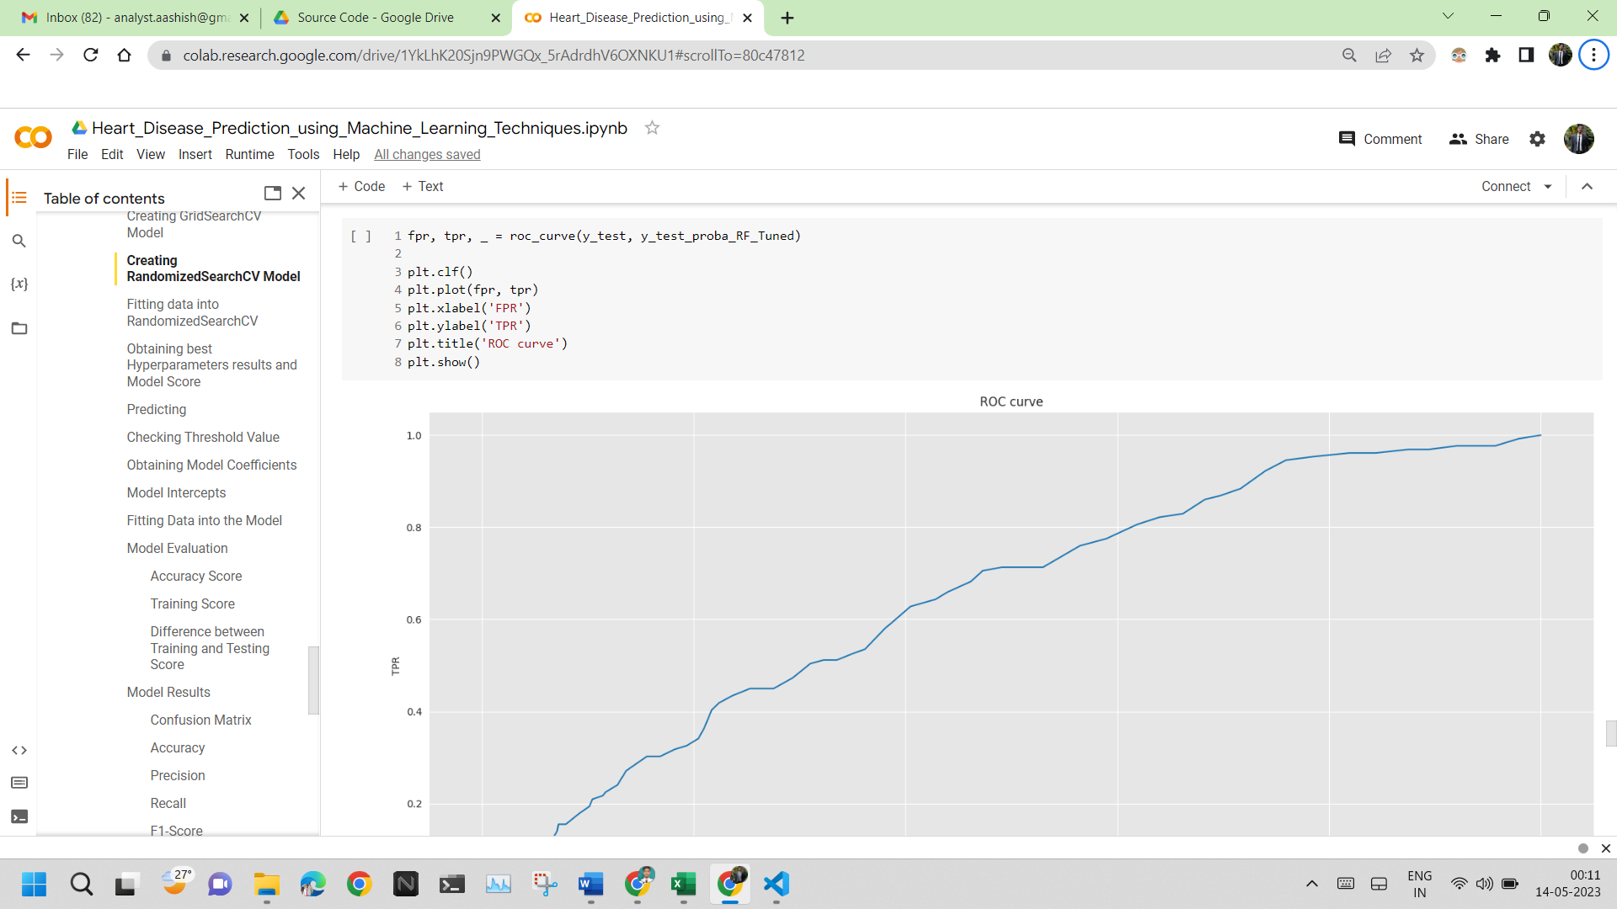

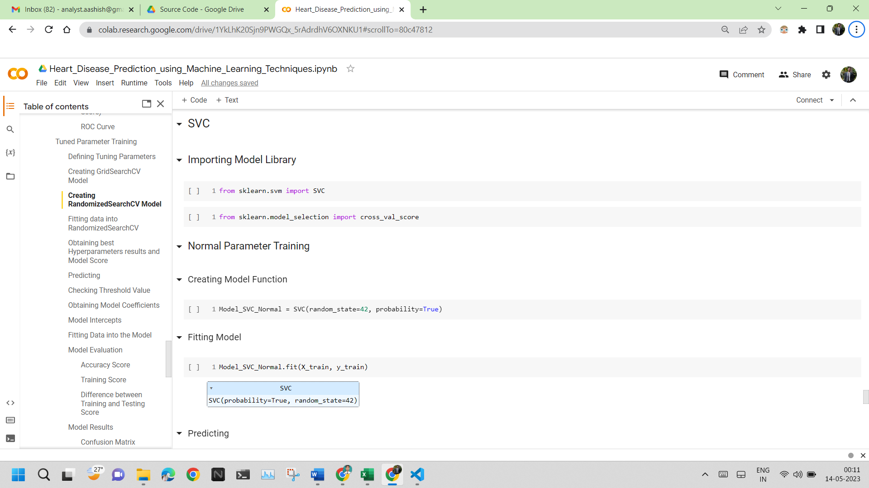

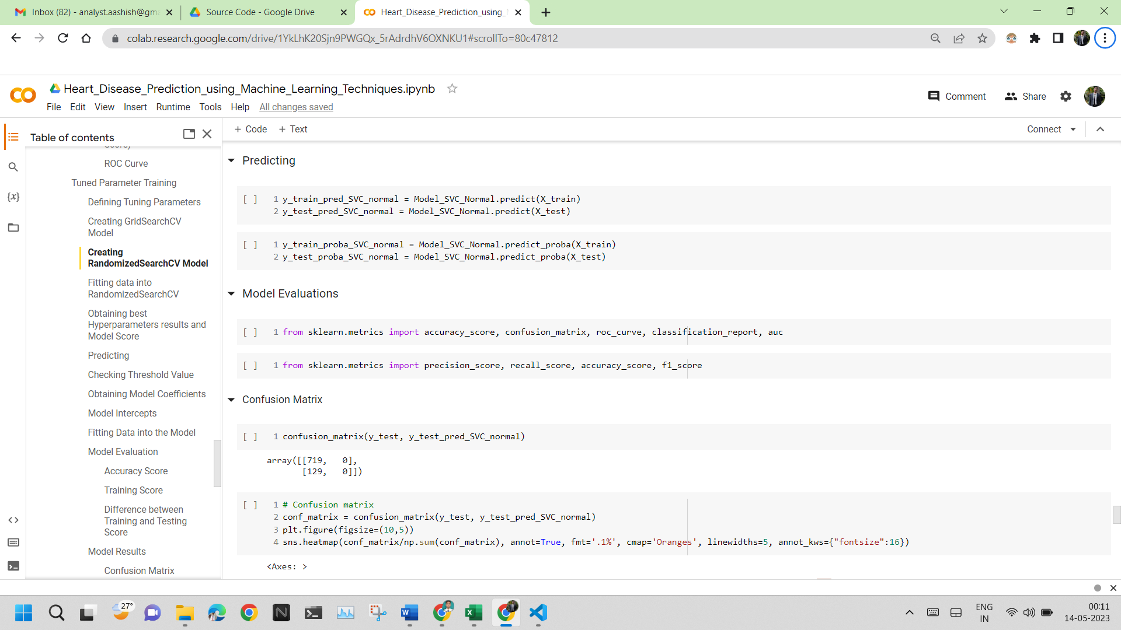

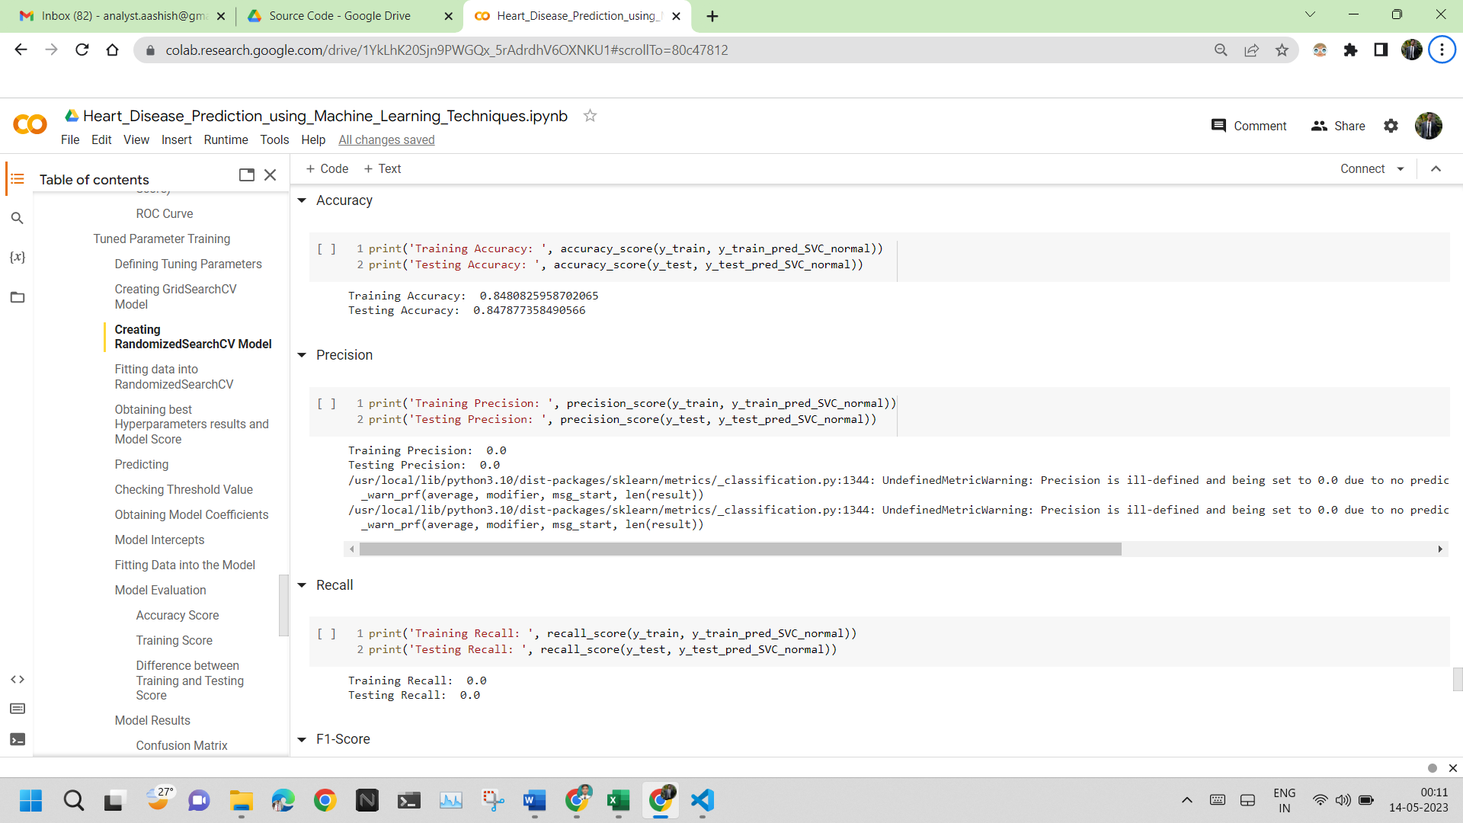

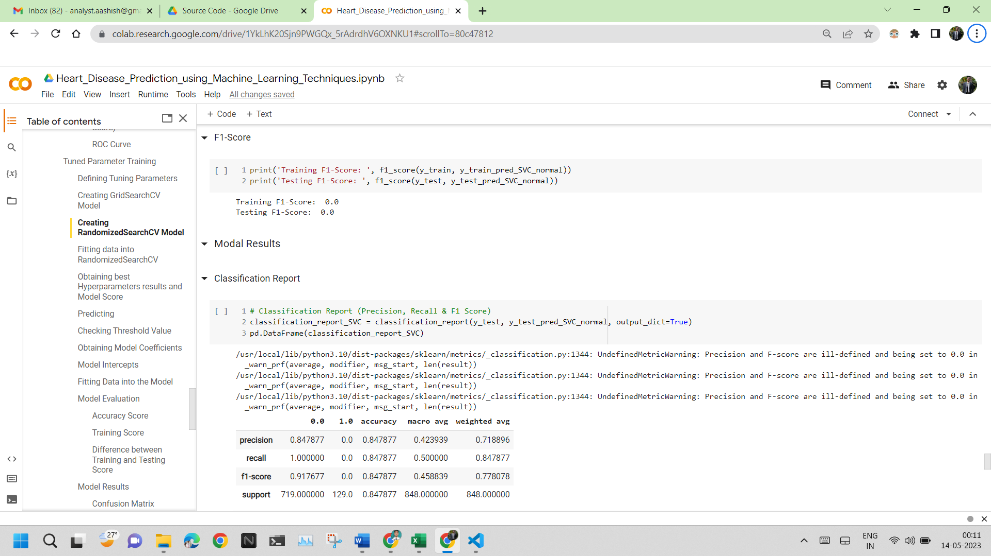

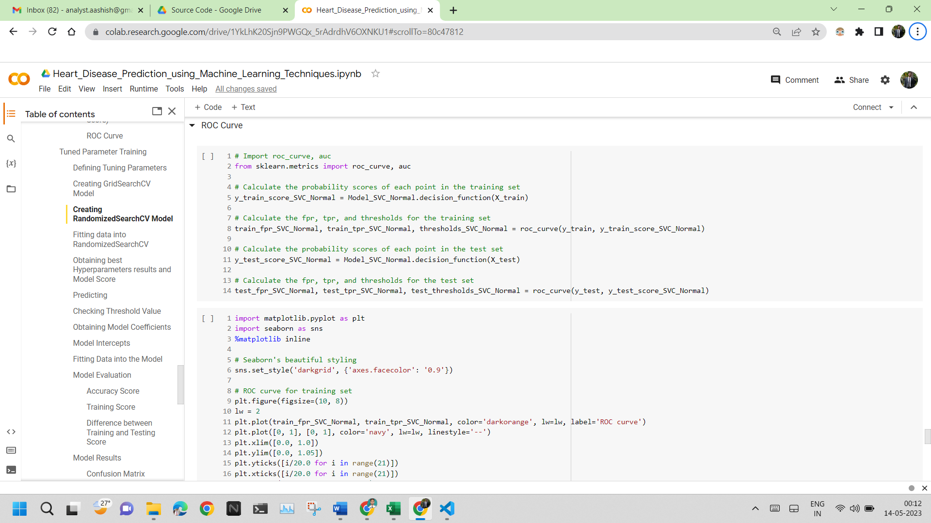

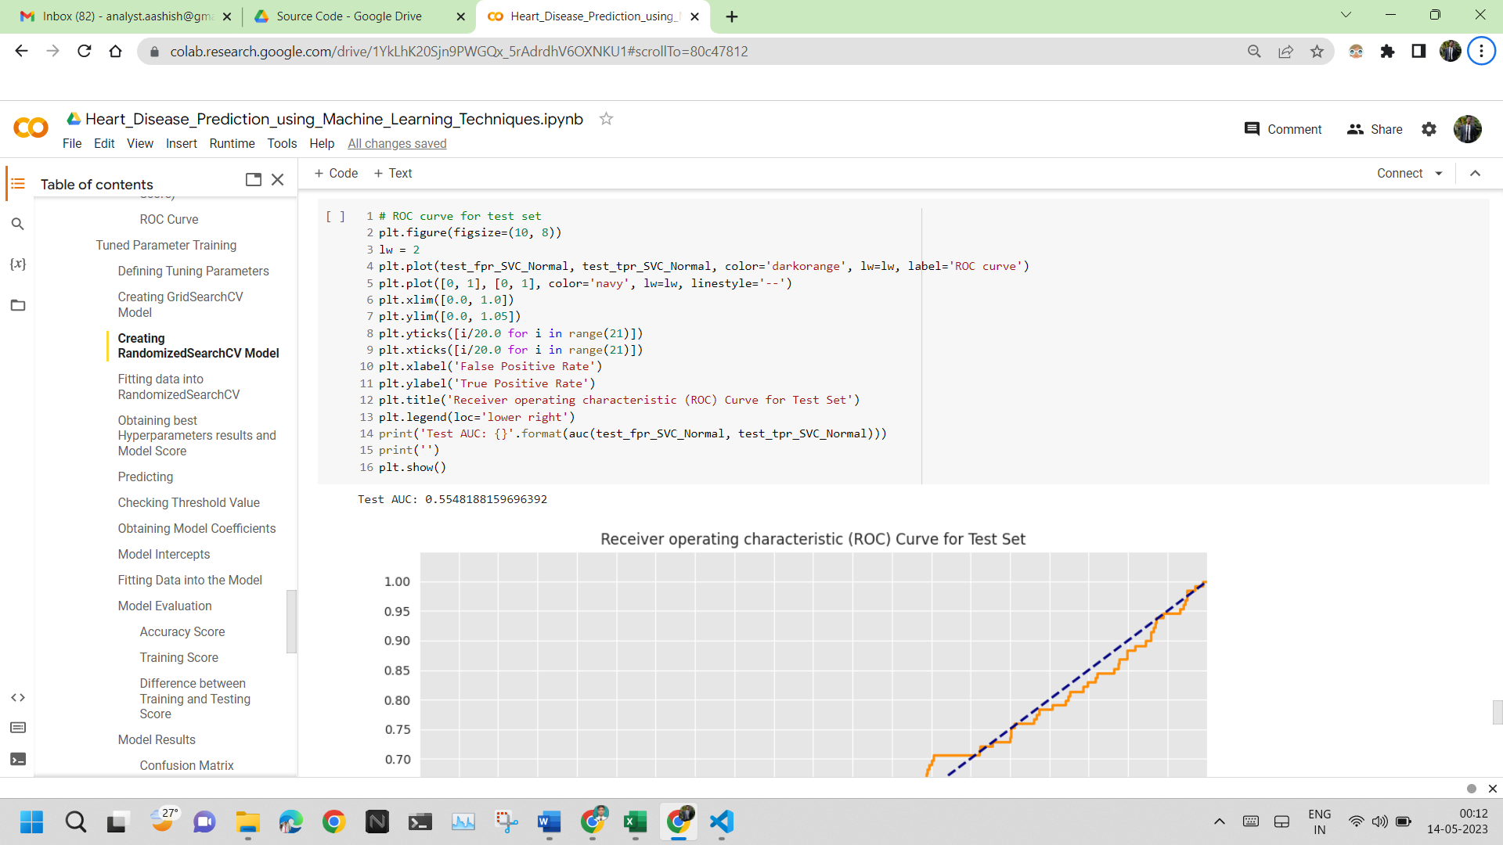

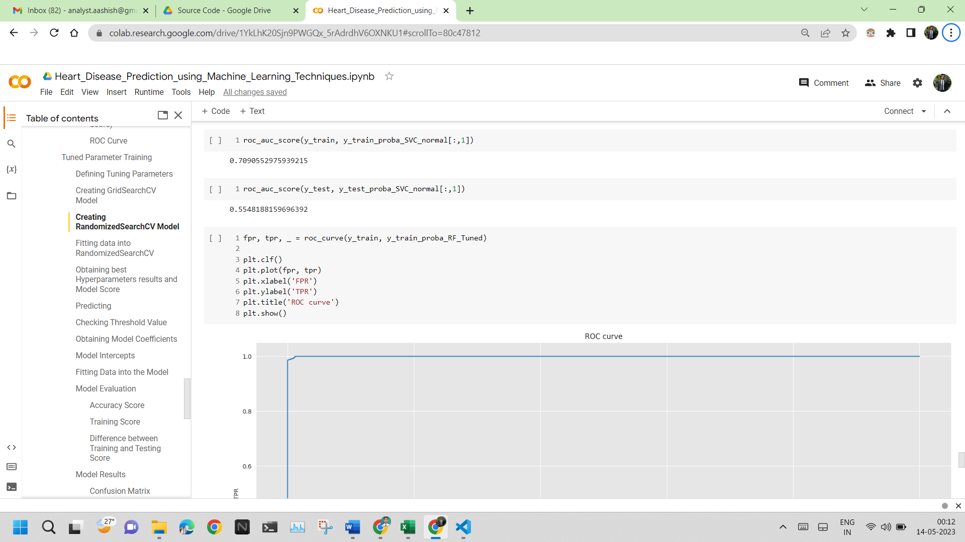

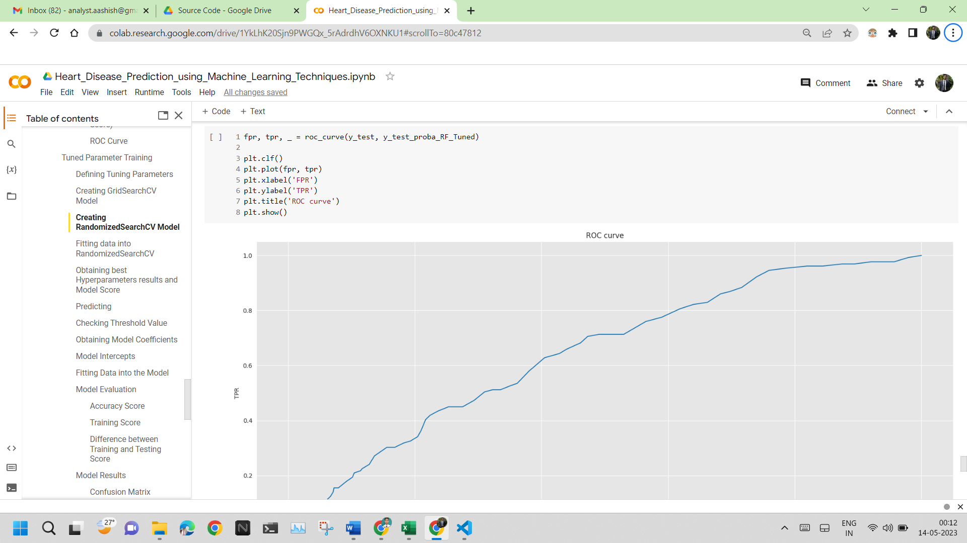

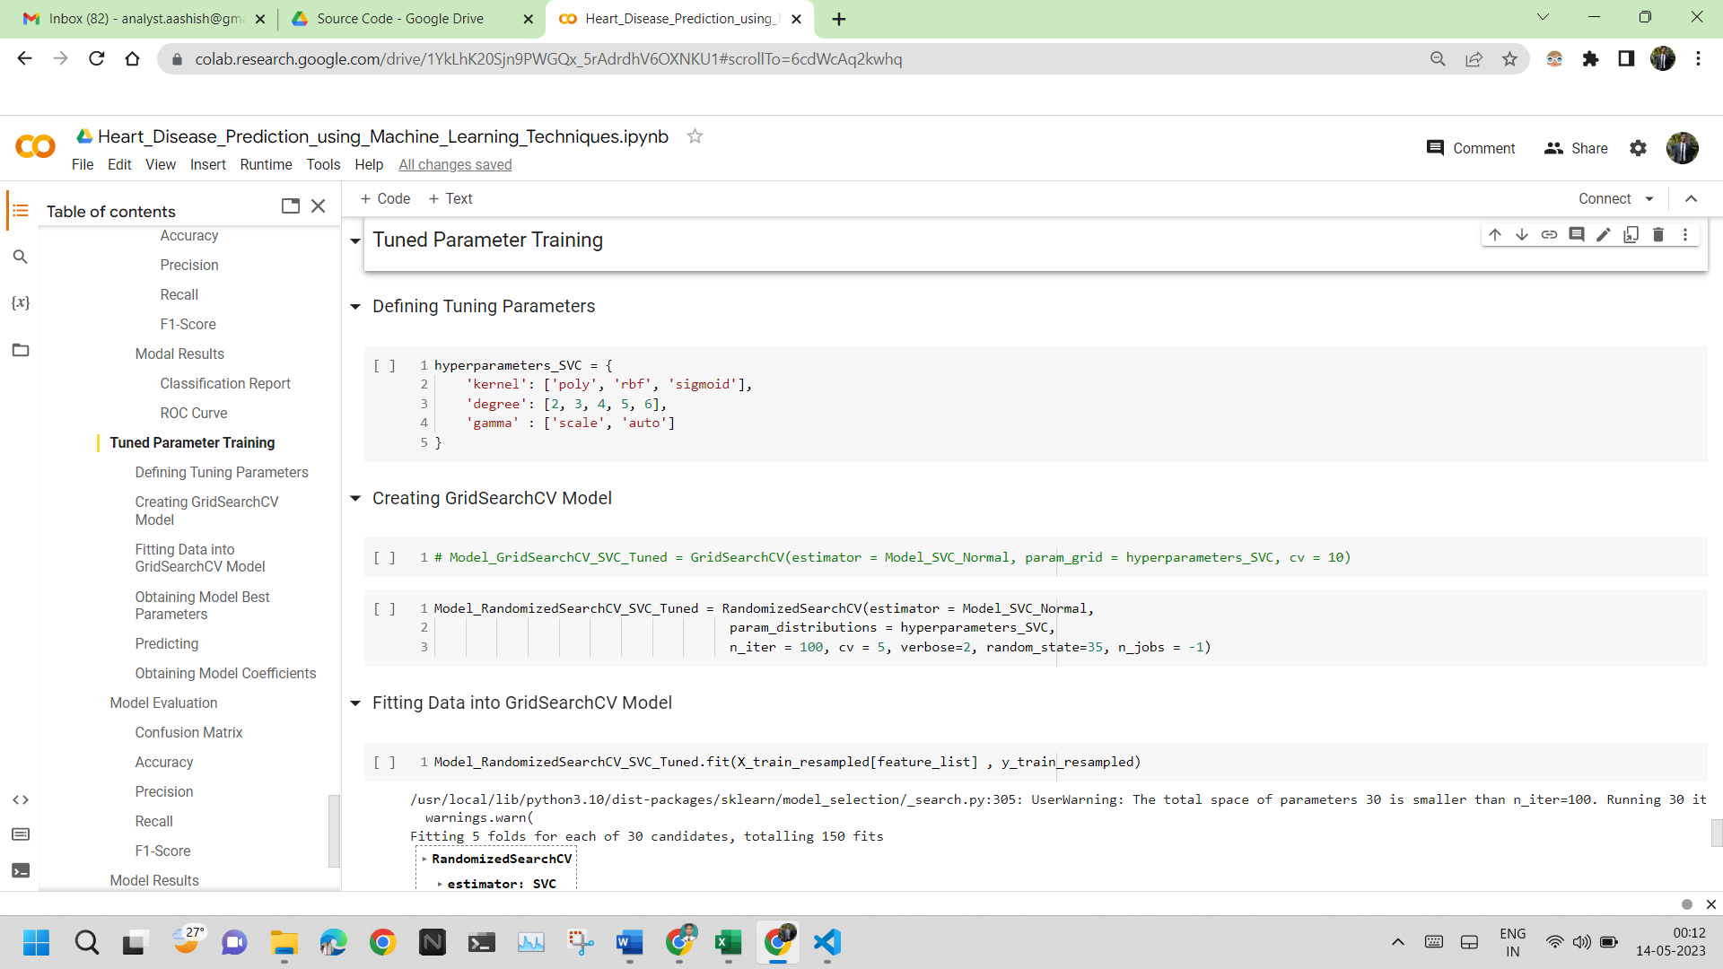

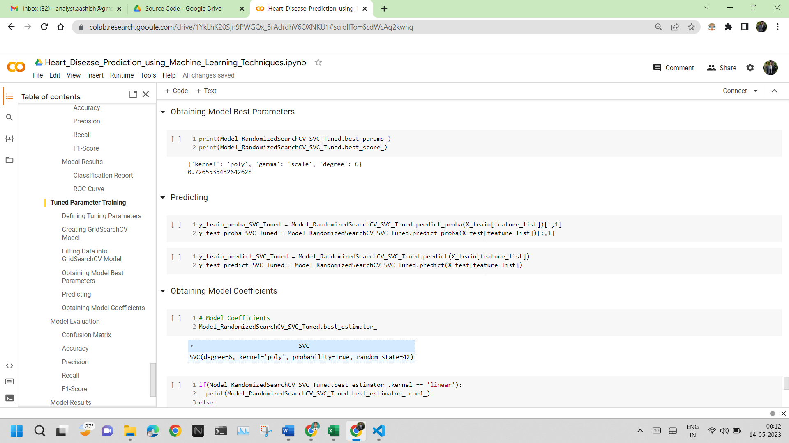

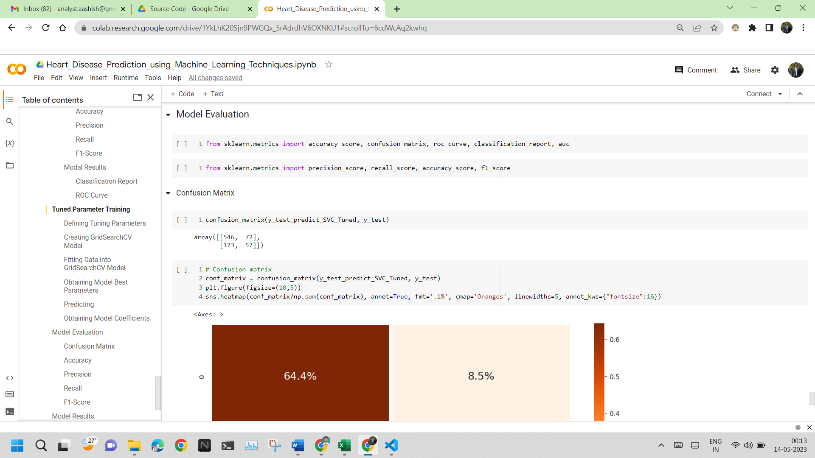

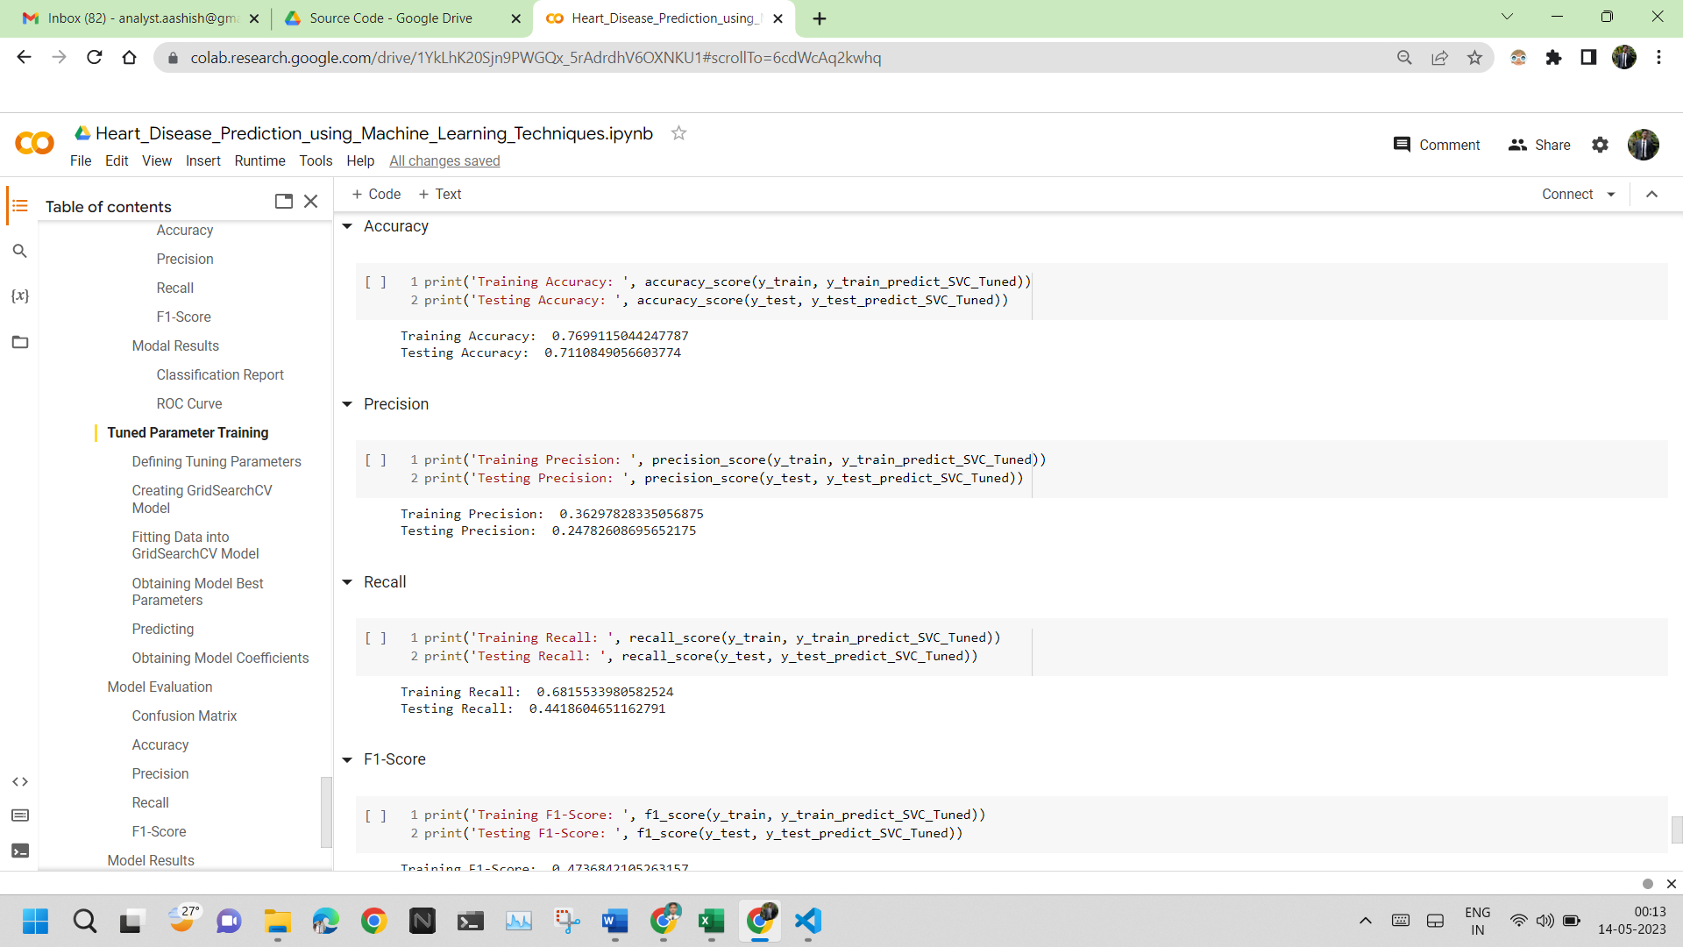

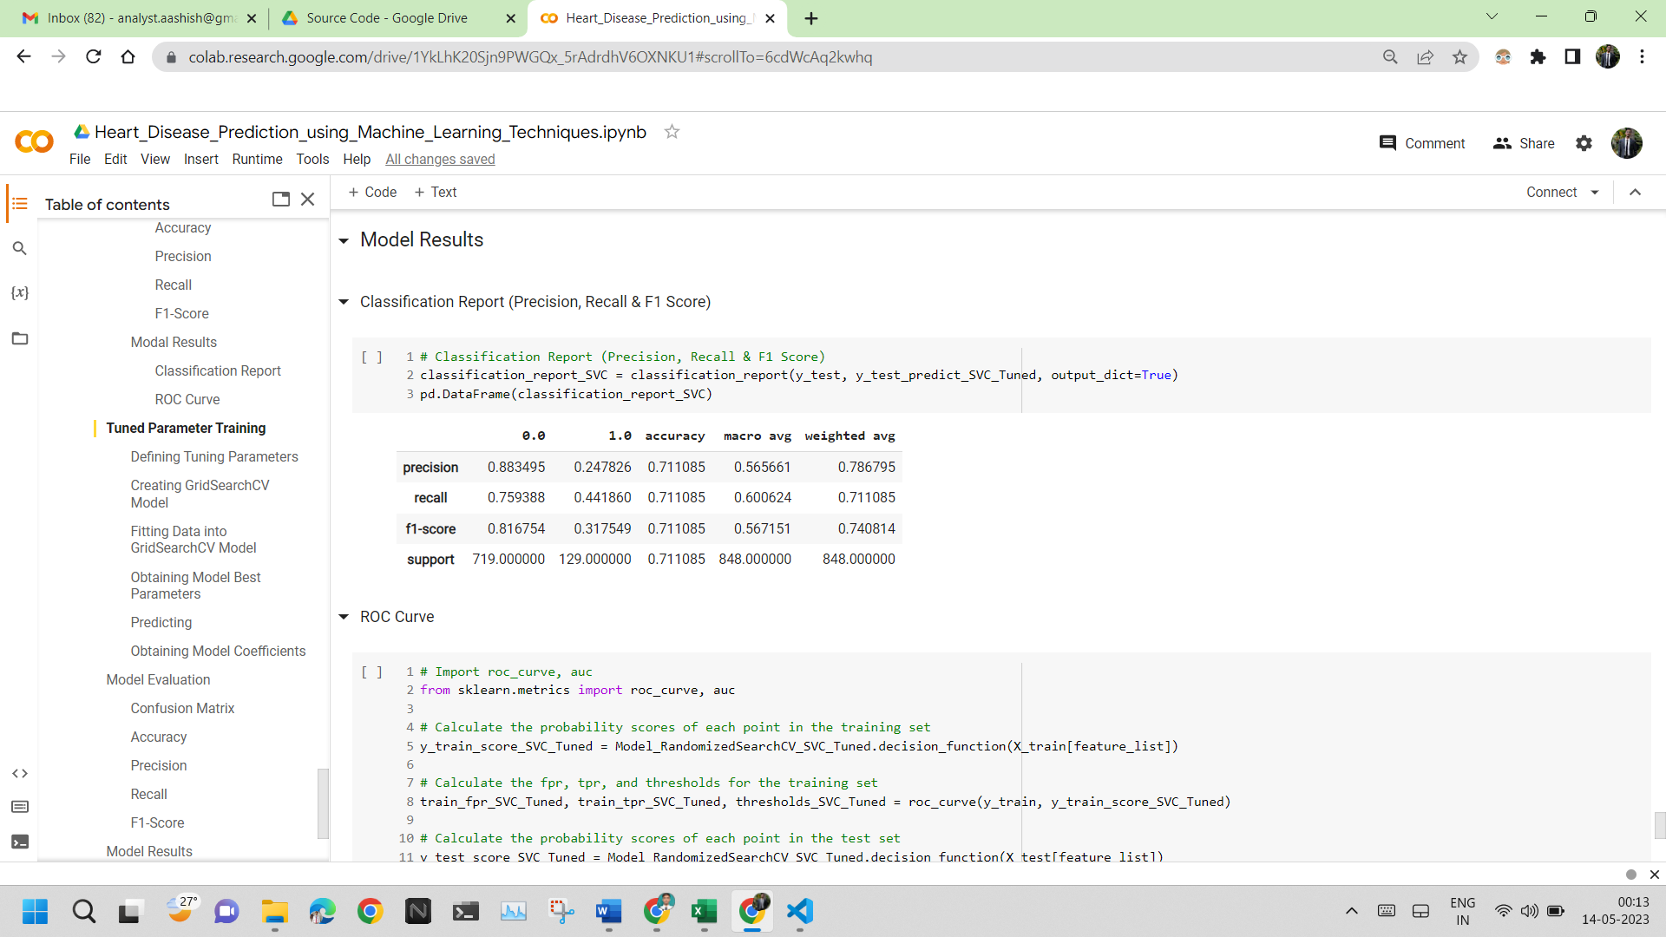

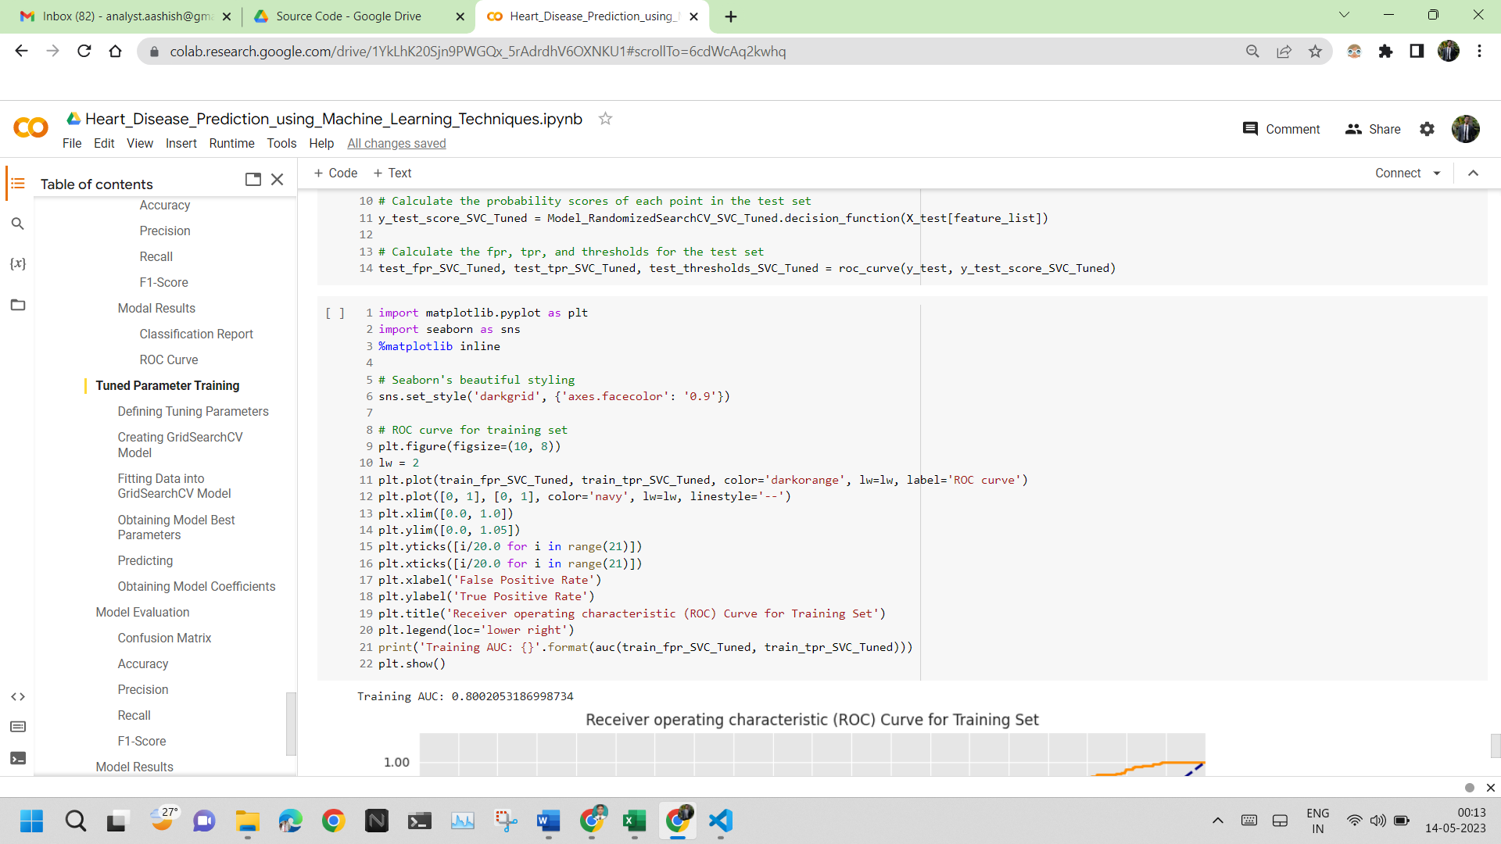

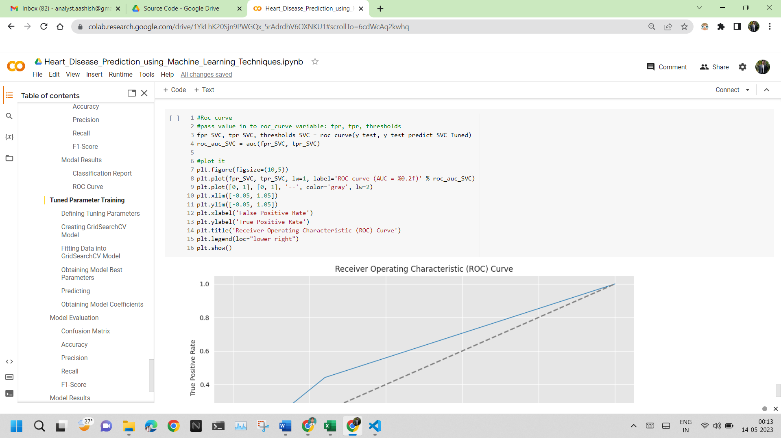

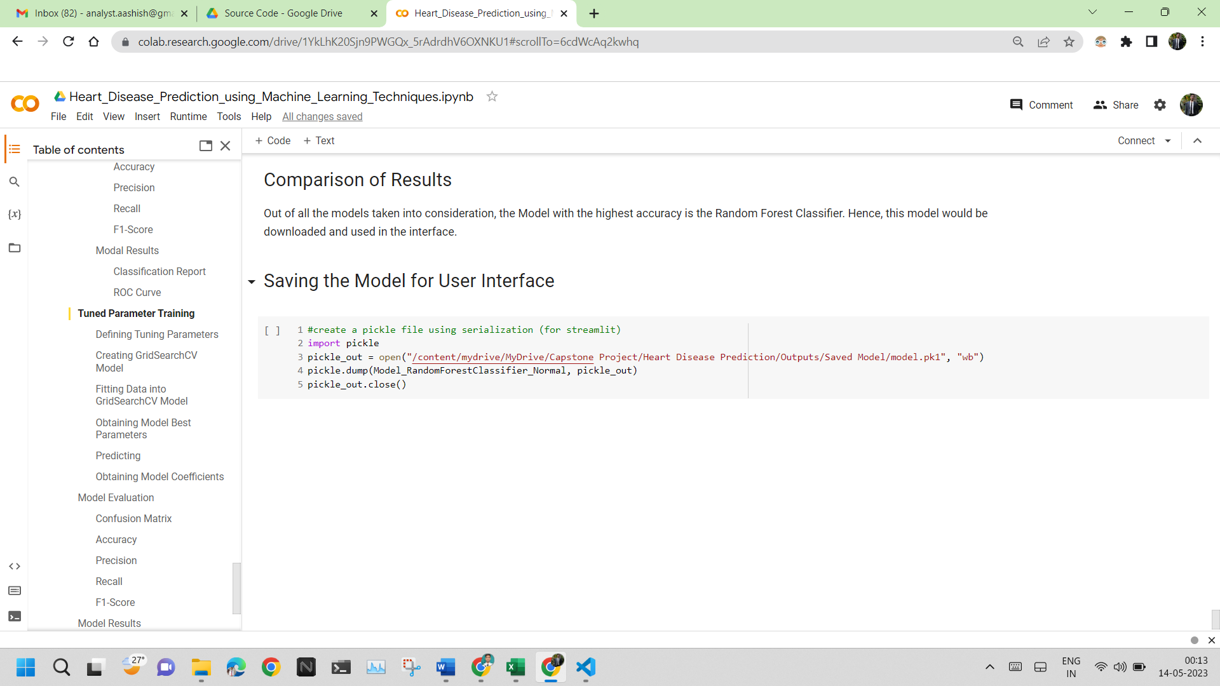

The source code for the User Interface is:

6.5 OUTPUT

The outputs obtained after executing the source code for the Machine Learning Model are:

The outputs obtained after executing the source code for the User Interface are:

**Chapter 7**

**Results**

7.1 RESULTS AND OUTCOMES

7.2 RESULT ANALYSIS

**Conclusions**

**Future Works**

**References**

[1]: Katari, S., Likith, T., Sree, M. P. S., & Rachapudi, V. (2023). Heart Disease Prediction using Hybrid ML Algorithms. 2023 International Conference on Sustainable Computing and Data Communication Systems (ICSCDS), Sustainable Computing and Data Communication Systems (ICSCDS), 2023 International Conference On, 121–125. <https://doi-org.egateway.vit.ac.in/10.1109/ICSCDS56580.2023.10104609>

[2]: Shaik, M. A., Sreeja, R., Zainab, S., Sowmya, P. S., Akshay, T., & Sindhu, S. (2023). Improving Accuracy of Heart Disease Prediction through Machine Learning Algorithms. 2023 International Conference on Innovative Data Communication Technologies and Application (ICIDCA), Innovative Data Communication Technologies and Application (ICIDCA), 2023 International Conference On, 41–46. <https://doi-org.egateway.vit.ac.in/10.1109/ICIDCA56705.2023.10100244>

[3]: Sk KB, D R, Priya SS, Dalavi L, Vellela SS, B VR. Coronary Heart Disease Prediction and Classification using Hybrid Machine Learning Algorithms. 2023 International Conference on Innovative Data Communication Technologies and Application (ICIDCA), Innovative Data Communication Technologies and Application (ICIDCA), 2023 International Conference on. March 2023:1-7. doi:10.1109/ICIDCA56705.2023.10099579

[4]: Reddy, S. D., Lohitha, S., & Shaik, F. (2023). Machine Learning based Mobile App for Heart Disease Prediction. 2023 International Conference on Innovative Data Communication Technologies and Application (ICIDCA), Innovative Data Communication Technologies and Application (ICIDCA), 2023 International Conference On, 464–470. <https://doi-org.egateway.vit.ac.in/10.1109/ICIDCA56705.2023.10099714>

[5]: Bajaj, M., Rawat, P., Bhatt, C., Chauhan, R., & Singh, T. (2023). Heart Disease Prediction using Ensemble ML. 2023 International Conference on Sustainable Computing and Data Communication Systems (ICSCDS), Sustainable Computing and Data Communication Systems (ICSCDS), 2023 International Conference On, 680–685. <https://doi-org.egateway.vit.ac.in/10.1109/ICSCDS56580.2023.10104770>

[6]: Anitha, C., Rajkumar, S., & R, D. (2023). An Effective Heart Disease Prediction Method using Extreme Gradient Boosting Algorithm Compared with Convolutional Neural Networks. 2023 9th International Conference on Advanced Computing and Communication Systems (ICACCS), Advanced Computing and Communication Systems (ICACCS), 2023 9th International Conference On, 1, 2224–2228. <https://doi-org.egateway.vit.ac.in/10.1109/ICACCS57279.2023.10112952>

[7]: Bakar, W. A. W. A., Josdi, N. L. N. B., Man, M. B., & Zuhairi, M. A. B. (2023). A Review: Heart Disease Prediction in Machine Learning & Deep Learning. 2023 19th IEEE International Colloquium on Signal Processing & Its Applications (CSPA), Signal Processing & Its Applications (CSPA), 2023 19th IEEE International Colloquium On, 150–155. <https://doi-org.egateway.vit.ac.in/10.1109/CSPA57446.2023.10087837>

[8]: Kumar, M. R., A, D. A., Saran, T. M. G., Kumar, R. J. R., Subramanyam, D. V. S. S., & T, M. N. (2023). Machine Learning based Cardiac Disease Prediction- A Comparative Analysis. 2023 9th International Conference on Advanced Computing and Communication Systems (ICACCS), Advanced Computing and Communication Systems (ICACCS), 2023 9th International Conference On, 1, 530–534. <https://doi-org.egateway.vit.ac.in/10.1109/ICACCS57279.2023.10112914>

[9]: Mondal, D., & Saini, R. (2023). Heart Disease Prediction: Optimization of Machine Learning Algorithms. 2023 2nd International Conference for Innovation in Technology (INOCON), Innovation in Technology (INOCON), 2023 2nd International Conference For, 1–4. <https://doi-org.egateway.vit.ac.in/10.1109/INOCON57975.2023.10101268>

[10]: Kumar, K. P., Rohini, V., Yadla, J., & VNRaju, J. (2023). A Comparison of Supervised Learning Algorithms to Prediction Heart Disease. 2023 International Conference on Artificial Intelligence and Knowledge Discovery in Concurrent Engineering (ICECONF), Artificial Intelligence and Knowledge Discovery in Concurrent Engineering (ICECONF), 2023 International Conference On, 1–5. <https://doi-org.egateway.vit.ac.in/10.1109/ICECONF57129.2023.10084035>

[11]: Swathi, P., & Gunasekaran, M. (2022). A Methodology For Early Prediction and Classification of Heart Diseases in Diabetic Patients With Machine Learning Techniques. 2022 IEEE 2nd International Conference on Mobile Networks and Wireless Communications (ICMNWC), Mobile Networks and Wireless Communications (ICMNWC), 2022 IEEE 2nd International Conference On, 1–7. <https://doi-org.egateway.vit.ac.in/10.1109/ICMNWC56175.2022.10031285>

[12]: Darapaneni, N., Rao, S. R., Sagare, D. R., Paduri, A. R., DS, B. N., Desai, S., BG, S., & R, H. (2022). Machine Learning Based Classification Algorithms Performance Analysis for Heart Disease Prediction. 2022 IEEE 9th Uttar Pradesh Section International Conference on Electrical, Electronics and Computer Engineering (UPCON), Electrical, Electronics and Computer Engineering (UPCON), 2022 IEEE 9th Uttar Pradesh Section International Conference On, 1–8. <https://doi-org.egateway.vit.ac.in/10.1109/UPCON56432.2022.9986435>

[13]: Vijaya, J. (2023). Heart Disease Prediction using Clustered Genetic Optimization Algorithm. 2023 International Conference on Intelligent and Innovative Technologies in Computing, Electrical and Electronics (IITCEE), Intelligent and Innovative Technologies in Computing, Electrical and Electronics (IITCEE), 2023 International Conference, 1072–1077. <https://doi-org.egateway.vit.ac.in/10.1109/IITCEE57236.2023.10091050>

[14]: Kanna, R. K., Devi, K. Y., Dhivy, A. J. A., Amutha, P. M. D., Gomalavalli, R., & Ambikapathy, A. (2022). Software Development Framework for Cardiac Disease Prediction Using Machine Learning Applications. 2022 IEEE International Conference on Current Development in Engineering and Technology (CCET), Current Development in Engineering and Technology (CCET), 2022 IEEE International Conference On, 1–7. <https://doi-org.egateway.vit.ac.in/10.1109/CCET56606.2022.10080016>

[15]: Rahman, S., Hasan, M. M., & Sarkar, A. K. (2022). Machine Learning and Deep Neural Network Techniques for Heart Disease Prediction. 2022 25th International Conference on Computer and Information Technology (ICCIT), Computer and Information Technology (ICCIT), 2022 25th International Conference On, 1086–1091. <https://doi-org.egateway.vit.ac.in/10.1109/ICCIT57492.2022.10055902>

[16]: Tushar, A. M., Wazed, A., Shawon, E., Rahman, M., Hossen, M. I., & Jesmeen, M. Z. H. (2022). A Review of Commonly used Machine Learning Classifiers in Heart Disease Prediction. 2022 IEEE 10th Conference on Systems, Process & Control (ICSPC), Systems, Process & Control (ICSPC), 2022 IEEE 10th Conference On, 319–323. <https://doi-org.egateway.vit.ac.in/10.1109/ICSPC55597.2022.10001742>

[17]: Venkatesh, V., Rai, P., Reddy, K. A., Praba, S., & Anushiadevi, R. (2022). An intelligent framework for heart disease prediction deep learning-based ensemble Method. 2022 International Conference on Computer, Power and Communications (ICCPC), Computer, Power and Communications (ICCPC), 2022 International Conference On, 274–280. <https://doi-org.egateway.vit.ac.in/10.1109/ICCPC55978.2022.10072285>

[18]: Sivaprasad, R., Hema, M., Ganar, B. N., Sunil, D. M., Mehta, V., & Fahlevi, M. (2022). Heart Disease Prediction and Classification using Machine Learning and Transfer Learning Model. 2022 International Conference on Automation, Computing and Renewable Systems (ICACRS), Automation, Computing and Renewable Systems (ICACRS), 2022 International Conference On, 595–601. <https://doi-org.egateway.vit.ac.in/10.1109/ICACRS55517.2022.10029279>

[19]: Saju, B., Asha, V., Prasad, A., P, H. K., V, R., & Nirmala, A. P. (2022). Heart Disease Prediction Model using Machine Learning. 2022 International Conference on Automation, Computing and Renewable Systems (ICACRS), Automation, Computing and Renewable Systems (ICACRS), 2022 International Conference On, 723–729. <https://doi-org.egateway.vit.ac.in/10.1109/ICACRS55517.2022.10029273>

[20]: A, S. G., Prabha, R., Razmah, M., Veeramakali, T., S, S., & R, Y. (2022). Machine Learning Heart Disease Prediction Using KNN and RTC Algorithm. 2022 International Conference on Power, Energy, Control and Transmission Systems (ICPECTS), Power, Energy, Control and Transmission Systems (ICPECTS), 2022 International Conference On, 1–5. <https://doi-org.egateway.vit.ac.in/10.1109/ICPECTS56089.2022.10047501>